A Devotion by Joe G.
July 24, 2024
Happiness is?
Galatians 5:22-23
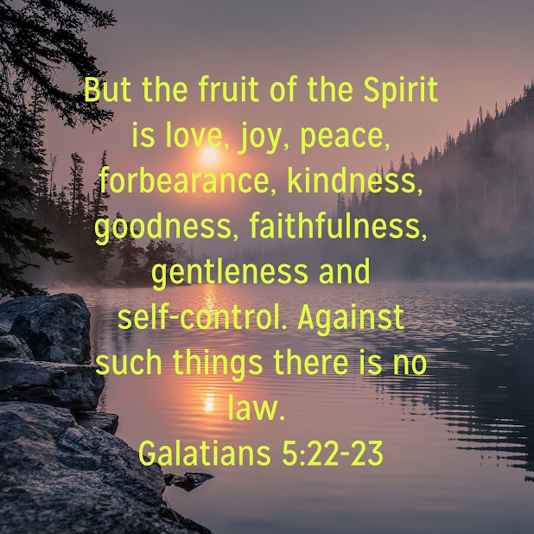
Most of us are eternally looking for happiness. The question is, what is happiness?
For some, happiness is the sound of a baby laughing; for others, it's getting a raise at work; for others, it's finding and marrying the perfect spouse.
But this, like most earthly happiness, is only temporary. The laughing baby grows up to be an adult. While many of us may get raises, they often come with more work and responsibility. And the perfect spouse we married, and the perfect life we hoped for isn't always so perfect.
There's an old song called "Happiness Is."
What happiness is
Happiness is
(Happiness is)
Happiness is
(Happiness is)
Happiness is
(Happiness is)
Different things to different people
That's what happiness is.
(Happiness Is, Ray Conniff and the Ray Conniff singers.)
It's true. Happiness is different things to different people. But what gives us true happiness? Let's find out.
**********************The Point*********************
Paul talks about the Fruit of the Spirit in his Epistle to the Galatians. The Fruit of the Spirit is in direct contrast to The Acts of the Flesh.
(We'll be looking at the Acts of the Flesh down the road.) For now, let's look at what Paul calls The Fruit of the Spirit.
"But the fruit of the Spirit is love, joy, peace, forbearance, kindness, goodness, faithfulness, gentleness and self-control. Against such things, there is no law."
Galatians 5:22-23
If you haven't counted yet, there are nine "Fruits" that Paul refers to. They are Christ-like attributes and are the way we should live our lives. Every one of them is in contrast to the acts of the flesh.
"These nine attributes come together in a Christian's life to reflect a complete picture of the character of Christ."
(https://www.compassion.com/christian-faith/fruit-of-the-spirit.htm)
This Fruit(s) of the Spirit is the way Christ lived his life, and by living our lives Christ-like, we can enjoy true happiness now and eternal happiness with Christ in Heaven.

(Over the next few weeks, in devotions, I will discuss the nine Fruit(s) of the Spirit as well as the worldliness and negativity of the Act of the Flesh)

