Lenten/Easter Devotion
The Miracles of Jesus
“Resurrection Sunday”
March 31, 2024
Matthew 28:1-10

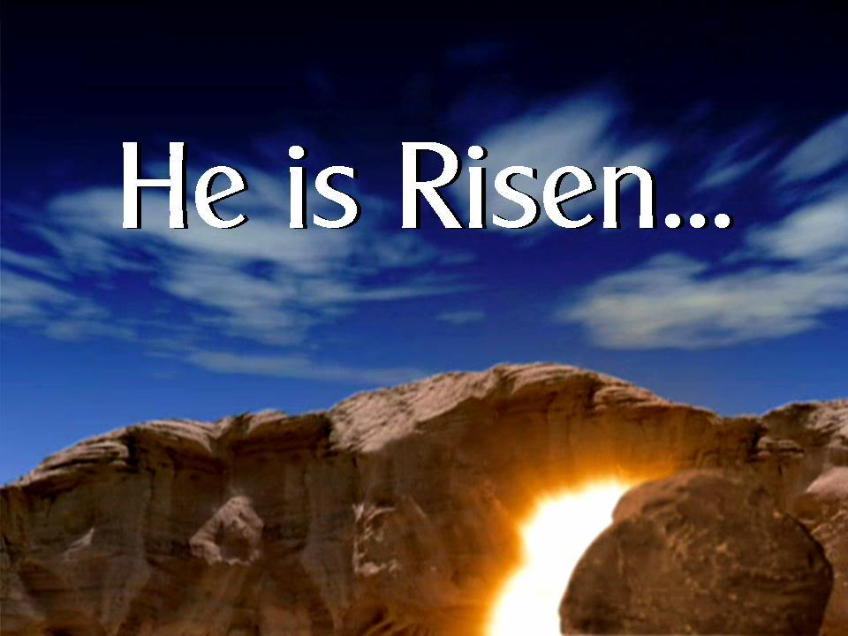

All four Gospels (Matthew, Mark, Luke, and John) describe the Resurrection. Each writer has his own perspective, with slight differences in each account. But one thing is for sure: in all four accounts, Jesus has risen. He has risen indeed.

Let’s take a look at Matthew’s account of the Resurrection:

“Now after the Sabbath, toward the dawn of the first day of the week, Mary Magdalene and the other Mary went to see the tomb. And behold, there was a great earthquake, for an angel of the Lord descended from heaven and came and rolled back the stone and sat on it. His appearance was like lightning, and his clothing white as snow. And for fear of him, the guards trembled and became like dead men. But the angel said to the women, “Do not be afraid, for I know that you seek Jesus who was crucified. He is not here, for he has risen, as he said. Come, see the place where he lay. Then go quickly and tell his disciples that he has risen from the dead, and behold, he is going before you to Galilee; there you will see him. See, I have told you.” So, they departed quickly from the tomb with fear and great joy and ran to tell his disciples. And behold, Jesus met them and said, “Greetings!” And they came up and took hold of his feet and worshiped him. Then Jesus said to them, “Do not be afraid; go and tell my brothers to go to Galilee, and there they will see me.”
Matthew 28:1-10

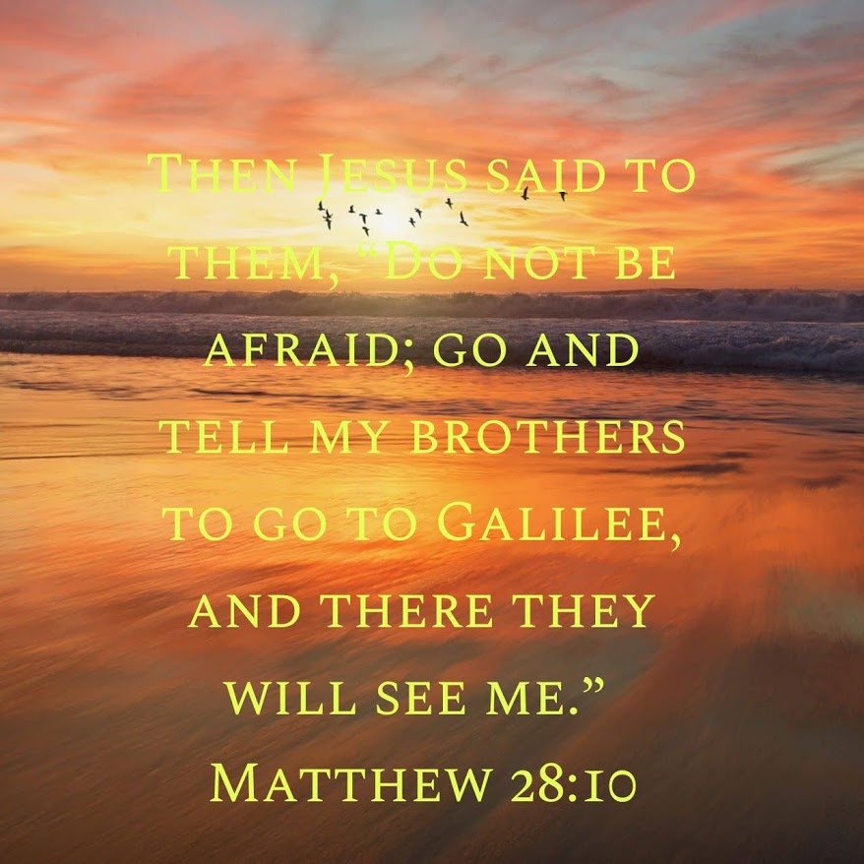
We find Mary Magdalene and the other Mary (The mother of James and Joses) arriving at the tomb. Mark’s Gospel is a bit more specific in that he states that they came with spices to anoint the body of Jesus.
Here’s another thought from Mark’s Gospel. In it, the women were worried about how they would move the stone to enter the tomb. Matthew’s Gospel solves that problem by describing another earthquake that occurred (Remember the first one? It was at the moment of Jesus’ death).
The earthquake occurs when an angel descends from heaven and rolls the stone away.
Okay, so do you remember the devotion yesterday about the guards? Well, here they are again. When all this commotion occurs, and they see what happens, Matthew’s account says, “And for fear of him the guards trembled and became like dead men.”
The words, ‘dead men” are open to a bit of interpretation. The guards could have possibly passed out from fear, thus laying on the ground like they were dead. They also could have been so terrified and stunned by what they had just observed that they couldn’t speak or move.
Either way, you’ll notice that the angel acts like the guards aren’t even there. He addresses the women, not the guards. He says these words, “Do not be afraid.” Hold those words in the back of your mind for a moment as we continue.
The angel wastes no time in telling the women what has occurred. Jesus has risen from the grave just like He said that He would. The angel then tells them to go and tell the disciples what they have seen and that they should go to Galilee, where Jesus will meet them.
Okay, please pardon my interruption at this point. But once again, we find the disciples not listening to what Jesus tells them to do. In Matthew 26:32, at the Last Supper, Jesus says, “But after I am raised up, I will go before you to Galilee.” That’s once; now, the angel tells the women to pass the same information on to the disciples. So that’s twice they’ve been told to go to Galilee.
As the infomercials say, “But wait, there’s more.” Suddenly, Jesus appears to the women as they leave and says, “Greetings!” And they came up and took hold of his feet and worshiped him. Then Jesus said to them, “Do not be afraid; go and tell my brothers to go to Galilee, and there they will see me.”
And that is the third time. Jesus passed this information along twice, and the angel reinforced it.
So, the women return and tell them what they heard and say, and the disciples believe them, correct? NOT! Luke’s Gospel, 24:10-12, says,
“Now it was Mary Magdalene and Joanna and Mary the mother of James and the other women with them who told these things to the apostles, but these words seemed to them an idle tale, and they did not believe them. But Peter rose and ran to the tomb; stooping and looking in, he saw the linen cloths by themselves, and he went home marveling at what had happened.”
Yes, the disciples doubted the women and had to see it for themselves. Only after Jesus had appeared to the disciples several times did they go to Galilee, where Jesus gave them The Great Commission.
Finally, remember I told you to tuck the words “Do not be afraid” into the back of your mind? I did that because it’s essential. The phrase is used over and over again in the New Testament. The angel appears to Zechariah and says, “Do not be afraid.” The angel appears to Mary and says? Yep, “Do not be afraid.” When the angels appeared to the shepherds, he said, “Do not be afraid.”
It’s true, they didn’t need to be afraid, nor do we. Remember what Psalm 23 says? “Even though I walk through the valley of the shadow of death,
I will fear no evil, for you are with me;”
There is no need for us to fear because Jesus overcame death by His death on the cross and His Resurrection. And it’s also true, as Jesus said in His final words of Matthew’s Gospel, “And behold, I am with you always, to the end of the age.”
“He is Risen, He is Risen Indeed.”
Dear Jesus. Thank you. You died on the cross and rose again three days later. You overcame death so we may live with you in eternity. B.GT.F. By Grace Through Faith, we are saved. Amen

References: The Holy Bible (ESV)
The Peoples Bible Commentary, Matthew, G.J. Albrecht and M.J. Albrecht.

