Lenten/Easter Devotion
March 28, 2024
Maundy Thursday
"He washed their feet."
John 13:1-20

In chapter four of my book, "Adventures in Youth Ministry," I discuss "TEACHING THEM TO BE COMFORTABLE PRAYING OUT LOUD."

The point of this chapter was to give some helpful hints on getting students to be comfortable with praying out loud.
I'm not going into all the details of our "Modern-day foot washing." Suffice it to say, there was no water involved, a lot of praying, and some astonishing results came out of it. "The students opened up; they cried, hugged, and gave each other advice because they felt safe and comfortable praying and opening up in a small group."
(Adventures in Youth Ministry, Chapter 4)

***********************The Point***********************

In the Gospel of John, chapter 13, beginning with verse one, Jesus and His disciples have come together for what we refer to as the Last Supper. Jesus and His followers are reclining at the Passover meal table when Jesus stands up and does a most peculiar thing, at least in the eyes of His disciples.

Jesus Washes the Disciples' Feet
"Now before the Feast of the Passover, when Jesus knew that his hour had come to depart out of this world to the Father, having loved his own who were in the world, he loved them to the end. During supper, when the devil had already put it into the heart of Judas Iscariot, Simon's son, to betray him, Jesus, knowing that the Father had given all things into his hands and that he had come from God and was going back to God, rose from supper. He laid aside his outer garments and, taking a towel, tied it around his waist. Then he poured water into a basin and began to wash the disciples' feet and to wipe them with the towel that was wrapped around him. He came to Simon Peter, who said to him, "Lord, do you wash my feet?" Jesus answered him, "What I am doing, you do not understand now, but afterward you will understand." Peter said to him, "You shall never wash my feet." Jesus answered him, "If I do not wash you, you have no share with me." Simon Peter said to him, "Lord, not my feet only but also my hands and my head!" Jesus said to him, "The one who has bathed does not need to wash, except for his feet, but is completely clean. And you are clean, but not every one of you." For he knew who was to betray him; that was why he said, "Not all of you are clean."
When he had washed their feet and, put on his outer garments and resumed his place, he said to them, "Do you understand what I have done to you? You call me Teacher and Lord, and you are right, for so I am. If I then, your Lord and Teacher, have washed your feet, you also ought to wash one another's feet. For I have given you an example that you also should do just as I have done to you. Truly, truly, I say to you, a servant is not greater than his master, nor is a messenger greater than the one who sent him. If you know these things, blessed are you if you do them. I am not speaking of all of you; I know whom I have chosen. But the Scripture will be fulfilled, 'He who ate my bread has lifted his heel against me.' I am telling you this now, before it takes place, that when it does take place, you may believe that I am he. Truly, truly, I say to you, whoever receives the one I send receives me, and whoever receives me receives the one who sent me."
John 13-1-20
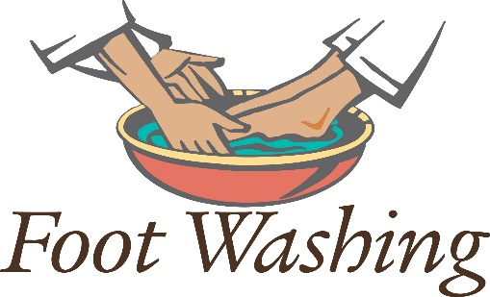
"Jesus washed their feet. Twelve disciples, twenty-four feet, and He cleaned them. On his knees, Jesus got down on what was probably a filthy floor in the upper room. Jesus wrapped a towel around His waist, which comes in handy when washing twenty-four feet. Then, He started working.
This was servant work, not something He should do! He was their leader, He was their teacher, and He was the guest of honor that night at the Passover meal. This scene happened over 2000 years ago in Jerusalem. There weren't many paved roads back then, so the streets were dusty and muddy when it rained. So, it was customary for the homeowner or host to provide a slave at the house's door to wash the dinner guests' feet as they arrived. If the home couldn't afford a slave, the responsibility generally fell to one of the early arriving guests. Interestingly enough, none of the disciples volunteered for this common task. So, we find the upper room filled with proud hearts and dirty feet!
So, He, God, who once took a lump of clay and formed a man, washed their feet. The same God who was born in a dirty stable and laid in an animal's feed trough. The same God who, in just a few minutes, would be offering His body and blood to his disciples during the Passover meal. He was the same God who would be tried, beaten, humiliated, whipped, crucified, and buried in just a few short hours.
Not just for those twelve disciples and twenty-four feet, but for all of us. He washed their feet as a servant. He loved them because He loves us.
On that first Maundy Thursday, Jesus taught His disciples a valuable lesson through experiential learning. By getting down on His knees and taking a basin and a towel, Jesus washed His disciples' feet as a servant. Jesus lived amongst us as one who served. He modeled the lifestyle He wants us to live every day of our lives. When we selflessly and lovingly help others, we live as Christ wants us to.
Jesus used the basin of water and the towel to teach us the essence of service. His Holy Spirit lives within us and calls us to live our faith out loud through serving others." (From my September 2019 Blog)
Dear Jesus. Please help us to look at servanthood the way you do. It was not a common task for you to wash the feet of Your disciples. It was an example that helped them and us learn how to serve. May we model your servant nature and support all of those in need that we know and cross our paths. Amen.

