The Miracles of Jesus
March 6, 2021
Jesus brings Jairus's daughter back to life
Mark 5:21—24; 35-43

If you've ever visited someone in a hospital ward or stayed there, it's not uncommon to hear the words, "Code Blue, Code Blue, Room #___, Stat!" Code blue indicates a medical emergency such as cardiac or respiratory arrest.
Doctors and nurses rush to the patient's room and try to get them breathing or heart pumping again. Sometimes, they succeed, and other times they don't.
***************************The Point***********************
The Synagogue leader, Jairus, came to Jesus asking for his little daughter's healing, who was near death. Here's what happened:

"When Jesus had again crossed over by boat to the other side of the lake, a large crowd gathered around him while he was by the lake. Then, one of the synagogue leaders, named Jairus, came, and when he saw Jesus, he fell at his feet. He pleaded earnestly with him, "My little daughter is dying. Please come and put your hands on her so that she will be healed and live." So, Jesus went with him."
(Jesus' journey with Jairus was delayed by the healing of the woman who had been bleeding for 12 years. Afterwards, Jesus' interaction with Jairus continued.)
"While Jesus was still speaking, some people came from the house of Jairus, the synagogue leader. "Your daughter is dead," they said. "Why bother the teacher anymore?"
Overhearing (5:36 Or Ignoring) what they said, Jesus told him, "Don't be afraid; just believe."
He did not let anyone follow him except Peter, James, and John, the brother of James. When they came to the home of the synagogue leader, Jesus saw a commotion, with people crying and wailing loudly. He went in and said to them, "Why all this commotion and wailing? The child is not dead but asleep." But they laughed at him.
After he put them all out, he took the child's father and mother and the disciples who were with him and went in where the child was. He took her by the hand and said to her, "Talitha koum!" (which means "Little girl, I say to you, get up!"). Immediately, the girl stood up and began to walk around (she was twelve years old). At this, they were completely astonished. He gave strict orders not to let anyone know about this and told them to give her something to eat.
Mark 5:21—24; 35-43

Here is another story of Faith and healing. Jairus had just witnessed the healing of a woman who had been bleeding for twelve years. (Yesterday's devotion) Jesus healed her based on her Faith. Now, Jairus needed a firm faith for what would come next that day.
- Messengers arrive and tell Jairus that his daughter is dead. They told Him not to bother the master anymore; it was too late for Him to do anything.
How would you feel at this point if you were Jairus?

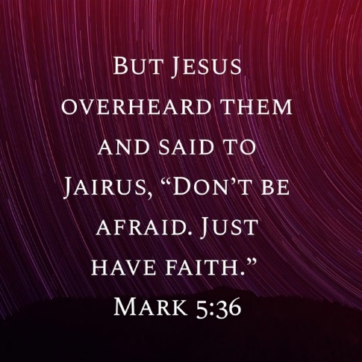
- Before Jairus can say anything to Jesus, Jesus says, "Don't be afraid. Just have Faith."
How strong would your Faith be, based on the healing you witnessed and the words of reassurance from Jesus?

- The group arrives at Jairus's home. There's a crowd of people mourning his daughter's death. Jesus says, "Why all this commotion and weeping? The child isn't dead; she's only asleep." The crowd laughs at Jesus.
You are full of mixed emotions. Your daughter is dead. Jesus says she's asleep. Yet, you maintain your Faith. Jesus has a plan. Why else would He have come home with you? You have put your Faith entirely in this man who claims to be the Son of God.

- Jesus enters the house and takes the girl's hand, saying, "Talitha koum," which means "Little girl, get up!" And she does just that. The twelve-year-old girl is alive and well.
For the first time, we see Jesus as more than a healer. He has the power over life and death. He is truly the Son of God.
This story is just the prelude to the big event to come just a couple of years later. Jesus would die on the cross, be buried, and rise again three days later. Jesus overcame death so that you and I might be saved.
Someday, unless we live till Christ's second coming, we all will die. But because of Christ's death on the cross, we too will be resurrected; we too shall rise from the dead and live eternally with Him.

Dear Jesus. You showed your mighty power over death when you healed Jairus's daughter. Please help us have strong Faith and never stop believing that one day we will rise and join you in eternity. Amen

