The Miracles of Jesus
Lent - March 16, 2024
Jesus heals a boy with an unclean spirit
Mark 9: 14-29


We all have ups and downs. The dictionary definition of ups and downs is:
"a succession of both good and bad experiences."
I'm sure everyone reading this has experienced times in their lives when they were on what we call a high. You just got promoted. The raise you wanted finally comes through. You got straight A's on your report card or a phone message from the auto-mechanic that says, "It wasn't anything serious, just a loose wire. There won't be any charge for the work."
Every one of those experiences can give us a euphoric feeling. Yet, it always seems we don't stay on that high very long before something drags us back to reality. Perhaps it's a phone call that a family member died, your doctor tells you that you need surgery, or you're driving down the road, and, bam, you get a flat tire.
******************The Point***************
In today's devotion, Jesus and three of His disciples were coming down a mountain on a spiritual high when the reality of the world met them at the bottom.
Jesus heals a boy of an unclean spirit.
"And when they came to the disciples, they saw a great crowd around them and scribes arguing with them. And immediately, all the crowd, when they saw him, were greatly amazed and ran up to him and greeted him. And he asked them, "What are you arguing about with them?" And someone from the crowd answered him, "Teacher, I brought my son to you, for he has a spirit that makes him mute. And whenever it seizes him, it throws him down, and he foams and grinds his teeth and becomes rigid. So, I asked your disciples to cast it out, and they were not able." And he answered them, "O faithless generation, how long am I to be with you? How long am I to bear with you? Bring him to me." And they brought the boy to him. And when the spirit saw him, immediately it convulsed the boy, and he fell on the ground and rolled about, foaming at the mouth. And Jesus asked his Father, "How long has this been happening to him?" And he said, "From childhood. And it has often cast him into fire and into water to destroy him. But if you can do anything, have compassion on us and help us." And Jesus said to him, " 'If you can'! All things are possible for one who believes." Immediately, the Father of the child cried out and said, "I believe; help my unbelief!" And when Jesus saw that a crowd came running together, he rebuked the unclean spirit, saying to it, "You mute and deaf spirit, I command you, come out of him and never enter him again." And after crying out and convulsing him terribly, it came out, and the boy was like a corpse, so that most of them said, "He is dead." But Jesus took him by the hand and lifted him up, and he arose. And when he had entered the house, his disciples asked him privately,
"Why could we not cast it out?" And he said to them, "This kind cannot be driven out by anything but prayer."
Mark 9:14-29
Jesus had just been transfigured atop Mount Tabor. (Read Mark 9:2-13) He had taken three of His disciples with Him, Peter, John, and Andrew. After what the disciples had seen and heard, they were definitely on a high. But, when they came down the mountain with Jesus, they encountered an argument going on between the scribes and the other nine disciples.
The disciples had failed at ridding a young boy of a demon that had been with him since he was little. Jesus seems slightly annoyed with His disciples when He says, "O faithless generation, how long am I to be with you? How long am I to bear with you?"
- Jesus was questioning out loud how long would it take for the things He had taught them to sink in?
At this point, Jesus was in His third year of teaching and preaching. He knew His time was limited.
So, at the Father's request, Jesus heals the young man. The demon even cries out as it leaves the young boy's body.
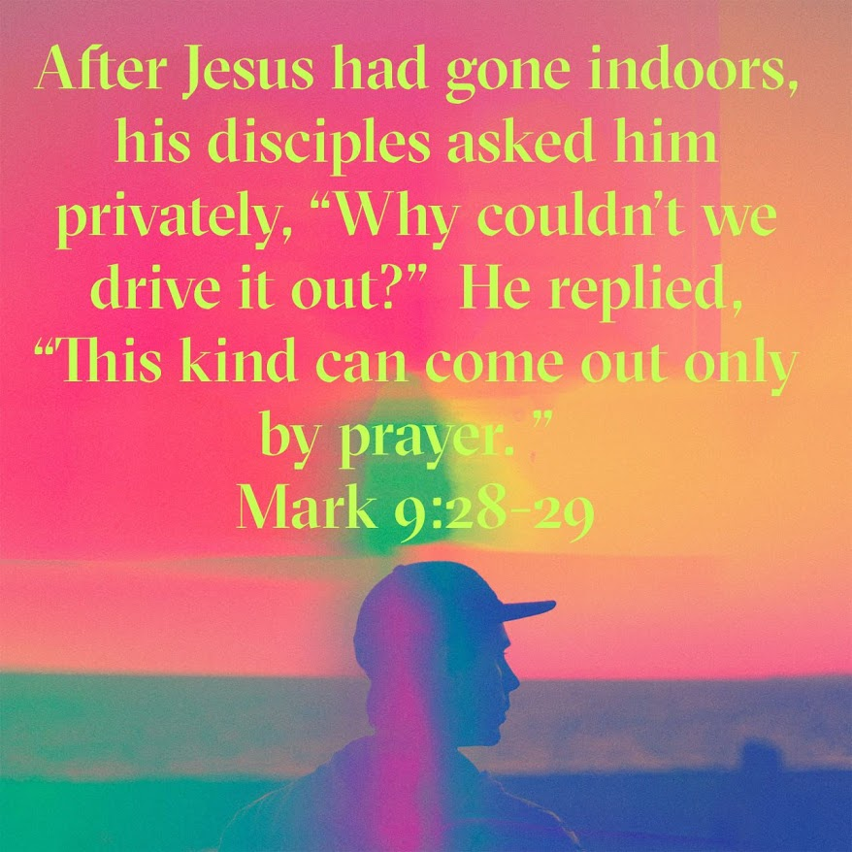
To me, the verses in the photo above are the most important of the entire passage.
- I can close my eyes and see the disciples sheepishly taking Jesus aside. Their heads are down and do little more than glance at Him when they say:
"Why couldn't we drive it (the evil spirit) out?"
- Jesus' answer seems to be spoken quietly. He's not angry at the disciples. He wants to get this crucial point across.
"This kind cannot be driven out by anything but prayer."
Jesus had given the disciples the power to heal and drive out evil spirits when He sent them out (Mark 6:7) into outlying communities. But for some reason, their attempt to rid the boy of the evil Spirit failed.
Remember, the disciples were not Jesus. When Jesus told a spirit to leave, it trembled at His very presence and had no choice but to listen to the Son of God.
Throughout the Gospels, we see Jesus praying before healing and performing a miracle (feeding the 5000). This is what the disciples were missing in this instance. When the evil spirit wouldn't come out of the boy, they should have called on the Father for help in prayer.
Calling on the Father for help in prayer. Calling on Jesus for help in prayer. Calling on the Holy Spirit for help in prayer.
- So often, we miss it too, don't we?
- We have a problem that seems unsolvable. We've tried every way humanly possible to solve it, and we've failed miserably.
- But we forgot one thing.
We didn't call upon the one who can do things that are not humanly possible.
The one who can heal the sick and raise people from the dead.
The one who helps to keep our faith strong and to stay on God's desired path.
We fail to pray to the one true Triune God. God waits for us to call on Him. He listens when we do and answers in His time, not ours. And He answers in a way that He knows is best for us, not what we think is best for us.
Instead of driving yourself crazy to solve everything by yourself, why not lead with prayer. Then, be still and wait for God's answer. He will answer.
Dear Jesus. So often in our lives, we try and solve our problems ourselves. We usually allow you to be an afterthought, not our primary comfort and resolution source. Help us call upon you as often as we need for your help, direction, love, and gentle guiding hand in all that we do. Amen.

