The Miracles of Jesus
Lent - March 14, 2024
Jesus heals a blind man at Bethsaida
Mark 8:22-30
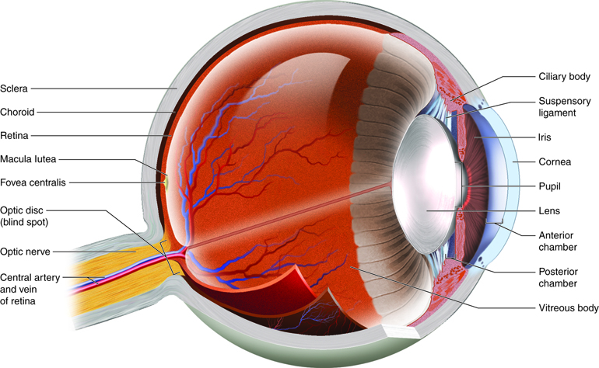
About 20 years ago, I had cataract surgery on both of my eyes. Until I had the two surgeries, I had no idea I lived in a darkish-yellow world. When the bandage came off from the first surgery, my wife, Kathy, asked me if I noticed a difference. I told her everything was white and bright; it was amazing.
Unfortunately, about two weeks after the second eye surgery, I woke up one morning with a shadow in my right eye, like a grey half-moon. I let it go for a few days but finally called the surgeon who had done my cataract surgery. The nurse who answered the phone told me to come to the office immediately.
After the doctor checked out my eye, he asked me the strangest question, "When was the last time you ate?" I told him about 3 hours earlier, and he said, "Good, because you're having surgery in about three hours; you have a torn retina."
I found out later that this happens in about one of every 10,000 people who have cataract surgery. Lucky me. If I had waited a few more days, the doctor also told me I might have had irreversible damage, if not total blindness, in that eye.
*********************The Point********************
Today's devotion is another miracle of Jesus healing a blind man. This healing is a bit different as it's a two-step process.
"And they came to Bethsaida. And some people brought to him a blind man and begged him to touch him. And he took the blind man by the hand and led him out of the village, and when he had spit on his eyes and laid his hands on him, he asked him, "Do you see anything?" And he looked up and said, "I see people, but they look like trees, walking." Then Jesus laid his hands on his eyes again, and he opened his eyes, his sight was restored, and he saw everything clearly. And he sent him to his home, saying, "Do not even enter the village."
And Jesus went on with his disciples to the villages of Caesarea Philippi. And on the way, he asked his disciples, "Who do people say that I am?" And they told him, "John the Baptist; and others say Elijah; and others, one of the prophets." And he asked them, "But who do you say that I am?" Peter answered him, "You are the Christ." And he strictly charged them to tell no one about him."
Mark 8:22-30

It's not clear from this passage that the man who was blind had faith. Almost certainly, though, those who brought him to Jesus believed Jesus to be a healer at the very least.
At first read, it seems Jesus couldn't perform this miracle on the first try. But there's more to this healing than that.
- After Jesus put spit on the man's eye, he was able to see blurry figures that looked like trees moving around.
Obviously, this man wasn't born blind, or he wouldn't know what a tree looked like.
- It's almost like Jesus wanted this to be a two-step process. The first time Jesus touched his eyes, the man could see partially.
Jesus wanted this to sink in, "Do you see anything?"
The blind man had partially recovered from his blindness. Mark doesn't say it, but he would have been excited. He probably thought, "This Jesus, He's the real thing, I can already see better."
- Then Jesus touched his eyes again, and the man was healed, able to see clearly.
- Jesus then tells the now-seeing man not to enter the village again. Jesus wanted this man to go home and be with his family. This was a big deal and a cause for celebration.

The last part of this passage isn't a miracle, as much as we see eyes being opened like the blind man.

Jesus and His disciples are far from where he healed the blind man. Even though this conversation may not have occurred on the same day, Mark chose to attach it to the miracle. Here's why:
- Jesus is walking with His disciples and asks a question, "Who do people say that I am?"
The disciples reply that some say He's John the Baptist, others say Elijah, and still others say one of the prophets.
At this point, I can almost see Jesus stopping and looking each of His disciples in the eye as He asks the next question.
- Let's hold there for a moment.
- These men had been following Jesus for quite a while, and even they had reservations about who He was.
- In the short time Jesus had been teaching them, they had observed one miracle after another.
- When the question came, they would have discussed these things with each other and finally came to this realization when Jesus said:
- "But who do you say that I am?"
- And Peter, being the leader of the group, answered for them
"You are the Christ."

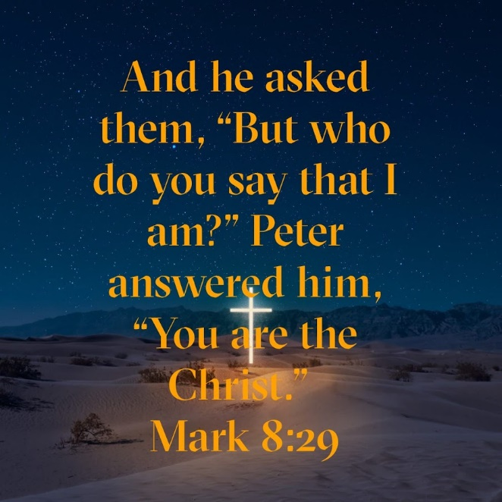

Bam! They got it. The disciple's eyes, like the blind man, had been opened. After numerous miracles, after being repeatedly taught about God's Kingdom, they finally saw what was in front of them. Jesus was the Christ, the Messiah, the Savior of the world, promised by God and foretold by the prophets.

Today, it is our responsibility. We are to bring God's word to the world and emulate His Son, Jesus, in all we do. In this way, everyone's eyes will someday be open to Salvation.

Dear Jesus. Just like you opened the eyes of the blind and those of the disciples, you have opened our eyes, hearts, and minds to you. We genuinely believe that you are the Savior of the world. Thank you for bringing your Father's love to us through your sacrifice on the cross. Amen.

