The Miracles of Jesus
Lent - March 12, 2024
Jesus heals a deaf and mute man
Mark 7:31-37



About 24 years ago, I was in a bowling league while serving as a youth minister at Our Savior Lutheran Church in Lake Worth, FL. The Wednesday night league consisted of about 24 teams. The team I was on was made up of church members and staff.
The first night of bowling, I noticed that the team several lanes over from ours was signing. I asked one of my team members about it, and they said the entire team was deaf. I thought it was interesting, as I watched the team talk to each other throughout the year using sign language.
Not being able to hear didn't hold anyone on the team back from performing well.
*******************The Point****************
In the Gospel of Mark 7:31-37, we read the story of Jesus healing a deaf and mute man.
"Then he returned from the region of Tyre and went through Sidon to the Sea of Galilee, in the region of the Decapolis. And they brought to him a man who was deaf and had a speech impediment, and they begged him to lay his hand on him. And taking him aside from the crowd privately, he put his fingers into his ears and, after spitting, touched his tongue. And looking up to heaven, he sighed and said to him, "Ephphatha," that is, "Be opened. And his ears were opened, his tongue was released, and he spoke plainly. And Jesus charged them to tell no one. But the more he charged them, the more zealously they proclaimed it. And they were astonished beyond measure, saying, "He has done all things well. He even makes the deaf hear and the mute speak."
Mark 7:31-37
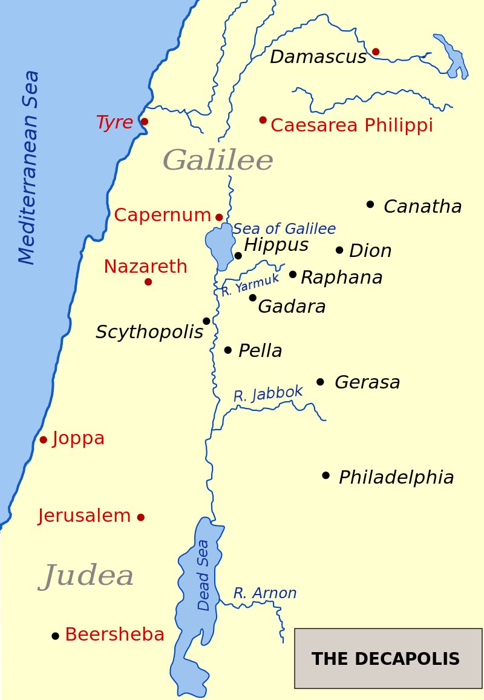
This is the second time we find Jesus in the Decapolis region (The ten cities). The last time He was there, Jesus drove a "legion" of demons from a man; the demons entered a herd of pigs, which then ran into the lake and drowned.
Now, Jesus and His disciples have returned. The word must have gotten out about His miracles because a deaf/mute man was brought to Jesus to be healed. Let's look at some crucial points in this story.
- Jesus was in the region of the Decapolis; He was there spreading the Word of God.
- When He was last in the area, people asked Him to leave. On this trip, people were seeking Jesus out for His help.

- This is the second time in Mark's Gospel we see Jesus using His native Aramaic for healing. Jesus said, "And looking up to heaven, he sighed and said to him, "Ephphatha," that is, "Be opened.
The first time we heard Jesus use His native tongue was when He brought Jairus' daughter back to life. "Holding her hand, he said to her, "Talitha koum," which means "Little girl, get up!"
When Jesus was looking up to heaven and sighed, He wasn't saying, "Okay, I'll heal another one." Instead, He let the man see that his healing was not coming from a man but from God.
Once again, Jesus commanded the people not to tell anyone who had healed the man. Jesus still had things to do and didn't need the Jewish religious leaders breathing down His neck.
Interestingly, Jesus' command for people not to tell anyone about Him no longer applies today. Instead, today, we are told to spread the word:
"Go therefore and make disciples of all nations, baptizing them in the name of the Father and of the Son and of the Holy Spirit, teaching them to observe all that I have commanded you. And behold, I am with you always, to the end of the age."
Matthew 28:18-19
Dear Jesus. We know You want us to go into the world and tell everyone about the Good News. Please help us to be good disciples; as we go, learn and serve you. Amen.

