The Miracles of Jesus
Lent – February 28, 2024
Jesus calms a storm on the sea of Galilee
Mark 4:35-41
In 1983, I was a manager for Albertson’s supermarkets in Lake Worth, FL. That year, I won a contest through Progresso Foods for best display. The prize was a four-day, three-night cruise to the Bahamas.
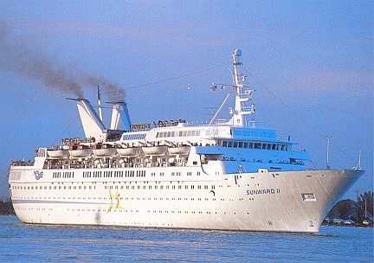
I had never been on a cruise, but I knew I get motion sick pretty quickly. So, before we left, I purchased one of those patches you put behind your ear to help with equilibrium and some Dramamine.
The day we left the port of Miami was a chilly and dismal day in March. We would be sailing on the SS Sunward II. Everything was fine until the ship got out onto the Gulf Stream. Then, the boat began to rock back and forth and up and down. At one point, we hit 20-30-foot swells. I thought we were going to sink and drown for sure.
Needless to say, I got sick, as did most of the people on the ship that day. I haven’t been on a cruise or any other kind of boat except a canoe since.
*************************The Point********************
In the 4th chapter of Mark’s Gospel, Jesus and His disciples have quite the adventure on the Sea of Galilee:
“As evening came, Jesus said to his disciples, “Let’s cross to the other side of the lake.” So, they took Jesus in the boat and started out, leaving the crowds behind (although other boats followed). But soon, a fierce storm came up. High waves were breaking into the boat, and it began to fill with water.
Jesus was sleeping at the back of the boat with his head on a cushion. The disciples woke him up, shouting, “Teacher, don’t you care that we’re going to drown?”
When Jesus woke up, he rebuked the wind and said to the waves, “Silence! Be still!” Suddenly, the wind stopped, and there was a great calm. Then he asked them, “Why are you afraid? Do you still have no faith?”
The disciples were absolutely terrified. “Who is this man?” they asked each other. “Even the wind and waves obey him!”
Mark 4:35-41

The type of storm that is described in this story is not unusual for the Sea of Galilee. I’ve had two pastors tell stories of their experiences with squalls while on a boat in the Sea of Galilee and on a tour of Israel. I have also read about signs posted in the car parking lots on the western shore. The post warns that the waves can swamp your car when a storm occurs. The windstorms seem to come out of no
where, and will toss a boat on the water around like a kid’s toy.

Let’s get back to our story. Jesus gets on a boat with His disciples after a long day of teaching. His goal? To get to Geresenes, where He knew someone needed help. Jesus was exhausted. He went to the back of the boat, laid on a pillow, and fell asleep.
Suddenly, one of those crazy Sea of Galilee storms comes up. The boat fills up with water and is tossed around like nothing most of the disciples had experienced before. They thought they were going to die.
Where was Jesus? In the back of the boat, sleeping. I don’t know about you, but I’m a light sleeper. I wake up when a train goes by on the other side of the Intracoastal, two miles away.

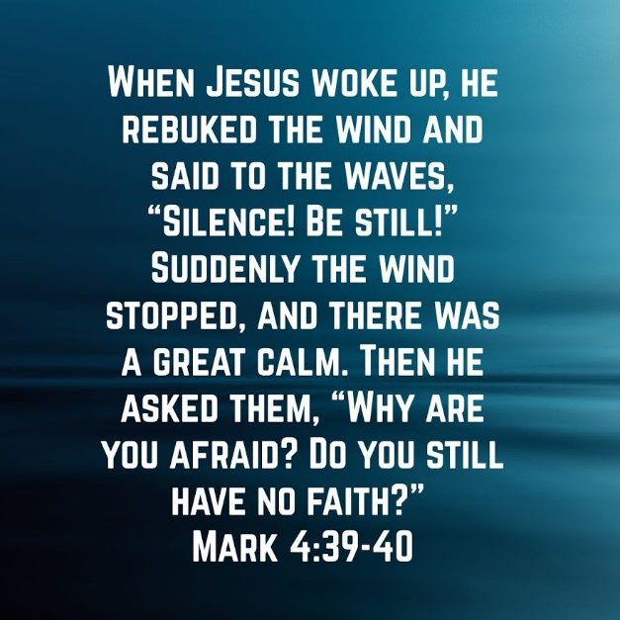
But Jesus knew who He was and was not worried about a storm. But His disciples were. They came to the back of the boat and awakened Him. They were probably screaming at the top of their lungs, “Lord, don’t You care if we die?”
Of course, Jesus cares. Jesus cares about everyone. So, He gets up and tells the raging waters and hurricane-force winds to SHUT UP! And that’s precisely what happened—no storm, no waves, just calm.
Jesus shows us His power at yet another level. Just like when God created the seas, the wind, and everything else, Jesus shows who He is by commanding them to stop. Not only can Jesus heal and drive out demons, but now, He shows His disciples that He also has command over the elements.
They are in awe yet still don’t quite understand the full meaning of who Jesus is.
Once again, let’s take a quick trip to the other side of history. You’re there, I’m there, and this miraculous thing happens. What is your reaction? What questions do you ask? Who do you tell about the experience? Take some time and ponder those questions.

Dear Jesus. You are in complete control of everything. You heal people, make the sunshine, and give us rainy days. You are everywhere and involved in every aspect of our lives. Thank you for always being with us. Amen

