The Miracles of Jesus
Lent – February 26, 2024
"Living on the other side of history."
(Jesus heals a man's withered hand on the Sabbath)
Mark 3:1-6; Exodus 10:8-11


In the late 1980s and early 1990s, Hannah Barbera (Creators of cartoons such as Yogi Bear, The Flintstones, and Jetsons) came out with a Biblically-based series of cartoons. This animated series was called "The Greatest Adventure: Stories from the Bible."
The series was an 'animated direct-to-video series that tells of three young adventurers who travel back in time to watch biblical events take place.' In the series, the three main characters travel to Old and New Testament locations to experience the Bible stories from a Christian perspective.
What would it be like to be sent back in time to observe some of the Biblical stories we've all learned over the years? Right now, we live on this side of history. So, we know the stories and often understand the stories' hows and whys.
*********************The Point*****************
Let's read about another of Jesus' miracles, in which the Pharisees observed Him healing a man on the Sabbath.

"Another time, Jesus went into the synagogue, and a man with a shriveled hand was there. Some of them were looking for a reason to accuse Jesus, so they watched him closely to see if he would heal him on the Sabbath. Jesus said to the man with the shriveled hand, "Stand up in front of everyone."
Then Jesus asked them, "Which is lawful on the Sabbath: to do good or to do evil, to save life or to kill?" But they remained silent.
He looked around at them in anger and, deeply distressed at their stubborn hearts, said to the man, "Stretch out your hand." He stretched it out, and his hand was completely restored. Then the Pharisees went out and began to plot with the Herodians how they might kill Jesus."
Mark 3:1-6
This story is pretty straightforward. Jesus is teaching at the synagogue on the Sabbath. The Jewish Sabbath had many laws, disallowing people from doing much of anything. No working in the fields, cooking, baking, and kindling a fire are just a handful of the no-nos during the Sabbath in Jesus's day. Here's what the book of Exodus says about observing the Sabbath.

"Remember to observe the Sabbath day by keeping it holy. You have six days each week for your ordinary work, but the seventh day is a Sabbath day of rest dedicated to the Lord your God. On that day, no one in your household may do any work. This includes you, your sons and daughters, your male and female servants, your livestock, and any foreigners living among you. For in six days, the Lord made the heavens, the earth, the sea, and everything in them, but on the seventh day, he rested. That is why the Lord blessed the Sabbath day and set it apart as holy.
Exodus 10:8-11

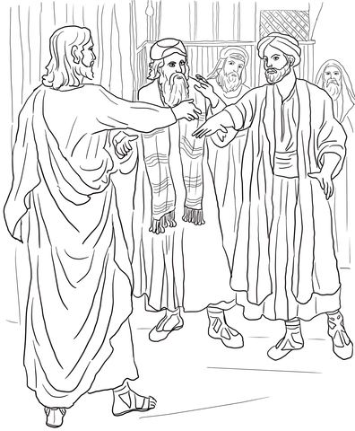
The Pharisees were waiting for Jesus to perform a miracle on the Sabbath because they felt it was work. Thus, if Jesus healed the man with the withered hand, Jesus would be breaking one of God's commandments, and they could rightly accuse Him.
Jesus knew what the Pharisee's thoughts were. Jesus told the man to stand up and then said to him, "Stretch out your hand." Jesus never said, "You are healed," or, "Your sins are forgiven." Technically, He had not broken the law.
But the Pharisees saw it differently and hated Him even more. So, along with the Herodians (Jews who followed Herod and the Roman Empire), they began plotting a way to kill Him.
Wow! It's Saturday (The Jewish Sabbath), and Jesus is preaching in the synagogue. He heals a man with a withered hand without saying a word about healing. And now, they want to kill Jesus.
Let's go back to what I said in the beginning. You and I are living on this side of history. We have the entire Bible to help us understand God's purpose, goals, love, plan, and forgiveness.



As I mentioned earlier in this devotion, what if you and I were on the other side of history. We're sent back in a time machine to the time of Jesus. But we no longer have the whole story; we no longer understand God's plan fully. As a Jew, what would your reaction be to Jesus' teaching and miracles? Would you be a follower or a Pharisee, a teacher of the law, or a Herodian? Would you be in awe of Jesus? Or would you want to put Him to death because of His teachings?
These are questions to think about that can help us read and understand the Bible objectively. Ponder these thoughts today.

Dear Jesus. On this side of history, I am a believer. I believe in your miracles and teachings and that you died for my sins. I pray that I will always be a believer, no matter what comes my way. Amen

