The Miracles of Jesus
Lent – February 20, 2024
Jesus Heals Many
Luke 4:40-41
"According to the CDC, nearly 136 million patients visit emergency rooms in the United States per year, with around 30 percent of those visits relating to injuries.
The yearly national average of emergency room patients, according to the CDC, is 42 for every 100 people or about 42 percent."
https://www.theemergencycenter.com/emergency-room-visit/
********************The Point***************

In yesterday's devotion, Jesus healed Simon Peter's mother-in-law. Here's what happened when word got out about Jesus healing her:
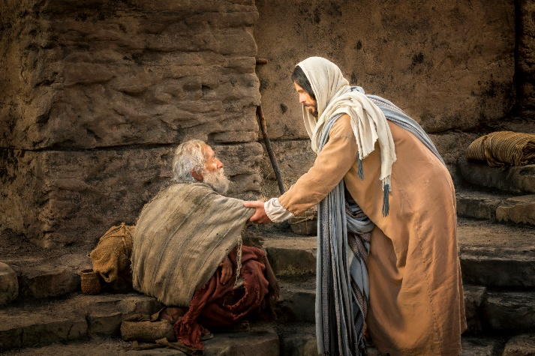
"As the sun went down that evening, people throughout the village brought sick family members to Jesus. No matter what their diseases were, the touch of his hand healed everyone. Many were possessed by demons, and the demons came out at his command, shouting, "You are the Son of God!" But because they knew he was the Messiah, he rebuked them and refused to let them speak."
Luke 4:40-41
So now the word has gotten out. There's a prophet at Simon Peter's house, and He can heal the sick. Let's face it, in Jesus' day, there would have been a lot of illness. There were no hospitals, emergency rooms, or walk-in clinics. There were doctors (like Luke), but the medicines they had or used were limited. So, when someone (Jesus) came to town and could heal a fever and other illnesses, the race was on for the whole community to bring themselves or anyone else who was sick to Jesus to be cured.
And Jesus did just that. The verse above says, "No matter what their diseases were, the touch of his hand healed everyone." As I stated in yesterday's devotion, that means Jesus healed everything from the common cold to an ingrown toenail to cancer. To many people, He was a walking emergency room. Everyone was amazed. That's great, isn't it? Well, yes and no. They were looking at Jesus as a prophet and a healer, not as the Son of God. Basically, they were using Jesus to fulfill their needs. For many, understanding and believing what he was teaching them didn't sink in. Most people didn't understand Christ's purpose until after He died and rose from the dead.
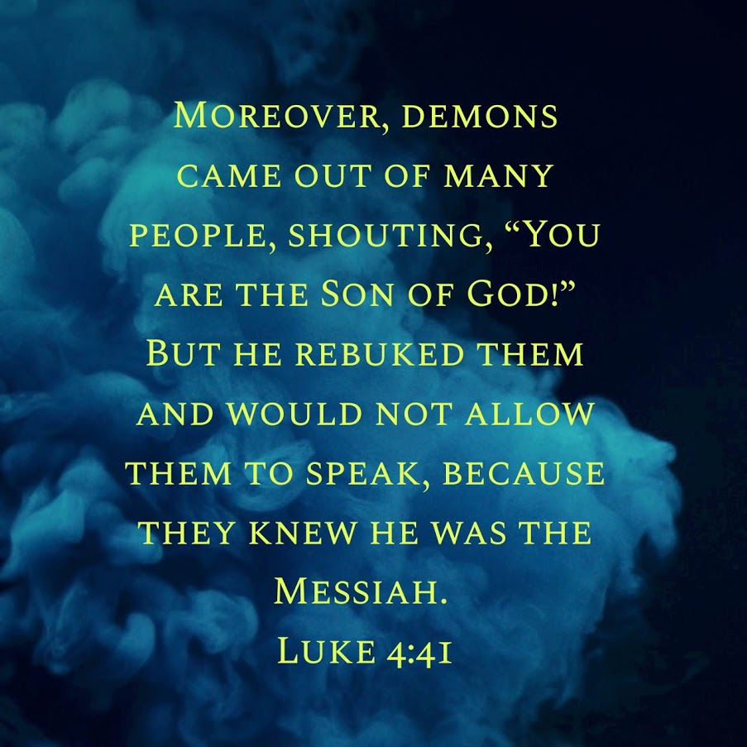
Here's the most exciting part of this passage. Many people who were brought to Jesus were demon-possessed. These demons knew who Jesus was. They came out of people after Jesus touched them, shouting, "You are the Son of God."
Wait a minute. How do these demons know who Jesus is?
These demons are showing their angelic root. The devil and his crew are fallen angels. These evil spirits knew precisely who Jesus was. But Jesus did not want them to bear witness to who He was, so Jesus silenced them.
As I said earlier, Jesus didn't want people to see Him merely as a healer who could cast out evil spirits. He wanted people to learn from Him by listening to His words and following Him. This way, they would understand who He really was, the Son of God who was sent to save the world from sin.
Dear Jesus. Thank you for your many healings. We believe you still heal people's minds, bodies, and souls today. Lord, there are so many sick and dying in our world today. We ask and pray that you place your healing hands upon them and continue to heal many more. Amen

