The Miracles of Jesus
Lent - February 19, 2024
Jesus heals Peter's mother-in-law
Mark 1:29-31
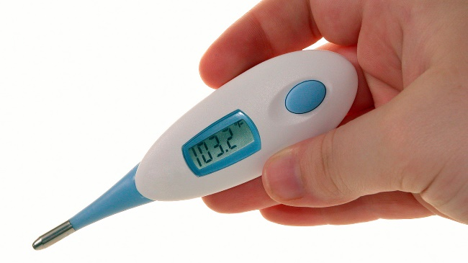
We've all had a fever at one time or another in our lives. Sometimes, the temperature is what we call "low grade" and leaves us tired and uncomfortable. Other times, fevers can be high, causing chills, dizziness, and even hallucinations.
I can recall a time 20 years ago when my daughter had a fever of over 104. It caused her to feel weak and chilled, and she was talking nonsense as if she didn't even know where she was.
One thing I do recall about having a high fever is that even after it broke, I still felt pretty weak and exhausted. Sometimes, it would take several days before I returned to some sort of normalcy.
********************The Point*******************
My fever story brings us to one of Jesus' early miracles:
"After Jesus left the synagogue with James and John, they went to Simon and Andrew's home. Now Simon's (Peter) mother-in-law was sick in bed with a high fever. They told Jesus about her right away. So, he went to her bedside, took her by the hand, and helped her sit up. Then the fever left her, and she prepared a meal for them."
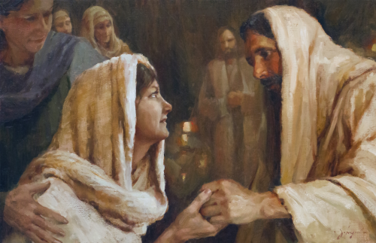

In this passage, we learn three important things.
First, Simon Peter was married. The man has a mother-in-law! You have to remember the disciples left everything to follow Jesus. Since we know Peter was married, we can presume he also put his personal life on hold while traveling with Jesus for the next three years.
Second, Simon's mother-in-law didn't just suddenly get well because her fever broke. This healing was a miracle. This woman not only had the temperature leave her body, but she also had the strength to get up, make food, and feed Jesus and His followers.
Third, Jesus was not a prophet or God who did miracles that would attract attention to Himself. (The miracle of water into wine was not done to draw attention, but it did). He was the God and healer of the ordinary person, healing this sick woman of a simple fever. One can only imagine all the healings Jesus did during His ministry that are not recorded. Jesus must have cured people of colds, fevers, sinus problems, warts, earaches, and ingrown toenails.
It's reasonable to believe that He did many mass healings for the ordinary "man" and common ailments because He came for everyone.

Dear Jesus. Thank you for being our great physician. We know you still heal people's bodies, minds, and souls daily. Thank you for having such empathy for your people. We love you for saving us and all you do for us each day. Amen

