A Devotion
By Joe Guagliardo
Ephesians 2:8-9
Jesus paid our bill
December 4, 2023

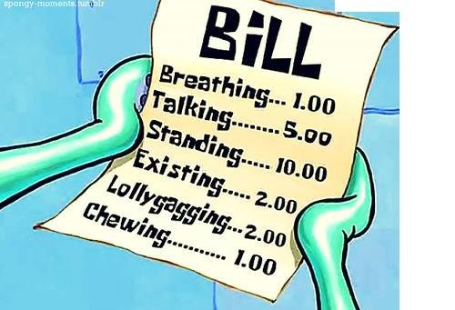
Most of you have health insurance. For some, it's very affordable, while for others, it can be costly.
My health insurance is pretty good. If I see my primary doctor, there is no charge. Also, most of my medications are covered by my insurance.
The one thing most of us dislike is our co-pay. Most of us have to pay a co-pay before we see the doctor. Depending on who your health insurance carrier is, the prices of co-pays vary
I don't have anything against co-pays, as I believe no matter what, a doctor should get paid for their services.
That brings us to today's story:
This morning, I had an 8 a.m. doctor's appointment. I arrived early, checked in, and paid my co-pay.
This is when it gets interesting. Several people who had appointments arrived after I did. Two of them checked in, paid their co-pay, and got called in before me (There are many doctors and nurse practitioners in the office). After I had been waiting for a few minutes, a third gentleman came in and checked in. He was told he had a co-pay (I didn't hear how much it was).
This patient (of middle age) told the receptionist that he shouldn't have to pay anything because the meds that the doctor had prescribed for him didn't work, and he was still sick.
The receptionist explained that patients must pay a co-pay every time they visit the office. He was adamant and told the receptionist he wouldn't pay another co-pay. I'm not sure what she said, but I presume it was something like, "If you don't pay your co-pay, you can't see the doctor."
He then stomped out of the office, mumbling, and said aloud, "This is ridiculous."
Your opinion is yours, but I had never seen such a scene before. I don't always enjoy making my co-payment, but I can honestly say I've never caused a scene over it.
***********************The Point*******************
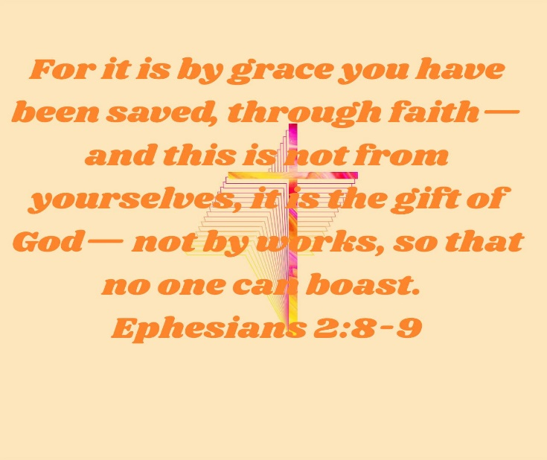
Unlike the odd encounter between the patient and receptionist, our salvation does not depend on you and me doing anything except believing (Faith). No indulgences (financial payment for the forgiveness of sins) will save us from our sins.
No, there's only one payment to be made, and it was made by the Grace of God through the death of His Son, Jesus. God's Son died for our sins. No payment on our part is necessary. All God asks us is to believe in His Son, Jesus. Believe in all that He taught, all that He healed, and how much He loves you and me.
B.G.T.F. By Grace through Faith. No co-pay and no indulgences are necessary. Our debt has been paid.

