A Devotion
By Joe Guagliardo
Matthew 22:37-39
"It's the day after the day after."
December 27, 2023
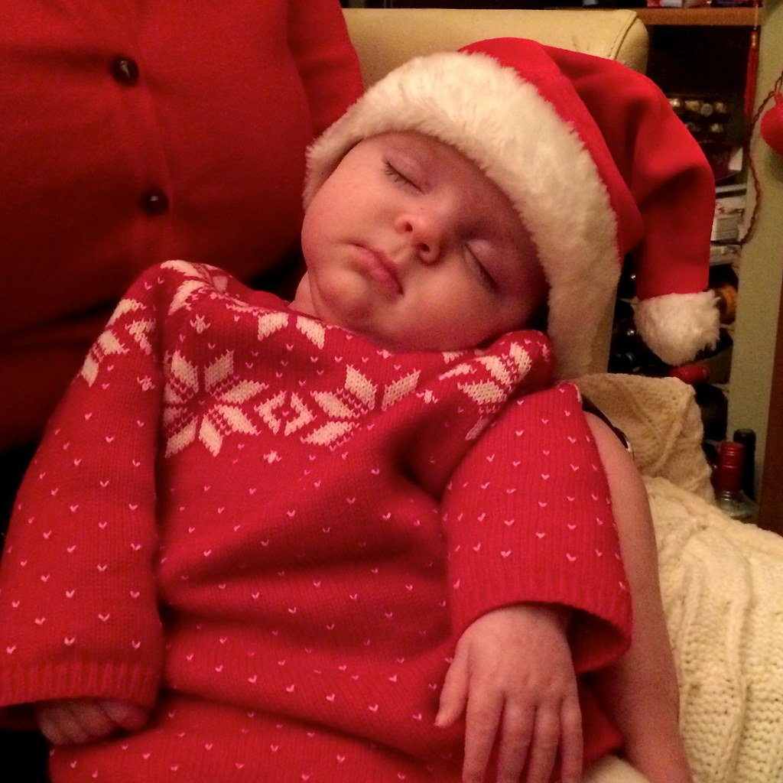
It's the day after the day after … Christmas, that is. The festivities and parties are over. The gifts have been exchanged with others and perhaps also at the store. Maybe, just maybe, you even attended a Christmas Eve or Day service.
We've celebrated Christmas, so what's next? Yes, next week is New Year's, but I seldom count that as a holiday. Kathy and I usually stay home and don't do anything (And we're in bed by 11 p.m.)
Epiphany comes after New Year's. That's when we remember the star in the east that led the wise men to the home of Jesus, Mary, and Joseph. But what's really next?
*************************The Point***********************
Has this Christmas impacted your life as we celebrated the birth of Christ, the Savior of the World?
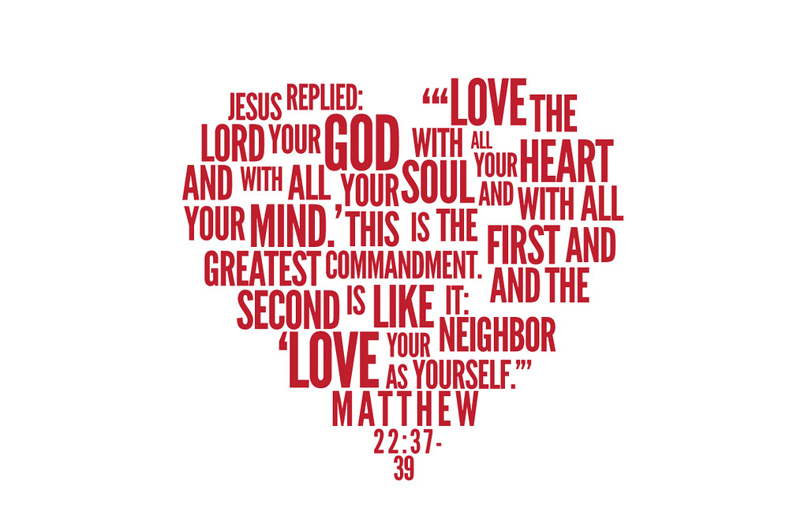
The point is, now that we've celebrated the birth of our savior, why don't we celebrate a new beginning.
Here are some thoughts:
- Love God
  - Matthew 22:37 says: 'Love the Lord your God with all your heart and with all your soul and with all your mind.'
Make God first in your life. Love Him the way He Loves you.

- Love Others
  - Matthew 22:39 says: 'Love your neighbor as yourself.'
Love, respect, and be kind to others.

- Read the Bible often. I've been connected to the church for 35 years, and I'm still learning something new every day when I read it.

- Attend church services regularly. When I go to services on Christmas Eve, I don't recognize over 50% of the people. Most only come a couple times a year. (A former Pastor of mine called them CEOs; Christmas and Easter only )

Whether you prefer traditional or contemporary worship services, there's one for you.
Remember this! Attending church is not just about worshipping God (Which is important). It's also about connecting to others who also love and worship Jesus.

- Finally, if you can, get involved this year. Join a small group Bible Study. Help out when and where you can at church and in the community.
There's so much to learn about Jesus and God's plan for us.
Plus, you'll begin making new friends and forming relationships with others who are like-minded people.
May this New Year be a new beginning for you and your family as you get to know God and His family better.

