A Devotion
By Joe Guagliardo
Imitate God!
1 John 4:9-11
November 7, 2023

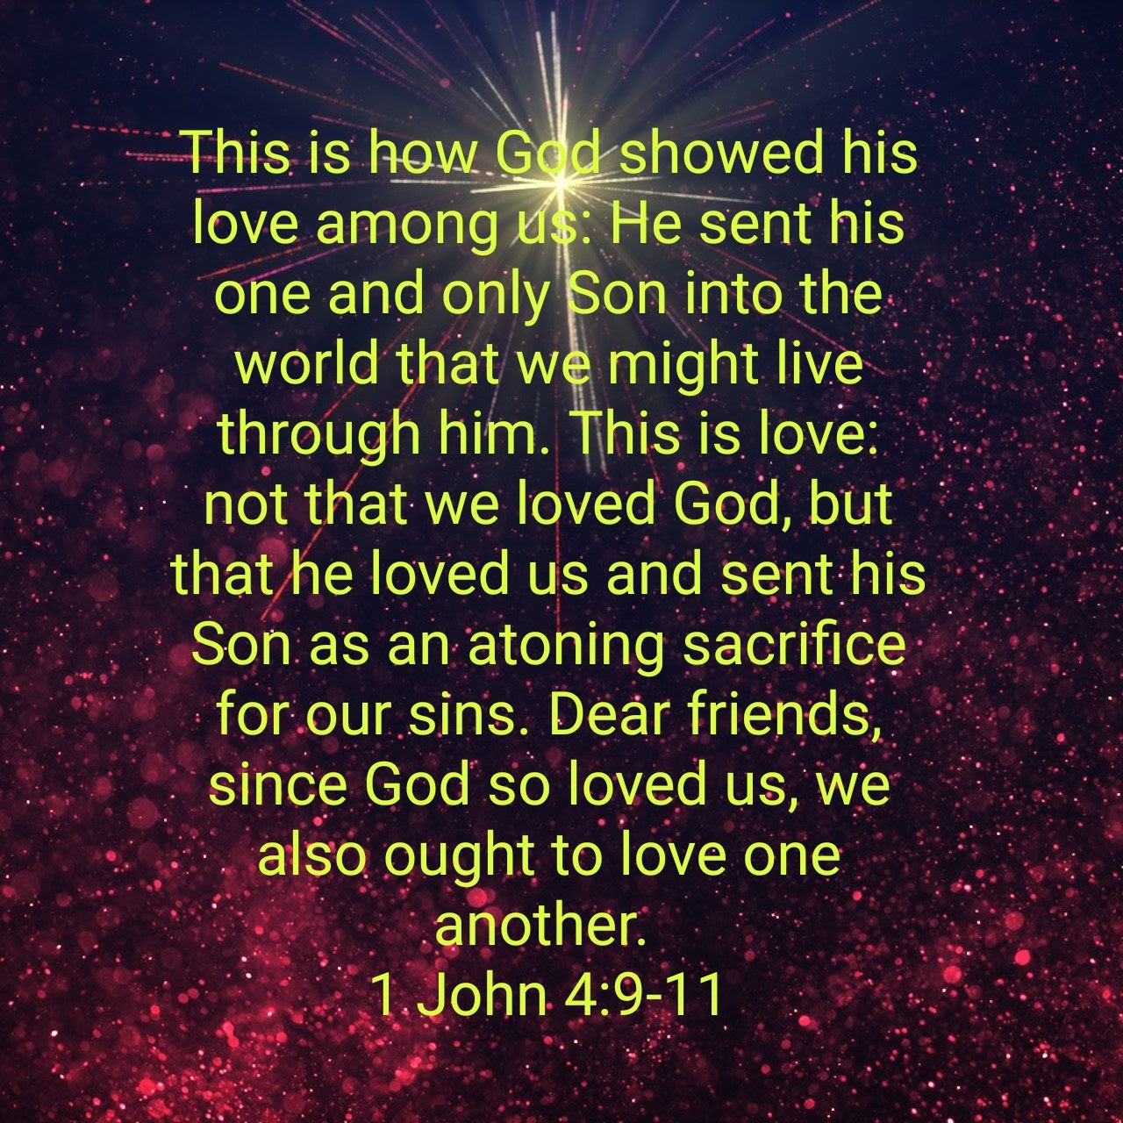
The above passage sounds a lot like John 3:16, doesn’t it?
But in 1 John, the Apostle makes the fact that God sent His Son Jesus even more intimate.
John 3:16 says:
“For God so loved the world that he gave his one and only Son, that whoever believes in him shall not perish but have eternal life.”
Powerful words by the Gospel writer John. God sent His Son, Jesus, to redeem us from our sins. All He asks is that we believe (have faith) in Jesus and what He did for us, and we (you and I) will have eternal life.
Then, in John 3:17, John tells us more:
“For God did not send his Son into the world to condemn the world, but to save the world through him.”
Verse 17 is a reiteration of verse 16 but takes God’s reasoning a step further. It would have been easy for God to send His Son to condemn it. Instead, because of His great love, He sent His Son to save it and be a living sacrifice.
God is asking us to have faith in Him, to understand why He sent His Son, and to believe He died for us. It’s almost too simple, isn’t it?
God loves you and me. And He showed that love by sacrificing His Son for us.
In 1 John 4, John reiterates much of John 3:16:
“This is how God showed his love among us: He sent his one and only Son into the world that we might live through him. This is love: not that we loved God, but that he loved us and sent his Son as an atoning sacrifice for our sins.”
1 John 4:9-10
The words are a bit different, but the meaning is the same. God loves us so much that He sent His Son, Jesus, as a sacrifice for our sins.
But in 1 John, the Apostle adds something else to the promise:
“Dear friends, since God so loved us, we also ought to love one another.”
1 John 4:11
John is telling us something we should do. No, it’s not about faith or belief. Instead, it’s about love!
John tells us that because God loved us so much that He was willing to sacrifice His own Son for us, we should love one another.
So, what’s the big deal. God sent His Son, we believe (have faith), and we have eternal life. What does loving one another get us?
It’s really not about getting anything. It’s about loving as God loves. God loved us so much that He was willing to Sacrifice His Son for us. Why wouldn’t we do the same to others?
John is telling us we should love one another. It’s not that original of a thought. He’s really reiterating what Jesus said:
“the Pharisees got together. One of them, an expert in the law, tested him with this question: “Teacher, which is the greatest commandment in the Law?”
Jesus replied: “‘Love the Lord your God with all your heart and with all your soul and with all your mind.’ This is the first and greatest commandment.
And the second is like it: ‘Love your neighbor as yourself.’
Matthew 22: 34b-39
As you can see, in the Gospel of Matthew, Jesus himself tells us to love our neighbor.
Easy to say, sometimes challenging or difficult to do. We are told to love our neighbor. But we have neighbors who are not nice, are insulting, and sometimes a bit evil. Yet we are told to love them.
Nothing God asks of us is easy. Loving God with all of our hearts is not easy. Helping the poor is not always easy. Even loving our own family isn’t always easy, is it?
But we do our best. And we try to be a better and more loving neighbors each day. Why?
Because we want to follow in God’s footsteps. And God loves us so much that He sacrificed His Son for us. Shouldn’t we be sacrificial, too, and love even the most challenging neighbor?
Something to think about.

