A Devotion
By Joe Guagliardo
Are You Thankful?
1 Thessalonians 5:18; 1 Chronicles 29:13; John 3:16
November 22, 2023

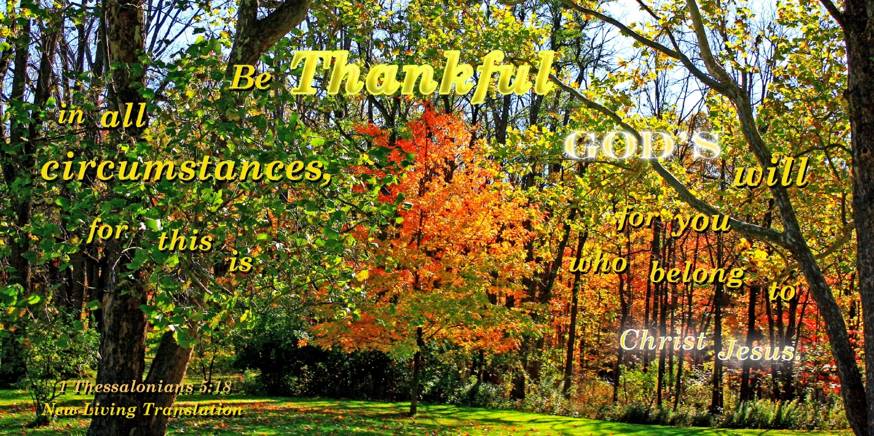
It's that time of year again. Yes, Christmas is just a few weeks away. But that's not what I'm talking about tomorrow's celebration, Thanksgiving.
Right now, the Supermarkets are full of last-minute shoppers purchasing that much-needed can of cranberry sauce or green beans.
I was in my local Publix supermarket this morning about 7:30 a.m. It was already getting pretty busy. I told my wife; as I walked through the store, I looked into the eyes of several people, and their look seemed to say, "You better stay out of my way. I have a short time to finish this shopping, and you better not slow me down."
Walking down the frozen food aisle, I noticed the turkey section was full. I guess no one wanted to try to defrost a bird overnight and cook it tomorrow morning.
To most of us, gathering together with family and friends on Thanksgiving is a tradition. Somewhere in the back of our minds, we remember the Pilgrims and Indians sitting together as they celebrated the harvest.
*************************The Point**********************
It's great that we get together for Thanksgiving with family and friends. Sometimes, the meal prep seems to be more work than it's worth, but being thankful is always worth a celebration.
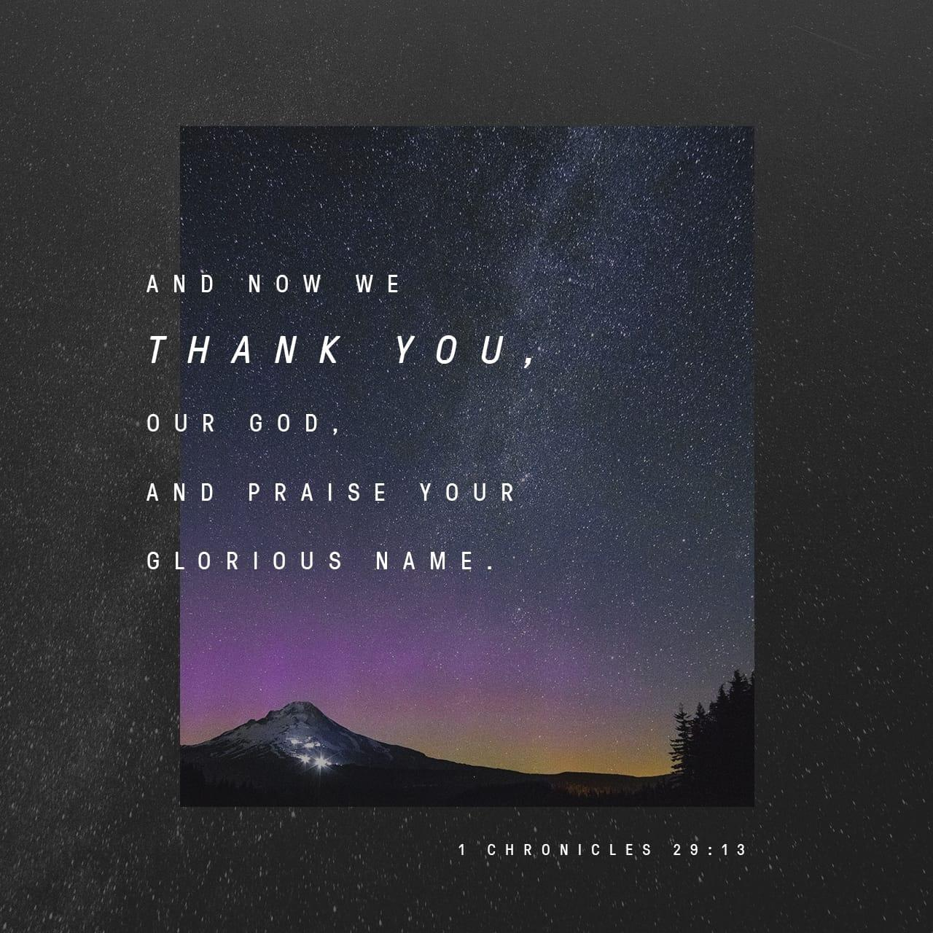
Of course, we should be thankful for so many things. If you have a job, be thankful. If you have a wife and kids, be thankful. Be thankful that you have food on the table and can feed your family. Brothers, sisters, moms, and dads, no matter what the circumstances, be thankful for them.
Most of all, be thankful that we have a loving God who provides. Sometimes, we forget that we wouldn't even be alive without Him.
And though it may not be Christmas, we should thank God every moment of every day for sending His Son, Jesus. Nothing is more important than what Jesus did for you and me. His death and resurrection should keep everything in perspective for us. Praise God and be thankful because, through His Son, He saved us from our sinful ways.

Now that's something to be thankful for.
Have a Blessed Thanksgiving.
Joe G.

