A Devotion
By Joe Guagliardo
We can do all things through Christ!
John 3:16-17
October 30, 2023
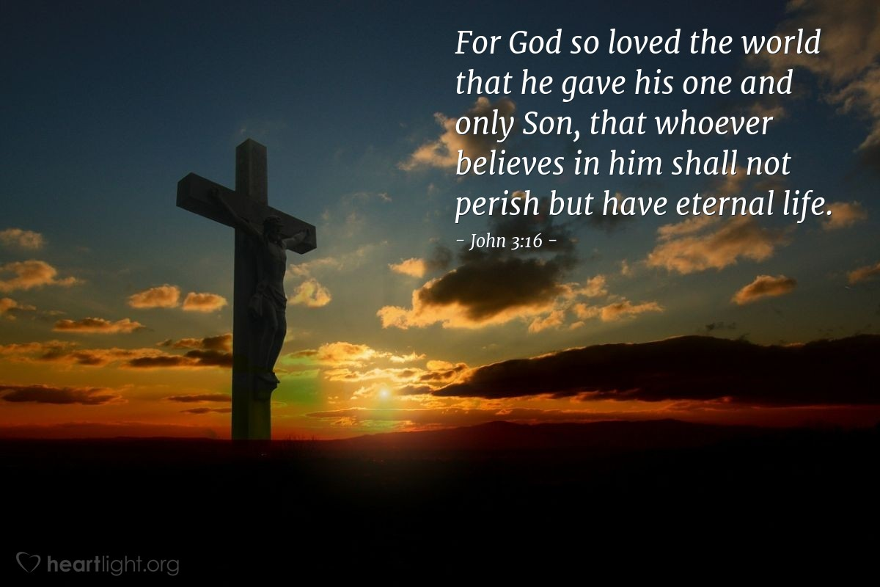
It's interesting how much alike people are. Oh sure, we are different sizes and colors and even have different beliefs. But most of us follow the same pattern as everyone else.
We're born, and we grow. Our parents raise us and teach us how to live and survive. We also learn in school. School teaches us some fundamentals of life. In addition, schools teach us basic math, reading, and writing skills. Some may excel in anything from education to marketing skills.
From that, we work and begin and pursue a career in many areas, such as retail, management, or even church work.
Many of us also pursue a spouse, get married, have children, and the cycle continues.
Of course, there are variations of this pattern. Some people are rich, others are known as middle class, and unfortunately, some are poor. But for now, let's think of our life cycle.
Of course, along the way, we also learn about a creator. A God who sent His only Son to save us from our sins.

You can read John 3:17 above. You see, God didn't send His Son Jesus into this world to follow the patterns of our life. Jesus was sent for a specific purpose. To save humanity from itself.
God could have easily sent Jesus to destroy sinners and wreak havoc on the world. But, He didn't. He (God) sent His Son to save it.
Jesus preached, taught, healed, lived, laughed, and instructed. But primarily, Jesus had a mission. His job was to do something we sinners couldn't and wouldn’t do for ourselves.
His calling was to die a horrible death for you and me. He, Jesus, was and is a living sacrifice for our sins.
Thanks be to God that:
"For God so loved the world that He gave His one and only Son. That whoever believes in Him shall not perish but have eternal life."
Why?
"God did not send His Son into the world to condemn its people."
No!
"He sent Him to save them." Them, is us!

