An Overview of Ephesians
By Joe Guagliardo
Ephesians 3:1-13
"We are all recipients of God's Grace."
August 10, 2023
When I was younger, I loved to read mystery novels. One of my favorite mystery characters is from the short stories and novels Sir Arthur Conan Doyle wrote. Of course, I'm speaking of course, of Sherlock Holmes.
I have many books with the original artwork and stories of Holmes. I've read more current books written by other authors with stories about Holmes. Many of those stories are written under the pretext that they are long-lost writings of Dr. Watson. Watson was Sherlock Holmes, sidekick and chronicler.
Like many of you, I have watched numerous movies about Holmes' cases. Some from the 1940s, and others more current, starring Robert Downey Junior as the reclusive detective. (I'm not a big fan of the 1940's movies as they treat Dr. Watson as a bit of a buffoon.)
I have always found these mysteries of Holmes' exploits exciting, intriguing, and effusive with logic.
In today's Bible verses, Paul mentions the words, Mystery, four times. Let's read the text and look at what he alludes to as Mystery.
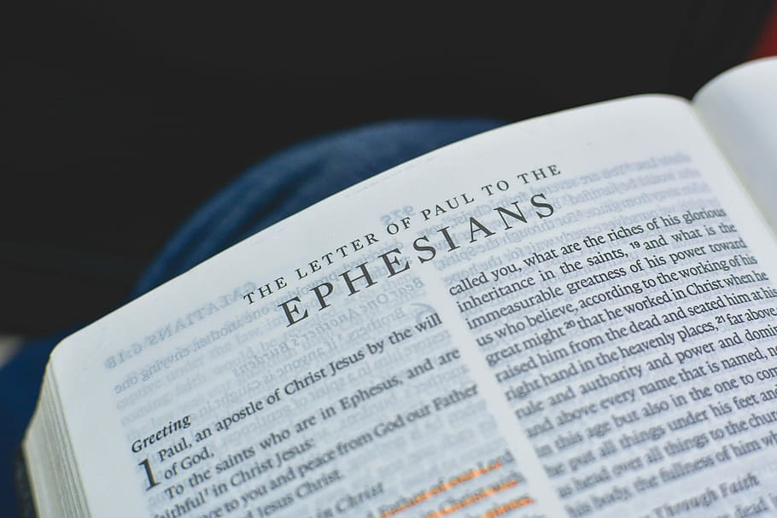

"For this reason, I, Paul, the prisoner of Christ Jesus for the sake of you Gentiles—
Surely you have heard about the administration of God's Grace that was given to me for you, that is, the Mystery made known to me by revelation, as I have already written briefly. In reading this, then, you will be able to understand my insight into the Mystery of Christ, which was not made known to people in other generations, as it has now been revealed by the Spirit to God's holy apostles and prophets. This Mystery is that through the gospel, the Gentiles are heirs together with Israel, members together of one body, and sharers together in the promise in Christ Jesus.
I became a servant of this gospel by the gift of God's Grace given me through the working of his power. Although I am less than the least of all the Lord's people, this Grace was given me: to preach to the Gentiles the boundless riches of Christ and to make plain to everyone the administration of this Mystery, which for ages past was kept hidden in God, who created all things. His intent was that now, through the church, the manifold wisdom of God should be made known to the rulers and authorities in the heavenly realms, according to his eternal purpose that he accomplished in Christ Jesus our Lord. In him and through faith in him, we may approach God with freedom and confidence. I ask you, therefore, not to be discouraged because of my sufferings for you, which are your glory."
Ephesians 3:1-13

It's interesting to note that the word "mystery" is used 20 times in the New Testament. Paul uses the word 4 times in these thirteen verses.

"Surely you have heard about the administration of God's grace that was given to me for you, that is, the mystery made known to me by revelation, as I have already written briefly."
Paul preached God's Grace to the Gentiles. That was the job God gave to him to do. It was not by Paul's choice that he revealed the Mystery of God's Grace. It was, as Paul says, "Given to me for you." We've already read that Jesus revealed himself to Paul in the book of Acts. He, Paul, is following the instruction of God to proclaim God's Grace to the Gentiles.

"In reading this, then, you will be able to understand my insight into the mystery of Christ, which was not made known to people in other generations as it has now been revealed by the Spirit to God's holy apostles and prophets."
Immediately after, Paul speaks of the Mystery made known to him again. Paul explains that the Mystery of Christ was kept from the people until it was revealed by God's Holy Spirit.

"This mystery is that through the gospel, the Gentiles are heirs together with Israel, members together of one body, and sharers together in the promise in Christ Jesus."
Finally, after dancing around the facts a bit to get his point across, Paul tells the Ephesians, what the Mystery is. As I mentioned in my previous devotion, the Gentiles and Israel (Jews) are both saved through Jesus' sacrifice on the cross.

"Although I am less than the least of all the Lord's people, this grace was given me: to preach to the Gentiles the boundless riches of Christ, and to make plain to everyone the administration of this mystery, which for ages past was kept hidden in God, who created all things."
Finally, one last time, Paul refers to the Mystery that Jesus accomplished for all of mankind.
God revealed this Mystery to Paul, so he could travel throughout the world and explain to the Gentiles (This includes you and me) that God had sent His Son, Jesus, as a living sacrifice to save everyone. Yes, for both the Gentile and Jew, the door to eternal life was now open.
God's Grace is given to us freely. Our faith in Jesus Christ, our Lord, and Savior, allows us to be free of our sins. His great love, through the Father, has set us free. Paul logically lays this out, so we may understand and believe.

