An Overview of Ephesians
By Joe Guagliardo
Ephesians 4:1-16
"Humility and Patience, it's not easy."
August 14, 2023
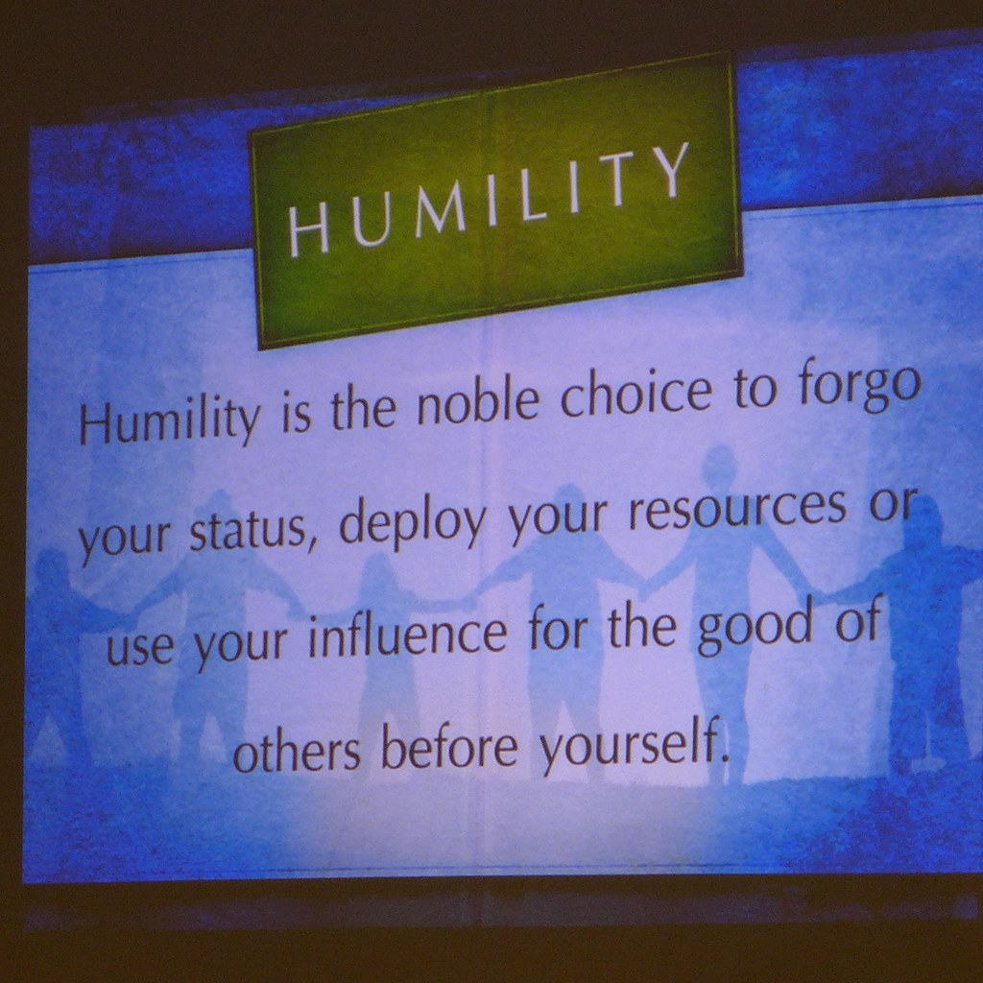

I'm sure most of you remember the song by Mac Davis, "It Hard to Be Humble." Here are some of the lyrics from the song's chorus:
"Oh Lord, it's hard to be humble
When you're perfect in every way
I can't wait to look in the mirror.
Cause I get better looking each day.
To know me is to love me.
I must be a hell of a man.
Oh Lord, It's hard to be humble,
But I'm doing the best that I can."
You might say that the person in the song is slightly cocky.
The songwriter's cockiness about humility is quite the opposite of what Paul says in today's passage.
"Be completely humble and gentle; be patient, bearing with one another in love."
No matter what we may think of another person, even if they are cocky, a loudmouth, or if they think that they are always right. God wants us to be gentle and patient with them while showing them love. No, that isn't the easiest thing in the world to do.
Let's look at Paul's words in today's passage and get some clarification.

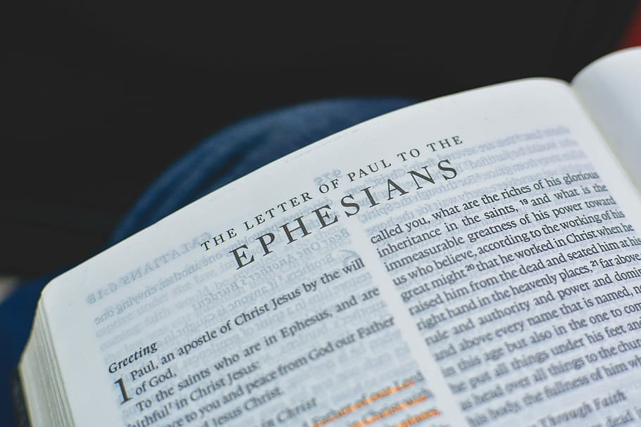

“As a prisoner for the Lord, then, I urge you to live a life worthy of the calling you have received. Be completely humble and gentle; be patient, bearing with one another in love. Make every effort to keep the unity of the Spirit through the bond of peace. There is one body and one Spirit, just as you were called to one hope when you were called; one Lord, one Faith, one baptism; one God and Father of all, who is over all and through all and in all.
But to each one of us, grace has been given as Christ apportioned it. This is why it (4:8 Or God) says:
"When he ascended on high,
he took many captives
and gave gifts to his people." (4:8 Psalm 68:18)
(What does "he ascended" mean except that he also descended to the lower, earthly regions4:9 Or the depths of the earth? He who descended is the very one who ascended higher than all the heavens, in order to fill the whole universe.) So, Christ himself gave the apostles, the prophets, the evangelists, the pastors, and teachers, to equip his people for works of service so that the body of Christ may be built up until we all reach unity in the Faith and in the knowledge of the Son of God and become mature, attaining to the whole measure of the fullness of Christ.
Then we will no longer be infants, tossed back and forth by the waves, and blown here and there by every wind of teaching and by the cunning and craftiness of people in their deceitful scheming. Instead speaking the truth in love, we will grow to become in every respect the mature body of him who is the head, that is, Christ. From him, the whole body joined and held together by every supporting ligament, grows and builds itself up in love, as each part does its work."
Ephesians 4:1-16

Paul begins by saying:
As a prisoner for the Lord, then, I urge you to live a life worthy of the calling you have received.
Paul is a called servant and ambassador of the Lord. As such, he encourages the Ephesians to follow their own calling as servants of the Lord. He urges them to find the proper balance between their Spiritual lives and the world.
Now we come to the passage I spoke of during my introduction.
Be completely humble and gentle; be patient, bearing with one another in love. Make every effort to keep the unity of the Spirit through the bond of peace.

First, Paul urges the Ephesians and us to be humble, patient, and gentle. We do this by being selfless, in other words, putting others needs ahead of our own. Paul calls for an Agape love, which is unconditional love.
Next, we mustn't spoil the Holy Spirit's work. We are to be at peace with each other. The Holy Spirit brings believers to Christ. Isn't it then logical that we love one another, no matter what?
Paul now speaks of the unity of the church. He mentions seven ways it is unified. The first three:
There is one body and one Spirit, just as you were called to one hope when you were called
The church is one body and of one Spirit. We are called to "one" hope. That hope is the knowing hope that we are saved by Jesus' death and resurrection.
The next unifying elements of the church are:
One Lord, one Faith, one baptism;
Jews and Gentiles are unified under one Lord, one Faith (we believe the same thing), and one baptism.
The seventh unifying element makes our Faith complete.
One God and Father of all, who is over all and through all and in all.

There's not much to say here. Paul tells us that God the Father is over everything. God's grace has blessed us forever in Christ.
(I'm going to jump ahead a bit here. My belief is that some of Paul's words are self-explanatory. I also have to remind myself not to immerse myself or you too deeply into these verses. This is a devotion, not a Bible study. :)

So, Christ himself gave the apostles, the prophets, the evangelists, the pastors, and teachers, to equip his people for works of service so that the body of Christ may be built up until we all reach unity in the Faith and in the knowledge of the Son of God and become mature, attaining to the whole measure of the fullness of Christ.
Although the passage above is self-explanatory, it's important to reiterate and reinforce Paul's point. God doesn't leave us alone to fend for ourselves or learn on our own.
Jesus put people in charge, i.e., prophets, teachers, etc. To equip us to better understand the unity He expects and the Faith He desires from us.

In conclusion, Paul wraps up his point of unity.
Speaking the truth in love, we will grow to become in every respect the mature body of him who is the head, that is, Christ. From him, the whole body joined and held together by every supporting ligament, grows and builds itself up in love, as each part does its work."

As it is for every Christian, our duty is to speak the truth. We don't spread false doctrine but pass on what we know to be true. And we do so in love, as we want everyone to be saved.
We all have our part to do. Yet, like a human body is held together by ligaments and bones, Christ holds us together as one Body.
May each of us grow strong in Christ as we spread the good news of Jesus Christ in the way God has chosen us to do so. In humility, with patience, and love. Amen.

