An Overview of Ephesians
By Joe Guagliardo
Ephesians 5:1-20
"A Fragrant Offering."
August 18, 2023

There's nothing quite as good as the fragrance of a pie in the oven. The aroma reaches throughout the house and just makes you say, "Ahhh." The above photo is of a blueberry pie I made on Thursday.
I must say it didn't disappoint. The taste was every bit as good as the aroma.

Another calming aroma is the smell of a scented candle. As you can see in the picture below, Kathy and I have a lot of scented Yankee Candles. Actually, what you see in the photo doesn't include all of the candles we have throughout the house. Our favorite scents are the fragrances available in the fall and around Christmas (my favorite is the Balsam and Cedar candle; it's like being in the middle of a tree farm every time you light it.)

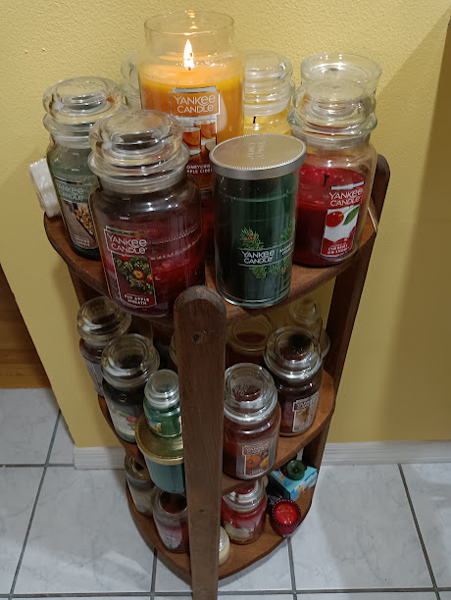

In today's reading from Ephesians, Paul talks about Jesus' sacrifice on the cross being a, "Fragrant offering and sacrifice to God."
"The Lord offered Himself to redeem mankind from our sins. This is why Paul calls Jesus a fragrant offering because Jesus was indeed a pleasing fragrance being offered to the Father. In the Old Testament, individuals had to provide sin offerings repeatedly because they would continue to sin."
ibelieve.com/faith/why-does-ephesians-52-call-jesus-a-fragrant-offering.
Yes, Jesus was a fragrant offering that God the Father finds pleasing. That's Paul's speaking the Gospel of love. But then, he continues with some stern warnings about Christian living. Let's look at today's passage and some of Paul's cautions.
"Follow God's example, therefore, as dearly loved children and walk in the way of love, just as Christ loved us and gave himself up for us as a fragrant offering and sacrifice to God.
But among you, there must not be even a hint of sexual immorality, or of any kind of impurity, or of greed, because these are improper for God's holy people. Nor should there be obscenity, foolish talk, or coarse joking, which are out of place, but rather thanksgiving. For of this, you can be sure: No immoral, impure, or greedy person—such a person is an idolater—has any inheritance in the kingdom of Christ and of God. Let no one deceive you with empty words, for because of such things, God's wrath comes on those who are disobedient. Therefore, do not be partners with them.
For you were once darkness, but now you are light in the Lord. Live as children of light (for the fruit of the light consists in all goodness, righteousness, and truth) and find out what pleases the Lord. Have nothing to do with the fruitless deeds of darkness but rather expose them. It is shameful even to mention what the disobedient do in secret. But everything exposed by the light becomes visible—and everything that is illuminated becomes a light. This is why it is said:
"Wake up, sleeper,
rise from the dead,
and Christ will shine on you."
Be very careful, then, how you live—not as unwise but as wise, making the most of every opportunity because the days are evil. Therefore, do not be foolish, but understand what the Lord's will is. Do not get drunk on wine, which leads to debauchery. Instead, be filled with the Spirit, speaking to one another with psalms, hymns, and songs from the Spirit. Sing and make music from your heart to the Lord, always giving thanks to God the Father for everything, in the name of our Lord Jesus Christ."
Ephesians 5:1-20

After Paul speaks of Jesus' sacrifice and what a fragrant offering He is, he jumps into Christian Living again. Paul begins by directly talking about sexual immorality.
But among you, there must not be even a hint of sexual immorality, or of any kind of impurity, or of greed, because these are improper for God's holy people. Nor should there be obscenity, foolish talk, or coarse joking, which are out of place, but rather thanksgiving. For of this, you can be sure: No immoral, impure, or greedy person—such a person is an idolater—has any inheritance in the kingdom of Christ and of God. Let no one deceive you with empty words, for because of such things, God's wrath comes on those who are disobedient. Therefore, do not be partners with them.

Paul dives right into sexual immorality. Some of the things he says may seem obscure. But Paul isn't speaking of just sex outside the boundaries of marriage. He also speaks of obscenity, coarse joking, and foolish talk.
Paul says:
No immoral, impure, or greedy person—such a person is an idolater
Paul takes on the second commandment and ties it to the sixth. If people are consistently sexually immoral, impure, and greedy and that makes them, or us, idolaters.
Acting in this manner leaves you open to God's wrath. And as the Galatians/we disobey God in this manner, there is no room for them in His world.
Paul continues to encourage the Galatians and us to live Godly lives and act in a way that is pleasing to God. Unfortunately, so many people don't live up to God's expectations.
Be very careful, then, how you live—not as unwise but as wise, making the most of every opportunity because the days are evil. Therefore, do not be foolish, but understand what the Lord's will is.
This section reminds me so much of the "Parable of the Sower."
"A farmer went out to sow his seed. As he was scattering the seed, some fell along the path; it was trampled on, and the birds ate it up. Some fell on rocky ground, and when it came up, the plants withered because they had no moisture. Other seed fell among thorns, which grew up with it and choked the plants. Still, other seed fell on good soil. It came up and yielded a crop a hundred times more than was sown."
Luke 8:5-8a
Paul is encouraging us to be more like the good seed.
"But the seed on good soil stands for those with a noble and good heart, who hear the word, retain it, and by persevering produce a crop."
Luke 8:15

Again, Paul returns to how we should praise God in all things.
Therefore, do not be foolish, but understand what the Lord's will is. Do not get drunk on wine, which leads to debauchery. Instead, be filled with the Spirit, speaking to one another with psalms, hymns, and songs from the Spirit. Sing and make music from your heart to the Lord, always giving thanks to God the Father for everything, in the name of our Lord Jesus Christ."

Paul encourages everyone to take the time to understand God's will for them.
Interestingly Paul tells the Galatians, as well as all of his readers, not only to not get drunk, or filled up with spirits, as we now refer to alcoholic beverages. This leads to debauchery, which is:
Excessive indulgence in sensual pleasures.
(Oxford Dictionary)
So, Paul comes full circle, once again speaking of the 6th commandment.

Instead of filling our bodies with spirits, we should allow ourselves to be filled with the Holy Spirit. If we do this, we will praise God in every form (song, praise, and worship) for everything He has done for us. Especially for he fragrant offering of His Son, Jesus, as a living sacrifice for us.

