An Overview of Galatians
By Joe Guagliardo
Galatians 5:26-6:6
"Don't get cocky!"
July 10, 2023

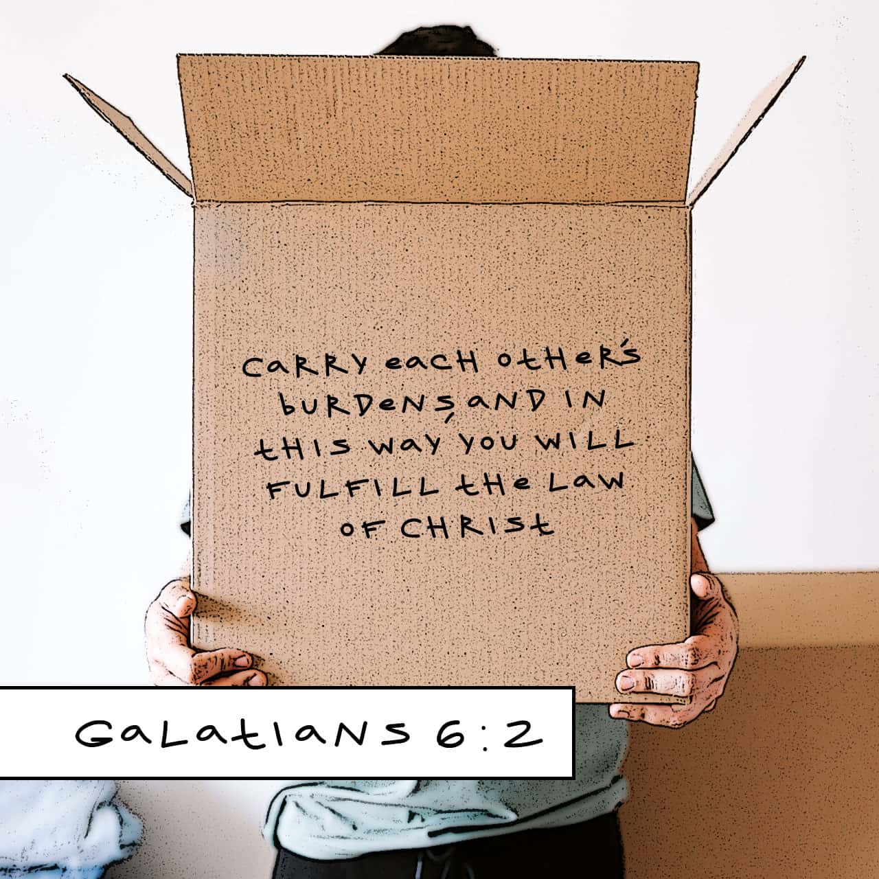
There are times in our lives when we can get a little cocky. We buy a new fancy car and brag about it to our friends. Or possibly, we get the highest grade in the class, or possibly we're named Valedictorian. It would be easy to get cocky over these accomplishments.
Even in comic book movies (Marvel), some of the characters get a little cocky. Ironman, Tony Stark, takes out three robots and says to his friend Rhode, "Did you see that?" And Rhode's answer to him is, "Don't get cocky!"
And, of course, who can forget Luke Skywalker shooting down his first Empire ship. After he yells out, "I got him," Han Solo puts him in his place and says, "Good job, kid, don't get cocky."

The dictionary definition of cocky is:
"Cocky means "overly self-confident," like a cocky announcement at the beginning of the season that your soccer team will win the championship."
Without even trying. Cocky originally meant "lecherous" or lustful, but evolved to mean "arrogantly pert" in the 1700s.
(Vocabulary.com)
We've all been cocky at one time or another in our lives. In today's devotion, Paul tells us we should be the exact opposite.

"Let us not become conceited, provoking, and envying each other. Brothers and sisters, if someone is caught in a sin, you who live by the Spirit should restore that person gently. But watch yourselves, or you also may be tempted. Carry each other's burdens, and in this way, you will fulfill the law of Christ. If anyone thinks they are something when they are not, they deceive themselves. Each one should test their own actions. Then they can take pride in themselves alone, without comparing themselves to someone else, for each one should carry their own load. Nevertheless, the one who receives instruction in the word should share all good things with their instructor."
Galatians 5:26-6:6
Paul begins this passage and says:
"Let us not become conceited, provoking, and envying each other. Brothers and sisters, if someone is caught in a sin, you who live by the Spirit should restore that person gently."
Another words, don't be cocky. Instead, we should support our friends and family (Brothers and sisters) and help them to turn away from sin. Paul also warns us that if we're not careful, we, too, can fall into sin.
I can remember many years ago, a young lady from my church who was active in several ministries, including choir, fell in love with a young man. She knew he was not a churchgoer, nor did he believe. After they were married, he slowly won her over. She eventually left the church.
It's easy to get pulled into the entrapments the world has to offer. Only our faith and belief in Jesus can help us overcome them.

Paul goes on to say:
"Carry each other's burdens, and in this way, you will fulfill the law of Christ."
If someone is doing something they should not be doing, then, we should help them. It is not being cocky if we admonish someone for their deed. Instead, we are doing what Jesus would do. (When Paul says "the law of Christ," he means doing as Christ would do, being Christlike.)
Paul goes on to tell us not to be prideful when we compare ourselves to others. That would be like a Pastor saying, "I'm a pastor, so I'm better than the rest of my congregation." First of all, that isn't the point of being a Pastor. And second, God calls people to be Pastors even though they are sinful, just like you and me.
Sometimes we think we are better or stronger than others (cocky), but that's not true. Each and every one of us needs God's grace and mercy each and every day. Remember, without God's Son, Jesus, dying on the cross and rising on the third day, we are all lost sinners. But thank God for His Son Jesus, who did, die for you and me to make us free.
Remember the words of Ephesians 4:32:
"Be kind and compassionate to one another, forgiving each other, just as in Christ, God forgave you."

