An Overview of Galatians
By Joe Guagliardo
Acts 15:1-21
"The Jerusalem Council"
June 5, 2023

I mentioned in my earlier devotion that Paul's writing to the Galatians had quite a different tone than many other letters he and other New Testament writers typically had.
From His demeanor, we can presume that this writing to the Galatians was during his second missionary journey and after the Jerusalem Council. For this reason, I would like to talk about the discussions and outcome of that council, which probably occurred during about 50 C.E/A.D.
The heart of the problems that Paul, his followers, and the Apostles were having was with Judaizers.
"The Judaizers were a group of early Christians that included both Jewish and non-Jewish converts to the Faith. They insisted that all converts must identify with the nation of Israel and observe the Law of Moses in order to truly have the favor of God. Most scholars believe that Paul's letter to the Galatians was written to refute the Judaizers' teaching".
(Classroom.synonym.com)

The Judaizers were so-called believers, but they insisted that the Gentiles should maintain specific laws (see above). The problem for Paul and the Apostles with that line of thought was that, what Jesus did, dying on the Cross, wasn't enough. So, the Judaizers believed in Faith and Works. While Paul and the Apostles adhered to the doctrine of, By Grace (God's), through Faith (Believe in Jesus and what He accomplished for us by dying on the Cross.
Let's take a look at Act 15:1-21.
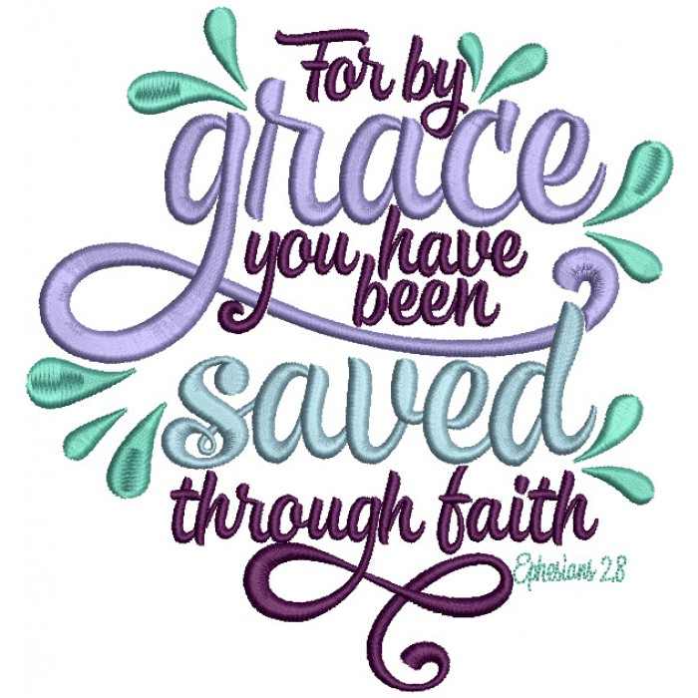
The Council at Jerusalem
"Certain people came down from Judea to Antioch and were teaching the believers: "Unless you are circumcised, according to the custom taught by Moses, you cannot be saved. (Judaizers)." This brought Paul and Barnabas into sharp dispute and debate with them. So, Paul and Barnabas were appointed, along with some other believers, to go up to Jerusalem to see the apostles and elders about this question. The church sent them on their way, and as they traveled through Phoenicia and Samaria, they told how the Gentiles had been converted. This news made all the believers very glad. When they came to Jerusalem, they were welcomed by the church and the apostles and elders, to whom they reported everything God had done through them.
Then some of the believers who belonged to the party of the Pharisees stood up and said, "The Gentiles must be circumcised and required to keep the law of Moses."
The apostles and elders met to consider this question. After much discussion, Peter got up and addressed them: "Brothers, you know that some time ago God made a choice among you that the Gentiles might hear from my lips the message of the gospel and believe. God, who knows the heart, showed that he accepted them by giving the Holy Spirit to them, just as he did to us. He did not discriminate between us and them, for he purified their hearts by Faith. Now then, why do you try to test God by putting on the necks of Gentiles a yoke that neither we nor our ancestors have been able to bear? No! We believe it is through the grace of our Lord Jesus that we are saved, just as they are."
The whole assembly became silent as they listened to Barnabas and Paul telling about the signs and wonders God had done among the Gentiles through them. When they finished, James spoke up. "Brothers," he said, "listen to me. Simon (15:14 Greek Simeon, a variant of Simon; that is, Peter) has described to us how God first intervened to choose a people for his name from the Gentiles. The words of the prophets are in agreement with this, as it is written:
"'After this, I will return
and rebuild David's fallen tent.
Its ruins I will rebuild,
and I will restore it,
that the rest of mankind may seek the Lord,
even all the Gentiles who bear my name,
says the Lord, who does these things'
things known from long ago.
"It is my judgment, therefore, that we should not make it difficult for the Gentiles who are turning to God. Instead, we should write to them, telling them to abstain from food polluted by idols, from sexual immorality, from the meat of strangled animals, and from blood. For the law of Moses has been preached in every city from the earliest times and is read in the synagogues on every Sabbath."
Acts 15:1-21

All twenty-one verses of this portion of Acts are important. But the parts that really stick out for me are:
No! We believe it is through the grace of our Lord Jesus that we are saved, just as they are."
These are Peter's words. We are all saved through the Grace of God and our Faith that Jesus' died on the Cross for us. That's it!

Finally, Peter's words toward the end of these verses.

"It is my judgment, therefore, that we should not make it difficult for the Gentiles who are turning to God. Instead, we should write to them, telling them to abstain from food polluted by idols, from sexual immorality, from the meat of strangled animals, and from blood."
Of course, we should be sexually moral and not hold up idols before ourselves (today, our favorite idol is money!).
For me, strangled animals (which we don't do anymore) and blood mean not eating raw meat, which we've learned is bad for us.
As you've seen and will continue to see in Galatians, Paul was angry because the decision by the church at large had been made. We are saved, By Grace, Through Faith.
Paul had not been away from Galatia very long, and the people were already falling away from the one true God. Some were accepting Faith and Works, as put forth by the Judaizers. Because of this, as we continue our journey through Galatian, we will find Paul angry and holding to the doctrine of Grace and Faith, as he should, and we do.

