Lenten Devotions
A Walk Through the Book of Luke
Luke 20:9-18
April 5, 2023
The Parable of the Tenants

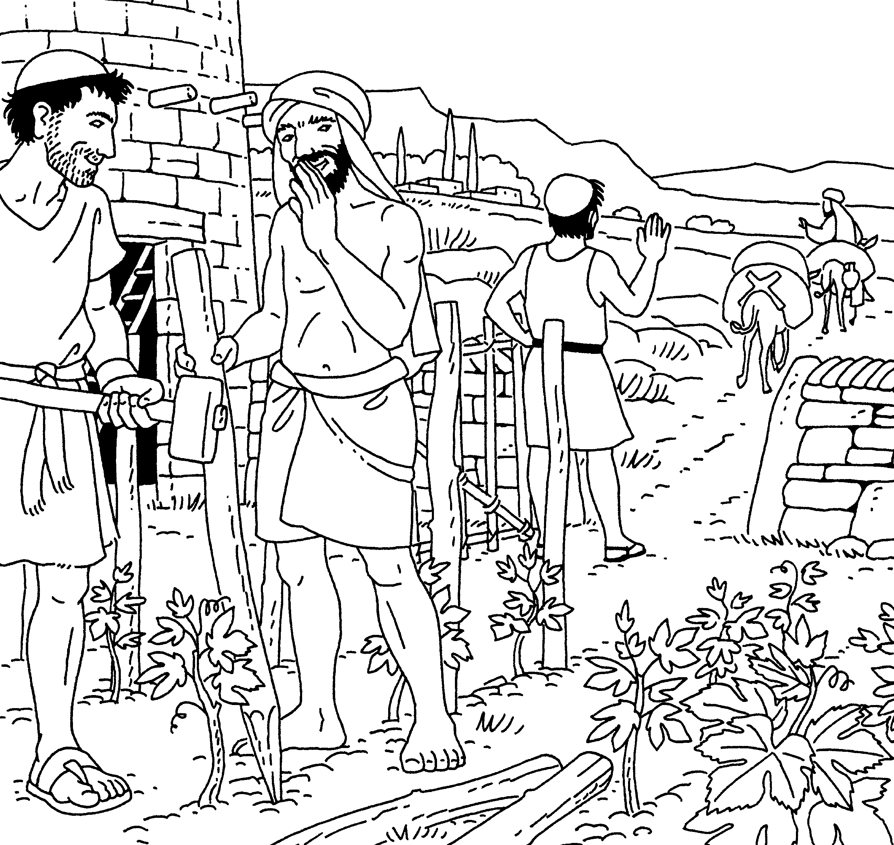
If you’ve ever owned a rental property, you know how difficult it can be to deal with tenants. There are times they are behind or don’t pay their rent. And others have very little respect for the apartment or home because it’s not theirs.
When I was young, all of my relatives lived in the Chicago area. One of my aunts and uncles owned a 2 ½ story apartment building. They lived on the first floor, another aunt and uncle lived on the third, and they rented out what would be called a garden apartment.
I can recall when I was about 9 years old, shortly after the tenants in the garden apartment had moved out. My aunt took our family down to the apartment to show us how the renters had left it.
To say it was a disaster would be an understatement. The wooden floors had holes in them, and the former tenants had unscrewed and taken all of the electric switch and socket covers as well as the ceiling lights. There were also many holes in the walls throughout the apartment.
Today’s parable tells us about a man who had planted a vineyard and rented it out to some farmers. Instead of leaving, like in the story I described, these tenants wanted to stay and keep the land for themselves.

The Parable of the Tenants
“He went on to tell the people this parable: “A man planted a vineyard, rented it to some farmers, and went away for a long time. At harvest time, he sent a servant to the tenants, so they would give him some of the fruit of the vineyard. But the tenants beat him and sent him away empty-handed. He sent another servant, but that one also they beat and treated shamefully and sent away empty-handed. He sent still a third, and they wounded him and threw him out.
“Then the owner of the vineyard said, ‘What shall I do? I will send my son, whom I love; perhaps they will respect him.’
“But when the tenants saw him, they talked the matter over. ‘This is the heir,’ they said. ‘Let’s kill him, and the inheritance will be ours.’ So, they threw him out of the vineyard and killed him.
“What then will the owner of the vineyard do to them? He will come and kill those tenants and give the vineyard to others.”
When the people heard this, they said, “God forbid!”
Jesus looked directly at them and asked, “Then what is the meaning of that which is written:
“‘The stone, the builders, rejected
has become the cornerstone’ (20:17 Psalm 118:2)?
Everyone who falls on that stone will be broken to pieces; anyone on whom it falls will be crushed.”

This parable tells us of Jesus’ fast-approaching death and the type of judgment that will be received by those who kill Him.
In chapter 5 of the book of Isaiah, the prophet describes Israel as a vineyard that failed to produce fruit.
In today’s parable, Jesus describes the tenants synonymously with the church leaders who have been and will eventually succeed in killing Him.
The owner sends two servants and his son to acquire the fruit from the vineyard. Just as the servants were poorly treated, so were prophets like John the Baptist and Moses. Finally, God sent His own Son, Jesus. He, too, was mistreated, not believed, and was eventually put to death.
Interestingly enough, when Jesus says:
“What then will the owner of the vineyard do to them? He will come and kill those tenants and give the vineyard to others.”
He is talking about the non-believing nation of Israel. The vineyards will be given to non-Jews and Gentiles.
I love the reaction of the people who heard this parable. They say: “God forbid.” Another way of saying this is, “May it never be.” They understood what Jesus meant in this parable.
But Jesus did not relent. When He speaks of the cornerstone, He is speaking of Himself. Jesus is the one who was and is still rejected by many.

Let me end with this Jewish proverb.
“If the stone falls on a pot, woe to the pot. If the pot falls on the stone, woe to the pot. Either way, woe to the pot.”
When Jesus one day returns, those who rejected Him will be punished and suffer for all of eternity. Those who have followed Him spread the Gospel message and have been a servant to others will be rewarded.

