Lenten Devotions
A Walk through the Book of Luke
March 4, 2023
Luke 6:12-16
Jesus' 12 Apostles
"52 MAB ST"
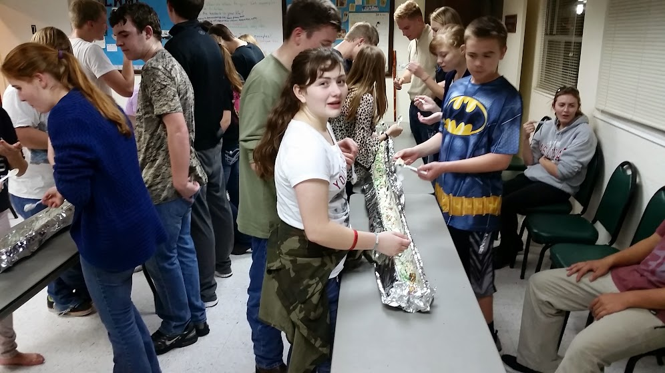
(One of my youth groups is shown here eating the largest ice cream sundae in the world.)
I served at three different churches during my almost 25 years in youth ministry. That is not to say I had only three youth groups. Students age out, go to college, move, or sometimes stop attending group activities. So, over my time in youth ministry, I probably served and led at least 10-12 youth groups.
Some students, like adults, are followers or supporters of the group. They attend regularly, are involved with group activities, and even attend church. It's okay to be a follower. Because without followers, there would be no need for leaders.
Other students are leaders. Some of their ability is learned, but much of it is God-given. In my first youth group, back in the 1990s, I had two young men who were the group's leaders. They would contact the other students regularly and encourage them to attend youth nights, church, and activities.
I had the same thing happen in the successive churches I served at. So, I like to think that I at least had a part in growing some of my students into leaders.
Today one of my former students serves as a missionary in the United Kingdom. Another serves as a Director of Christian Education in Texas. And yet another is a Lutheran school principal, also in Texas.
Jesus had many disciples. From those disciples, He was very deliberate in choosing His twelve apostles.
***********************The Point**********************
If you were unaware of it, there is a distinction between a disciple and an Apostle. Jesus had many disciples but only chose twelve to be His Apostles.
"One of those days, Jesus went out to a mountainside to pray and spent the night praying to God. When morning came, he called his disciples to him and chose twelve of them, whom he also designated apostles: Simon (whom he named Peter), his brother Andrew, James, John, Philip, Bartholomew, Matthew, Thomas, James son of Alphaeus, Simon who was called the Zealot, Judas son of James, and Judas Iscariot, who became a traitor." Luke 6:12-16
Jesus specifically chose these twelve men to be His Apostles. So, what's the difference, you may ask?
A disciple is a learner and follower of Jesus. An Apostle is also a follower of Jesus, but they are sent out to spread the Good News of Jesus Christ. Jesus's Apostles were explicitly chosen to carry on His work after He was gone. They were a part of Jesus' inner circle. Christ's Apostles traveled with Him, ate with Him, and, most importantly, learned from Him. He gave them inner strength, so they could carry on His work without Him.

Today, we can be both. We can be learners and followers of Jesus, but we can and should share the Good News with others.
Early on in my ministry, I learned how to memorize the names of Jesus' 12 Apostles, as they appear in the book of Luke. It's a great teaching tool for students. I've even shared this teaching tool during children's messages.

The Apostle's address is 52 MAB ST. Let me explain.
Those 12 Apostles. What were their names again?
Here's a fun way to learn to memorize the names of Jesus' 12 Apostles, using the address at the top of the page. On a whiteboard or newsprint, write out the address 52 MAB ST, like this:

5
2
M
A
B
S
T
Now have the students go back to the reading from Luke. If they read it carefully, they may actually figure it out. So, here's the answer to the address question.
5 John, James, James, Judas, Judas
2 Phillip, Peter
Matthew
Andrew
Bartholomew
Simon
Thomas

So, there are five apostles whose name starts with the letter J. There are two apostles whose name begins with the letter P. The rest are just the first letter of the remaining five's first name.
Bartholomew seems to be the hardest for students to remember, so I tell them to remember "Bart Simpson .

Learning the names of the 12 Apostles can be fun. But Jesus chose them for some very serious business. First and foremost, they were selected to spread Christ's Gospel message to the world.

