Lenten Devotions
A Walk through the Book of Luke
March 3, 2023
Luke 2:41-52
The Boy Jesus at the temple
"Where have you been, young man?"

As many of you already know, it wasn't that many years ago that our ability to communicate with each other was much more limited. Today we have what I like to call our false God, a cellphone (Yes, I have one). With it, we can reach almost anyone, anywhere in the world, at any hour of the day. We can text people, use Instagram and Twitter, and have computers. But, of course, computers are just a large version of a cellphone.
When I was a teenager in the 1960s, we had two forms of helpful communication. We could talk to someone face to face (still very useful even today) or call someone on a home or pay phone. Back in the 1960s, most people did not have answer machines. So, when you called someone, you hoped and prayed they answered because you couldn't leave them a message. (If you're under 25 years old, you may call me a dinosaur if you wish).
On more than one occasion, I remember telling my mom or dad I was going out and who I'd be with, and of course, they would tell me what time I needed to be home. I was anywhere from 15-30 minutes late getting home several times over the years. Then the third degree would begin! "Where were you? Why are you late? Why didn't you call? And, of course, the inevitable, "You're grounded!"
Jesus was just 12 years old when something similar happened. In Jesus' case, He was missing for three (3) days. (I can only imagine what my punishment would have been for that). Jesus also got the third degree, but His answers struck a different chord with His parents.
*************************The Point**********************
Let's join Mary, Joseph, and their 12-year-old Son Jesus, as they attend and depart the Festival of the Passover in Jerusalem.

"Every year, Jesus' parents went to Jerusalem for the Festival of the Passover. When he was twelve years old, they went up to the festival, according to the custom. After the festival was over, while his parents were returning home, the boy Jesus stayed behind in Jerusalem, but they were unaware of it. Thinking he was in their company, they traveled on for a day. Then they began looking for him among their relatives and friends. When they did not find him, they went back to Jerusalem to look for him. After three days, they found him in the temple courts, sitting among the teachers, listening to them and asking them questions. Everyone who heard him was amazed at his understanding and his answers. When his parents saw him, they were astonished. His mother said to him, "Son, why have you treated us like this? Your Father and I have been anxiously searching for you."
"Why were you searching for me?" he asked. "Didn't you know I had to be in my Father's house?" But they did not understand what he was saying to them.
Then he went down to Nazareth with them and was obedient to them. But his mother treasured all these things in her heart. And Jesus grew in wisdom and stature, and in favor with God and man." Luke 2:41-52

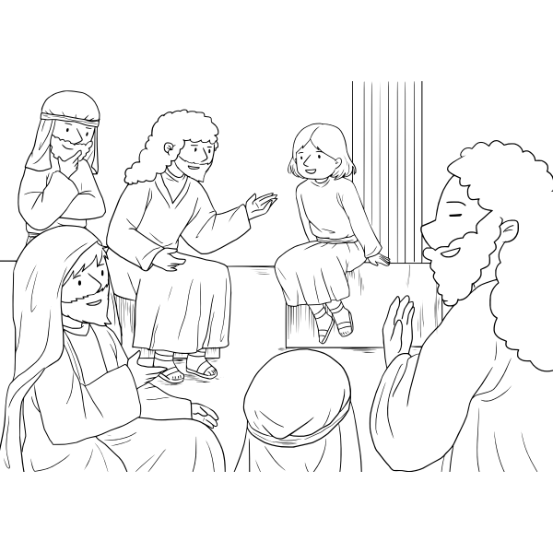
From the time Jesus was a baby or very young, we don't hear about His life again until He is 30.
"The unknown years of Jesus (also called his silent years, lost years, or missing years) generally refers to the period of Jesus's life between his childhood and the beginning of his ministry, a period not described in the New Testament." https://en.wikipedia.org/wiki/Unknown_years_of_Jesus
There is one exception in these silent years, and the story is contained in today's reading from Luke.
Mary, Joseph, and Jesus, age twelve, go to Jerusalem to celebrate The Passover. Jerusalem's average population at this time is no more than about 25,000. But because of the Passover celebration, an estimated 60-100,000 people pack themselves into the city. (New Bible Commentary, 21st-century edition, Luke 2, pp. 985).
After the completion of the Passover festivities, Mary, Joseph, and they thought Jesus was part of a group of hundreds, if not thousands heading back to their hometowns. Unfortunately, the Bible story doesn't give us much information, but for some reason, Mary and Joseph don't realize that Jesus isn't with them until they are a day into their travels. After looking furtively for Him for three days, they finally find their Son, Jesus, in the temple court.
My brain has all sorts of red flags going up on this portion of the story. I realize hundreds and hundreds of people are on the road with you, but how do you not keep track of your twelve-year-old Son? And what did Jesus do for food and water for three days until his parents arrived? I realize many explanations could answer both of these questions. But, as a parent myself, the circumstances leave me wondering.
Interestingly, Jesus' parents find Him at the last place they would expect. He was in the temple court, listening to the teachers of the law and asking questions. At the age of twelve, Jesus was probably not teaching. But, as the reading says, "Everyone who heard him was amazed at his understanding and answers."
In my eyes, the actual theme of this passage is obedience. When Mary approaches her Son and, in so many words, says, "How could you do this to us? Your dad and I've been looking for you for three days. We thought you were lost or worse."
Interestingly enough, the twelve-year-old (speaking for the first time in the book of Luke) rebukes His mother.
"Why were you searching for me? Didn't you know I had to be in my Father's house?"
As I read this passage several times, I concluded that, at times, Mary and Joseph forgot who their Son was. For all the amazing things the angel Gabriel told them, they sometimes lost sight of what was shared with them. Their Son, Jesus, was and is the Son of God sent to save His people from sin.
At a very early age, Jesus knew who He was and put His relationship with His Father, God, first.
I've mentioned something many times in my devotions and Bible studies.
God comes; first, family comes second, work comes third, and everything else comes after that. Jesus understood that. The mission His Father sent Him on was His top priority, even at the age of twelve.

