Lenten Devotions
A Walk through the Book of Luke
March 12, 2023
John 4:5-27
Jesus teaches the Samaritan Woman
"A drive through the desert"
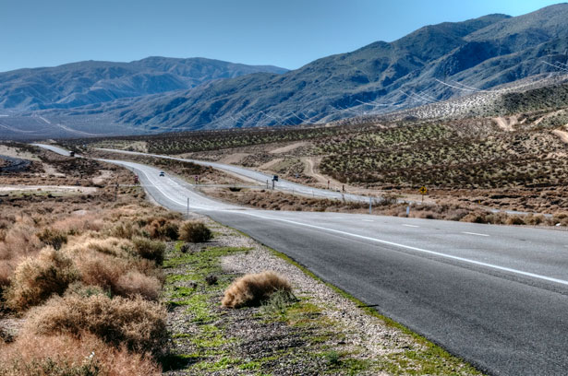
In the summer of 1977, my wife took a trip to Disneyland in California. I had just left my job in Colorado, and we set out on a mini vacation. At the time, I was driving a 1974 Plymouth Duster. The car was metallic purple and had a small V8 engine without air conditioning.
Our trip took us to Flagstaff, Arizona, and along I-40 to California. When you drive through Arizona on I-40 west, you travel through the southern portion of the Mojave Desert. To this day, I have no idea how warm it was, but the heat was dry, and we drove with the windows down.
After a while, we came across a sign that said, "Last gas 96 miles." I looked at my wife and said, "Well, we have a full tank of gas, so here goes." I don't recall the speed limit; it may have been 70 mph.
Along that 96-mile stretch, we encountered car after car broke down on the side of the road. Every one of them was a large car that probably had an air-conditioner. Finally, after over an hour of driving, we saw a sign, "Gas 10 miles."
We didn't really need gas, but boy, oh boy, were we thirsty and hungry. I don't recall what the town was that we ended up at after our 96-mile desert trek. But it did have a Denny's. So, we went in, and thankfully it was air-conditioned. The waitress came over and gave us menus and walked away.
Now, back in 1977, any restaurant I had ever been to never asked if you wanted water; it was brought to the table automatically. So, I finally called the waitress over and asked if we could have some water. She apologized and said customers had to ask for water because of their location. Water was a premium item at the edge of the desert, and no one wanted to waste it.
After our discussion, the waitress did bring us water. She may have refilled my glass five or six times.
Today's Bible story is about Jesus and the woman at the well. It seems Jesus' human side was showing, and He was thirsty.
**********************The Point********************
The passage below states that Jesus was tired and thirsty. At Jacobs well, he encountered a Samaritan woman. He used this encounter as a teaching moment that led to the woman's conversion.
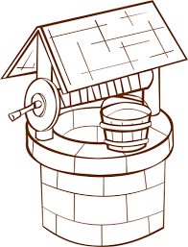
"So, he came to a town in Samaria called Sychar, near the plot of ground Jacob had given to his son Joseph. Jacob's well was there, and Jesus, tired as he was from the journey, sat down by the well. It was about noon.
When a Samaritan woman came to draw water, Jesus said to her, "Will you give me a drink?" (His disciples had gone into the town to buy food.)
The Samaritan woman said to him, "You are a Jew, and I am a Samaritan woman. How can you ask me for a drink?" (For Jews, do not associate with Samaritans.)
Jesus answered her, "If you knew the gift of God and who it is that asks you for a drink, you would have asked him, and he would have given you living water."
"Sir," the woman said, "you have nothing to draw with, and the well is deep. Where can you get this living water? Are you greater than our Father Jacob, who gave us the well and drank from it himself, as did also his sons and his livestock?"
Jesus answered, "Everyone who drinks this water will be thirsty again, but whoever drinks the water I give them will never thirst. Indeed, the water I give them will become in them a spring of water welling up to eternal life."
The woman said to him, "Sir, give me this water so that I won't get thirsty and have to keep coming here to draw water."
He told her, "Go, call your husband and come back."
"I have no husband," she replied.
Jesus said to her, "You are right when you say you have no husband. The fact is, you have had five husbands, and the man you now have is not your husband. What you have just said is quite true."
"Sir," the woman said, "I can see that you are a prophet. Our ancestors worshiped on this mountain, but you Jews claim that the place where we must worship is in Jerusalem."
"Woman," Jesus replied, "believe me, a time is coming when you will worship the Father neither on this mountain nor in Jerusalem. You Samaritans worship what you do not know; we worship what we do know, for salvation is from the Jews. Yet a time is coming and has now come when the true worshipers will worship the Father in the Spirit and in truth, for they are the kind of worshipers the Father seeks. God is Spirit, and his worshipers must worship in the Spirit and in truth."
The woman said, "I know that Messiah" (called Christ) "is coming. When he comes, he will explain everything to us."
Then Jesus declared, "I, the one speaking to you—I am he." John 4:5-26

Let's take a moment to look at the friction between Jews and Samaritan’s by reviewing our text.
"When a Samaritan woman came to draw water, Jesus said to her, "Will you give me a drink?" (His disciples had gone into the town to buy food.)
The Samaritan woman said to him, "You are a Jew, and I am a Samaritan woman. How can you ask me for a drink?" (For Jews, do not associate with Samaritans.)"

"Going through Samaria for Jews was a little like walking into a neighborhood marked as gang territory in the United States today. It could lead to a hostile encounter (see verse 9). This condition existed from the time Assyria had conquered the Northern Kingdom of Israel, took most of its people into captivity, and settled it with foreigners (722 B.C.). These people mingled with the Israelites, who were allowed to remain. As a result, the mixed people in Samaria continuously combined false religions with worship to the Lord and harassed the Jews." (People's Bible Commentary, John, by Gary P. Baumler.)
This explains the woman's hesitancy to even speak to Jesus, let alone give Him some water to drink. Jesus knew everything about this Samaritan woman. He knew how many husbands she had and that she was now living with a man she was not married to.
Jesus went on to tell the woman that He was the living water He had spoken of in the passage. Then, Jesus came right out and said to her that He was the Messiah that the Jews had been waiting for.
The woman heard Jesus's words and believed. Immediately she became an evangelist, telling all the townspeople about the man she had just encountered.
"Then, leaving her water jar, the woman went back to the town and said to the people, "Come, see a man who told me everything I ever did. Could this be the Messiah?" They came out of the town and made their way toward him." John 4:28-30
They came, saw Jesus, talked with Him, and many in the town became believers.
Sometimes it's easy; people hear about Jesus, listen to His words, and believe. Other times it's not as easy. But it is our job as Christians to plant the seed of the Gospel with everyone we encounter and let the Holy Spirit work on their heart and bring them to Christ.

