A Devotion by Joe G
“Perfection”
12/6/2022
Hebrews 2:9-10

What’s your definition of perfect?
“It’s perfect.” I’ve heard the expression often, haven’t you? The statement it’s perfect is used in many ways.
“Their wedding ceremony was perfect!” “The weather outside today is perfect!” “My parents have the perfect marriage!” “My life couldn’t be any better; it’s perfect!”
We all know there is no such thing as a perfect wedding, weather, marriage, or life. Another thing isn’t perfect. The photo of Alice in Wonderland and a child (above) isn’t perfect.
If you know me personally, you know that my wife and I are Disney freaks. In our 48 ½ years of marriage, we have been to Walt Disney World over 700 times.
Over the years, I have taken thousands of photos at various Disney parks and hotels. The one above is the closest to a perfect photo I’ve ever taken. Can you see the imperfection in it? Yes, it is a beautiful moment between Alice and a child at the England pavilion in Epcot. But it’s not perfect. If you look at the photo again, you’ll have to admit the moment is heartwarming. But, if you look just behind the child, you’ll see the edge of her stroller. It’s not awful, but it ever so slightly takes away from a beautiful interaction in a colorful garden.
For all of our imperfections, we are truly blessed. We have been made perfect in God’s sight through the suffering, death, and resurrection of His Son, Jesus.
*******************************The Point*************************
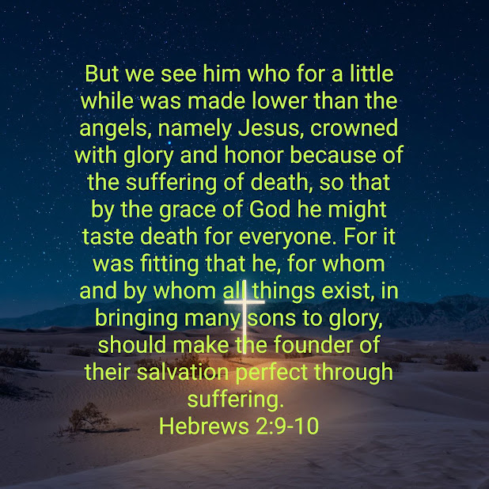
A moment ago, I just mentioned, “We have been made perfect in God’s sight through the suffering, death, and resurrection of His Son, Jesus.”
Jesus’ sacrifice was perfect because He was and is “Perfect.” Imagine yourself as a pure white balloon. Now, add a tiny dot to the balloon for every sin, every transgression, and everything you’ve ever said or done wrong. I would venture to say that if you could remember every sin you have ever committed, your balloon, as well as my own, would be more than a white balloon with a bunch of black dots on it. No, it would be a black balloon.
Now take another pure white balloon. Even if you reread the four Gospels repeatedly, you would not find one incident of sinfulness during Jesus’ time on earth as a man. The balloon was and would remain pure white.
That is why Jesus was the perfect sacrifice. He was, is, and always will be perfect. Only through Jesus’ saving work on the cross can we live in eternity.
Once again, remember my four favorite letters. B.G.T.F. Because of God’s underserved Grace, we are saved through our Faith (Total belief) that Jesus is God’s Son and He sacrificed Himself on the cross for you and me.
By Grace, Through Faith. We are saved. Why? Because God the Father sent the Perfect sacrifice to save us from our sins. His only Son, Jesus Christ.
Dear Lord. Thank you for sending your Son, Jesus. I truly believe that He is Your Son and that You sent Him to die for our sins. Yes, Lord, I believe that He, Jesus was and is the perfect sacrifice. Amen.

