A Devotion by Joe G
“Our Favorite Christmas Memory.”
December 17, 2022
Luke 2:1-7

Several years ago, my wife Kathy and I wrote a series of Advent Devotions entitled Christmas memories. We sat down for several hours, thinking about and discussing the Christmas memories we had together and the ones before we met.
I recall one of Kathy’s we wrote about, which was the birth of her younger brothers Christ (Pronounced Chris-t) on December 25. Another story was about one of our many Christmas parties for my youth group at our home. The best party memory was of the youth having a snowball fight in our backyard with Hostess Snowballs.

Just recently, Kathy mentioned one of her favorite Christmas’ was in 2014. That year, we went to Disney’s Hollywood studios for the day; that night, we were in the middle of the street for the Osborne Family Spectacle of Dancing Lights. (Check out this website for more info. https://allears.net/2020/11/22/the-complete-history-of-the-osborne-family-spectacle-of-dancing-lights/.)
As many of you know, my wife Kathy has M.S., and she gets around with either a walker or an electric cart. Unfortunately, in 2014, we did not have an electric cart, so I always pushed Kathy around Disney in a wheelchair.
Kathy remembers being in the middle of the street in her wheelchair. As the music and lights came alive all around us, I kept turning her wheelchair in circles, so she could see the entire show from different perspectives. A really great holiday memory for us. Here are a few photos of the now-discontinued Osborne family spectacle of dancing lights.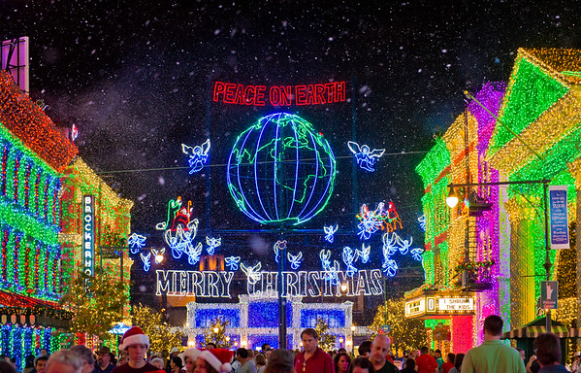
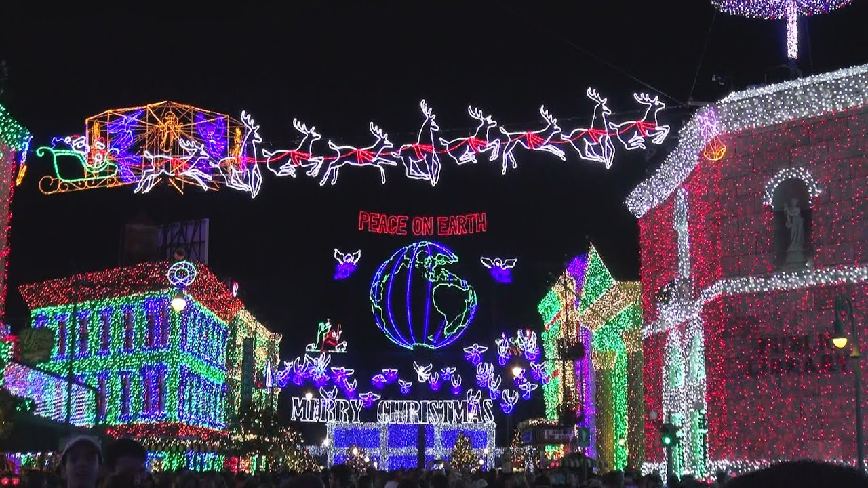
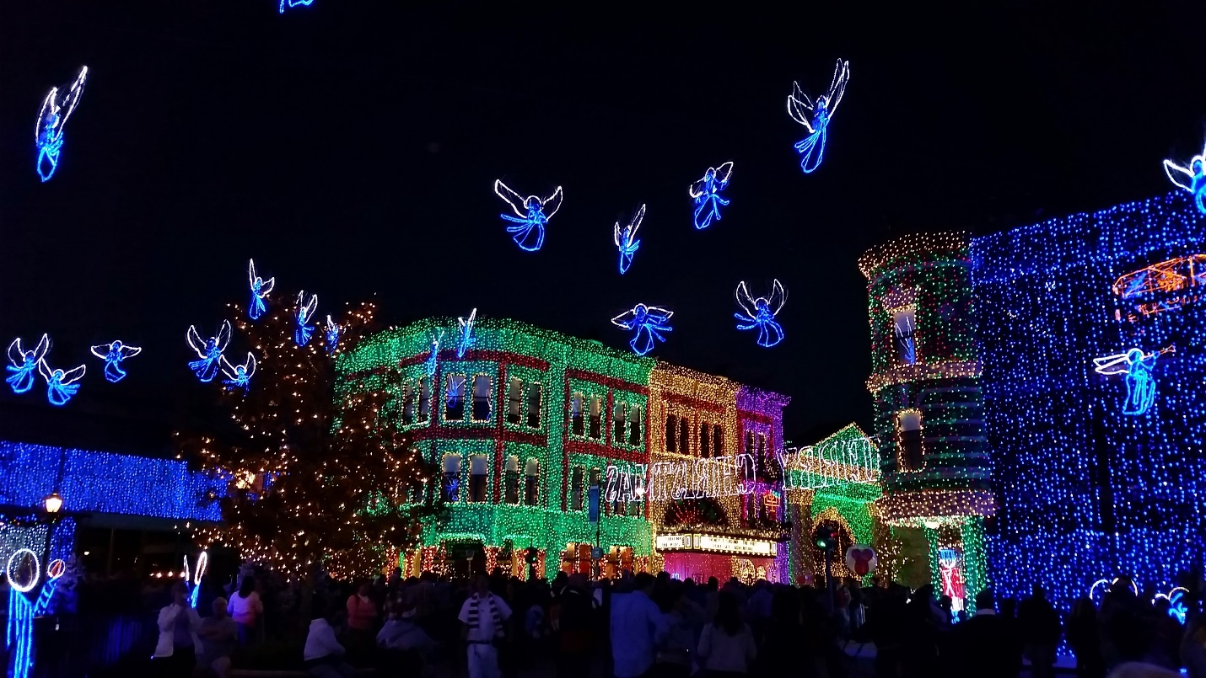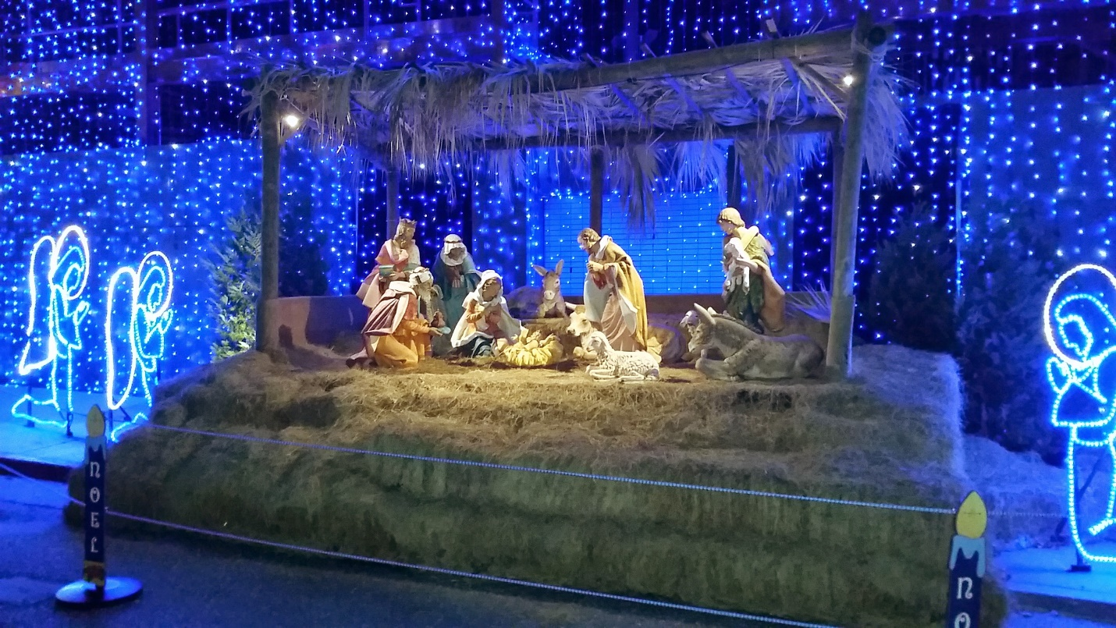
**************************The Point****************************
It’s okay to have fun. Even at Christmas time. Christmas is a time of joy and celebration as we praise and thank God for sending His Son, Jesus.
But, (Don’t you hate when someone says, “But.” ) we should focus on the birth of our Savior. The parties are fine, as are the lights, trees, and gift-giving.
Just don’t let all of these holiday traditions, including sharing stories of Christmas past, become more important than the story of the birth of the Christ Child.
“Now in those days, a decree went out from Caesar Augustus, that a census be taken of all the inhabited earth. This was the first census taken while Quirinius was governor of Syria. And everyone was on his way to register for the census, each to his own city. Joseph also went up from Galilee, from the city of Nazareth to Judea, to the city of David, which is called Bethlehem, because he was of the house and family of David, in order to register along with Mary, who was engaged to him; and was with child. While they were there, the days were completed for her to give birth. And she gave birth to her firstborn son, and she wrapped Him in cloths, and laid Him in a manger because there was no room for them in the inn.” Luke 2:1-7
This story is just part of the Greatest Story Ever Told. God sent His Son to be born as a baby to save the world from itself.
The parties, the light (especially the ones at Disney), trees, food, decorations, and getting together with family and friends. It’s all part of Christmas.
Just remember one thing, without Christ being born, there would be no Christmas.
Amen.

