A Devotion by Joe G
“Florida to Canada, with no GPS.”
December 13, 2022
Matthew 2:1-12; Daniel 2:49

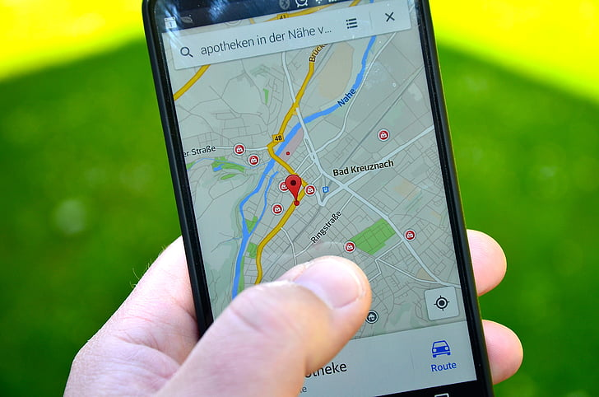

In 1996, I took my first big trip (Other than our church body’s tri-annual national youth gathering) with my youth group. I rented a 35-foot motor home, and with 11 high school students and 3 adults, we drove from South Florida to Saskatchewan, Canada. I could write a book about that two-week trip, but I’ll focus on one incident for this devotion.
My group had been traveling for over three days, staying at a different church each night. Finally, on the fourth day, we were all set to arrive in Canada. I was driving the motorhome at the time, and one of my students was keeping track of where we were on a map. (That’s right. There was no GPS, just a map book from triple-A.)
I don’t recall the exact route we took, but I do know we stopped at a McDonald’s in Minot, North Dakota, for lunch. Our destination for that night was Regina, Saskatchewan. Our best guess was that we’d arrive in Canada in a couple of hours, and then there would be another 2-3-hour drive to Regina.
Unfortunately, the Highway we were on was very rural. It was all farmland and very few signs (except for one we missed). After driving and driving, we came upon a sign that didn’t say what we thought it would. We were looking for a road to turn north toward the Canadian border no more than 30 miles away.
Instead, the sign we came upon said, “You are now entering Montana.” We found out later we had overshot our turn by over 30 miles. Then, to make things more complicated, there were no towns or roads to turn our 35-foot motor home around.
Finally, we came upon a farm with its gate open. The group could see no cars or trucks on the property. So, I turned into the farm, drove on a bumpy dirt path around a barn, and turned around. We then drove about 30 miles east when we saw a sign that was at least 30 feet long and 20 feet high, with flashing lights and an arrow that aimed north.
The sign said, “Turn here for the Canadian border.”
11 Students and 3 adults, and not one of us had seen the big lit-up sign giving us directions. Today, we have GPS on our cell phones, which would have made much of our trip easier 27 years ago. I could tell many more stories from that trip, but we’ll save those for another day.
*********************The Point***********************

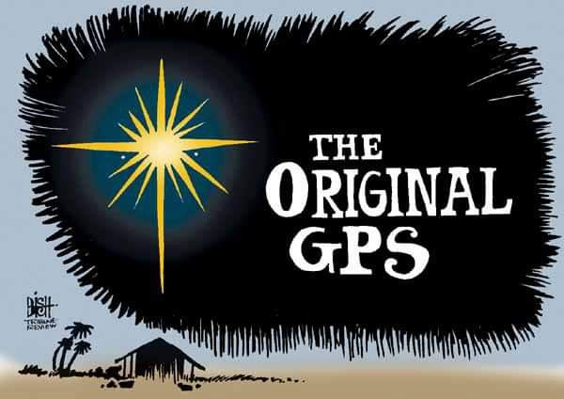
As the illustration above states, the star the three Wisemen followed was the original GPS. It led them to where Jesus was.
The Wisemen were probably Greek astrologers. It is believed that they traveled from Babylon, which today is known as Baghdad, Iraq.
Interestingly, the star is only mentioned in the book of Matthew.
“Now after Jesus was born in Bethlehem of Judea in the days of Herod the King, behold, wise men from the east came to Jerusalem, saying, “Where is he who has been born King of the Jews? For we saw his star when it rose and have come to worship him.” When Herod the King heard this, he was troubled, and all Jerusalem with him; and assembling all the chief priests and scribes of the people, he inquired of them where the Christ was to be born. They told him, “In Bethlehem of Judea, for so it is written by the prophet:
“‘And you, O Bethlehem, in the land of Judah,
are by no means least among the rulers of Judah;
for from you shall come a ruler
who will shepherd my people Israel.’”
Then Herod summoned the wise men secretly and ascertained from them what time the star had appeared. And he sent them to Bethlehem, saying, “Go and search diligently for the child, and when you have found him, bring me word, that I too may come and worship him.” After listening to the King, they went on their way. And behold, the star that they had seen when it rose went before them until it came to rest over the place where the child was. When they saw the star, they rejoiced exceedingly with great joy. And going into the house, they saw the child with Mary, his mother, and they fell down and worshiped him. Then, opening their treasures, they offered him gifts, gold and frankincense, and myrrh. And being warned in a dream not to return to Herod, they departed to their own country by another way.”
Matthew 2:1-12
Two questions always come up after reading the above passage. I’ll address the second first. When the Magi found Jesus, He was not in a stable. Instead, they found Mary, Joseph, and Jesus in a house. Also note it doesn’t denote Jesus as a baby, but rather as a child. As the Magi had traveled over 900 miles from Babylon, it is believed that Jesus was possibly as old as two years old. At this time, Mary and Joseph had established themselves in the city and lived there.
But now, here’s the most fascinating question. Why did those Magi travel over 900 miles to find Jesus?
One only needs to look back into the book of Daniel. After Daniel had interpreted a dream for King Nebuchadnezzar of Babylon in chapter two of the book of Daniel, this is what verse 49 says:
“Then the king gave Daniel high honors and many great gifts and made him ruler over the whole province of Babylon and chief prefect over all the wise men of Babylon.” Daniel 2:49
The King made Daniel chief prefect (in charge of) the wise men of Babylon. Undoubtedly, Daniel, a follower of the one true God, shared the stories with his fellow wise men and how Christ would be born. These stories would have been handed down from generation to generation until the day-wise men saw the star and followed it to a small town. There they found the young child Jesus and His family. There they praised Him and presented gifts.
God used a star as a GPS to bring wise men from 900 miles away to praise the newborn King, and take the story back with them to share. The Son of God, Jesus, had been born into the world. Amen.

