A Devotion by Joe G
November 28, 2022
"Be Kind"
Ephesians 4:32

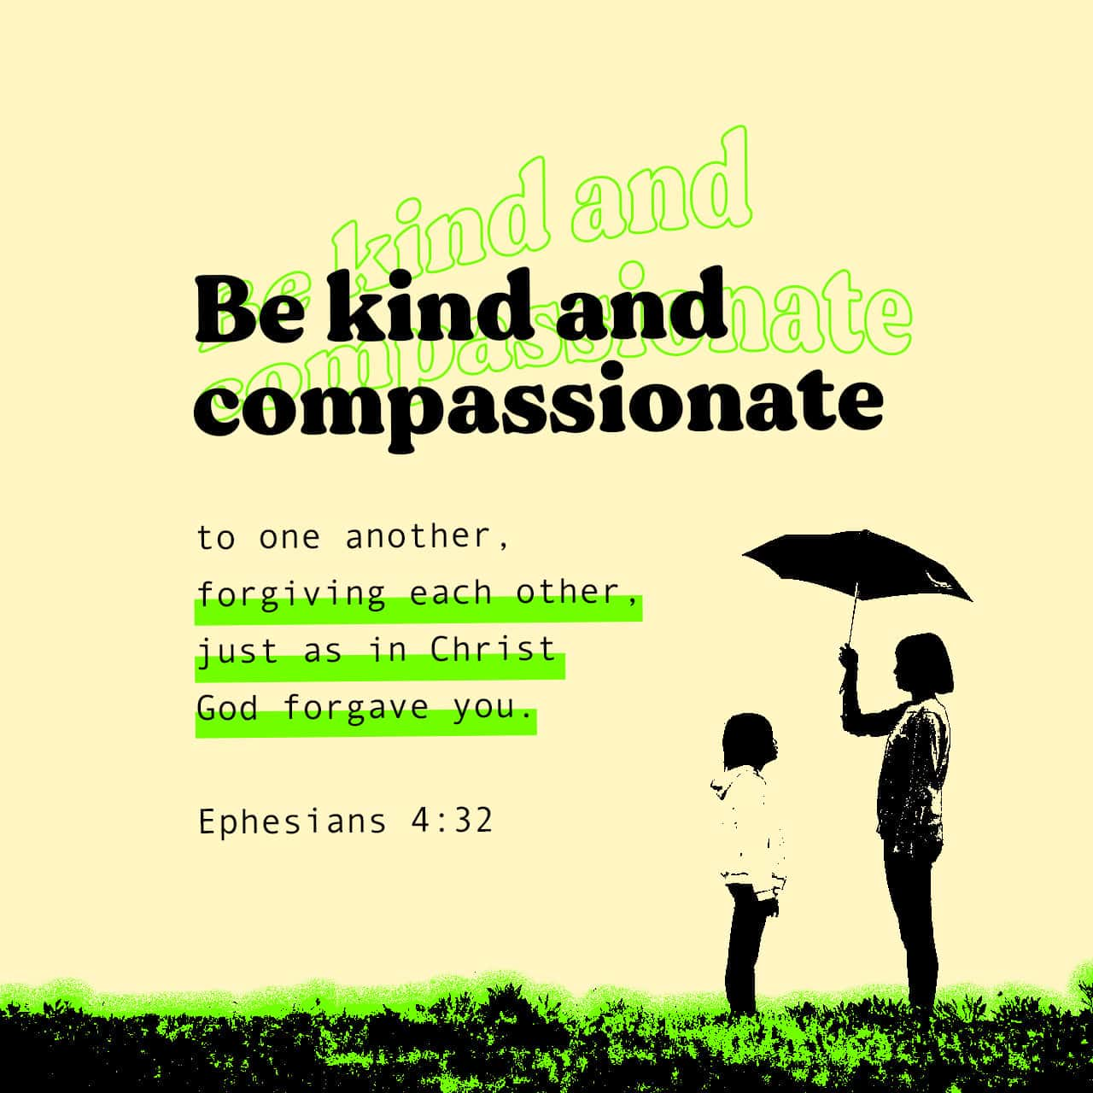
My wife, Kathy, and I left the house early this morning. She had some lab work that needed to be done. For the test, she had to fast. Since it was early, I joined her and fasted, also.
When we arrived at the hospital and checked her in, we found out that I also had blood work ordered by one of my doctors. Glad I fasted.
After the blood work was all done, we headed to our favorite breakfast restaurant in Cape Canaveral. The servers and hostesses are some of the most patient and friendliest people I have ever met.
We then headed to the local Walmart to pick up a few things. That's when the niceness of the day ended. As I pulled into a parking place, someone honked at me. To this moment, I have no idea why. We entered the store, and we picked up a couple of items. As I walked around, it wasn't easy to find anyone smiling.
The lines were somewhat long, and there were many people in the few aisles we went down. I kept thinking to myself, "Everyone looks sad, tired, or annoyed."
The self-checkout was backed up at least 15 deep when we went to check out. So, I told Kathy to meet me outside (she was driving an electric cart). I walked to the far end of the store to the area where there were 12 self-checkout lanes. I checked out and headed to the door.
As I did this, I saw an employee with a scowl on his face sorting through several returns baskets. Then, I met Kathy outside; we walked (and drove) to our car and loaded her and our purchased items into the vehicle. I then drove the electric cart back into the store where they were kept and plugged it back in.
We then headed home, watching cars cutting each other off, honking at each other, and seeing a couple of gloomy homeless people along the way.
Happy Thanksgiving, and Merry Christmas!
************************* Here's The point***********************
As I sit at my desk writing this true story, I can't help but ask myself, What Happened? A few days ago, many of the sad, unhappy, and sometimes difficult people we encountered were sitting at a Thanksgiving Feast. They were thanking God for family and all they have.
I guess we really do need Advent to prepare for the birth of Christ.
Ephesians 4:32 says, "Be kind and compassionate to one another, forgiving each other, just as in Christ God forgave you."
That sounds simple enough. Be kind to each other, and forgive each other, just as Christ has forgiven us.
But wait, there's more!
Verse 31 says: Get rid of all bitterness, rage, and anger, brawling and slander, along with every form of malice.
As you may notice, the Bible gives us the good stuff after telling us the bad stuff. So when those horns were honking at people today, I can well imagine there was some anger, if not rage, when it happened. And inside the car, there may have been some slander going on. The employee who had to sort the three carts of groceries may have been a little bitter because he had to do that "dirty job." Should I go on?
Guess who's talking to you right now? If you said Joe G., you'd be correct. But I say, I'm someone who is sometimes bitter, angry, and full of rage, and I've slandered a person or two in my time. So yeah, I'm not perfect. I screw up; I get my dander up, just like you do.
Once again, Paul said in Ephesians 4:31: Get rid of all bitterness, rage, and anger, brawling and slander, along with every form of malice.
It's difficult. Isn't it? So what does one do? We pray we ask for help to improve. We take time to think before we act or speak. It's just that easy, isn't it? No, of course, it isn't
I can think of three separate times this morning when I waved someone to come out of a parking lot and pull in front of me. Does that make me a saint? Not even close. But I did think for a split second and showed kindness to a fellow human being.
As we approach the day of celebration of the birth of our Lord and Savior, Jesus Christ. Think before you speak and act. Try and be more Christ-Like. And remember:
"Be kind and compassionate to one another, forgiving each other, just as in Christ God forgave you."
Dear Jesus. So many times, we do not treat our fellow man/woman with love and kindness. Please help us to do better. Help us to live our lives like you, being a people of love and compassion.
Amen!

