A Devotion by Joe G
It's not about what you do but what He did for you!
Romans 10:9-13; John 3:16-17
November 11, 2022


We live in an interesting society. So many things we want are directly tied to physically doing something.
"Study hard, so you can get into college." "Do all your chores daily, and I'll give you a weekly allowance of $20." "If you're a good boy/girl and listen to grandma while I go shopping, I'll take you for ice cream later." "Go and clean your room and then you can watch T.V. (Or use your cell phone).
We hear it from our parents, as well as at the workplace. "Work hard, show up early, leave late, and you'll get promoted someday." It's always about us doing something to achieve a goal or receive something that we want.
Having some parameters to work within isn't the worst thing in the world. We need rules to live by and set goals to attain. Without rules, we live in chaos. And without set goals to strive for, life is just that, life; it's not living.
Believing in God and receiving eternal life with Him is not tied to what we do but to what He did.
>>>>>>>>>>>>>>>>>The Point<<<<<<<<<<<<<<<<<

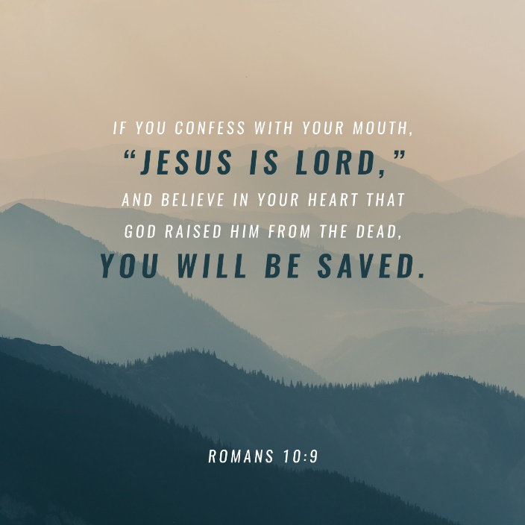
Unlike in our own lives, when it comes to salvation, it's not about us; it's about God and what He did for us. Read the words of the Apostle Paul:

"If you declare with your mouth, "Jesus is Lord," and believe in your heart that God raised him from the dead, you will be saved. For it is with your heart that you believe and are justified, and it is with your mouth that you profess your faith and are saved. As Scripture says, "Anyone who believes in him will never be put to shame." 10:11 Isaiah 28:16 For there is no difference between Jew and Gentile—the same Lord is Lord of all and richly blesses all who call on him, for "Everyone who calls on the name of the Lord will be saved." Romans 10:9-13
Being saved and receiving eternal life is not something we do or earn. Instead, it's you and I confessing and believing that Jesus Christ is our Lord and Savior. He sacrificed his life for ours. He paid our debt of sin by dying on the cross.
Then Jesus rose from the dead. He overcame death, guaranteeing that we, too, shall be saved. How? As I've said many times before. By Grace (God's perfect love for us) through Faith (You and I believing that Jesus Christ died for our sins.)
You're not alone if, at times, this is hard to accept. But it's true.
"God has already done what is needed to secure righteousness (He sent His Son as a living sacrifice.); all that we are required to do is believe."

And as they say in so many infomercials on television, "But wait, there's more!"
Paul relates an essential point in this passage.
Anyone who believes in him will never be put to shame." 10:11 Isaiah 28:16 For there is no difference between Jew and Gentile—the same Lord is Lord of all and richly blesses all who call on him, for "Everyone who calls on the name of the Lord will be saved." Romans 10:11-13
Paul is precise in this section of the passage. God's grace and mercy are available to everyone. It doesn't matter who you are, where you live, what nationality you are or what religion you are.
To receive God's gift of grace and eternal life, all we have to do is believe in God's fulfilled promise. He sent His Son, Jesus, for us. And all you/we have to do is believe.
Of course, passing on this Good News to others doesn't hurt. But that is for another day's devotion. So, for now, remember and live out these words spoken by Jesus.
"For God so loved the world that he gave his one and only Son, that whoever believes in him shall not perish but have eternal life. For God did not send his Son into the world to condemn the world, but to save the world through him." John 3:16-17

