The Parables of Jesus
April 9, 2022
His Word endures forever
Matthew 24:32-35

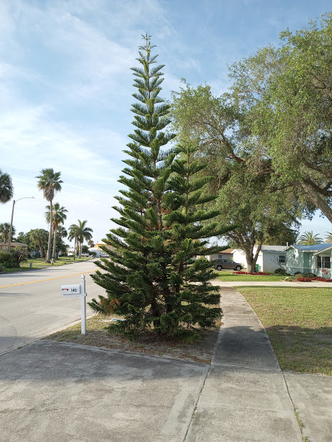

The Evergreen tree you see above is in front of our home. I planted it there in 2007. It was in a large pot. The tree had been given to us as a gift before we left my last call in Fort Myers, FL.
I left it outside for a few months. It was drying out and looked horrible. So, I decided to plant it next to our mailbox. I never fed it; I just let nature take its course. The Evergreen is now about 15 feet tall. Most trees in Florida are green year-round, but this tree has a deep tone that contrasts with the other trees. It's incredible what God can do with a weak little shrub taken from a pot and planted in the ground.
My story leads us to today's Parable.
*********************************************
Jesus tells us several stories about fig trees throughout the Gospels. However, this one is quite different than the others.

The Parable of the Fig Tree
"Now learn this lesson from the fig tree: As soon as its twigs get tender and its leaves come out, you know that summer is near. Even so, when you see all these things, you know that it (24:33 Or he) is near, right at the door. Truly I tell you, this generation will certainly not pass away until all these things have happened. Heaven and earth will pass away, but my words will never pass away." Matthew 24:32-35
Interestingly the majority of trees in Palestine are Evergreens. The other two prominent trees are almond and fig. Both the almond and fig trees blossom in spring, the almond in early spring, and the fig in late.
As the last tree blossoming tree, you can use it as a barometer that summer is coming soon. Jesus uses this fact as an analog. Some theologians say this Parable describes the second coming of Christ. Others say it is more likely that it alludes to the destruction of Israel by the Roman in 70 A.D.
Let's briefly look at two things Jesus says in this Parable.
"Truly, I tell you, this generation will certainly not pass away until all these things have happened." This statement indeed seems to be pointing to the destruction of Israel. Jesus says that the present generation will not pass away until "these things happen."
Then Jesus says, "Heaven and earth will pass away, but my words will never pass away." Of course, these words could be a foretelling of the world's end. But I like to think that He is speaking about the strength of His words.
The Gospel message, Jesus' Words can endure anything. Let me leave you with this story that took place during WWII.
"Toward the end of WWII, downtown Warsaw was virtually leveled. On the main street only, the skeleton of one building remained standing. Many devout Polish people considered it something of a shrine. It was the badly damaged headquarters of the British and Foreign Bible Society. The Word on the only remaining wall were clearly legible from the street: "Heaven and earth will pass away, but my word will never pass away."
(Peoples Bible Commentary. Matthew. G.J. Albrecht and M.J. Albrecht. C.P.H. 1996. Pp.353)
Christ's love and Word endure forever.
Amen

