The Parables of Jesus
April 7, 2022
Are you prepared?
Matthew 25:1-13
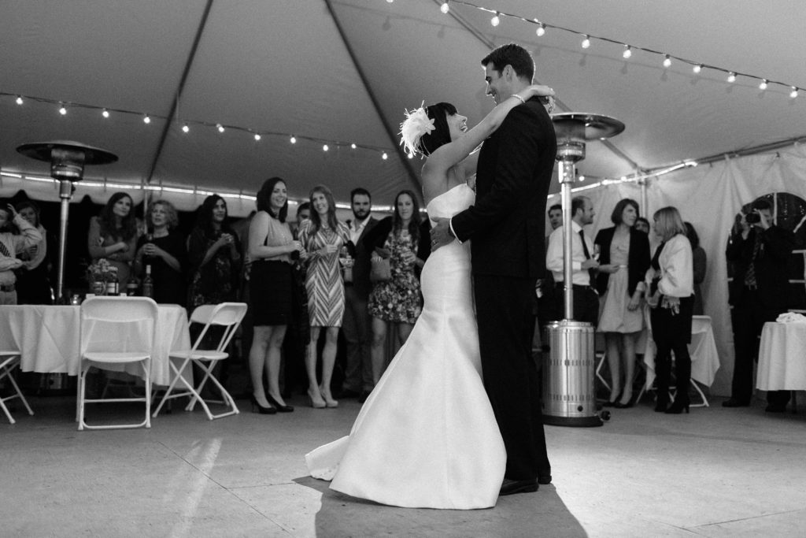
For those of you who are married, do you remember your wedding day? Honestly, mine is a bit of a blur after almost 48 years? But, here's what I do remember:
My best man and groomsmen and the maid of honor and bridesmaids were waiting and greeted Kathy and me at the altar.
One of the bridesmaids fainted at the altar.
We danced at the reception to "our" song, "Time in a Bottle."
Some great memories. I'm sure if I sat with Kathy and talked with her, I could come up with more.
The best part? We're still together through many ups and downs, and I wouldn't have it any other way.
That brings us to today's Parable.
*********************************************
Today's story is another Parable from Jesus about being ready.

The Parable of the Ten Virgins
"At that time, the kingdom of heaven will be like ten virgins who took their lamps and went out to meet the bridegroom. Five of them were foolish, and five were wise. The foolish ones took their lamps but did not take any oil with them. The wise ones, however, took oil in jars along with their lamps. The bridegroom was a long time in coming, and they all became drowsy and fell asleep.
"At midnight, the cry rang out: 'Here's the bridegroom! Come out to meet him!'
"Then all the virgins woke up and trimmed their lamps. The foolish ones said to the wise, 'Give us some of your oil; our lamps are going out.'
"'No,' they replied, 'there may not be enough for both us and you. Instead, go to those who sell oil and buy some for yourselves.'
"But while they were on their way to buy the oil, the bridegroom arrived. The virgins who were ready went in with him to the wedding banquet. And the door was shut.
"Later, the others also came. 'Lord, Lord,' they said, 'open the door for us!'
"But he replied, 'Truly I tell you, I don't know you.'
"Therefore, keep watch because you do not know the day or the hour. Matthew 25:1-13

When Jesus uses the word virgins, for us today, we would probably say bridesmaids. The lamps would most likely have been torches wrapped with oil-soaked rags. That type of torch would require you to add oil to it every so often; that is why the wise virgins brought extra oil.
What was the occasion? These women were to be part of a wedding processional as the groom brings his bride home.
All of the virgins fall asleep waiting for the bridegroom. As I said earlier, the wise ones were prepared because they had brought additional oil for their torches. But unfortunately, the foolish ones had to go to the store to purchase more oil. By the time they got back, the groom had arrived, and the banquet doors had been shut. Therefore, they missed the finale, the marriage of Jesus and His church.
As I mentioned earlier, this is a story of being ready. You read that all 10 virgins fell asleep while waiting for the groom. This is analogous to you and me awaiting Christ's return. We don't know when He'll return; we just know he will.
Five of the virgins were prepared with extra oil. How can we be prepared for Christ's return? Jesus isn't saying we have to constantly be looking up to the heavens for when He will return. Even Jesus said,
"But about that day or hour, no one knows, not even the angels in heaven, nor the Son, but only the Father." Matthew 24:36
I sometimes imagine God the Father turning to His right, looking at Jesus, and saying, "It's a go! Today is the day."
So how can we be prepared like the five wise virgins?
I've said it before, and I'll repeat it. We must be about the work that Jesus gave us to do. We are to go and make disciples of all nations.
Each of us has been given at least one spiritual gift by the Holy Spirit. We must discover what it is to better serve the Lord and His calling.
I genuinely believe that the Holy Spirit gives us unique gifts, and at times He takes them away or adds new ones.
For 25 years during my full-time ministry, my title was Youth Minister. But my gift was teaching and leading.
Now my gift has been changed. Sure, I'm still teaching and perhaps even leading by example. But now, the Holy Spirit has given me the written word to communicate the Gospel message. I use this gift as often as I can.
If you don't know what your gift is, ask God to enlighten you. Then use that gift and all you are to spread the Good News of Jesus Christ.
Be faithful, love the Lord, and share the Gospel. That's how you prepare.

Dear Jesus. We don't know the day or hour of your return. But we have faith that you will. So help us be ready while spreading Your Gospel story so all of the world may be prepared for your return. Amen.

