The Parables of Jesus
March 9, 2022
“Not all seeds take root.”
Matthew 13:1-9;18-23

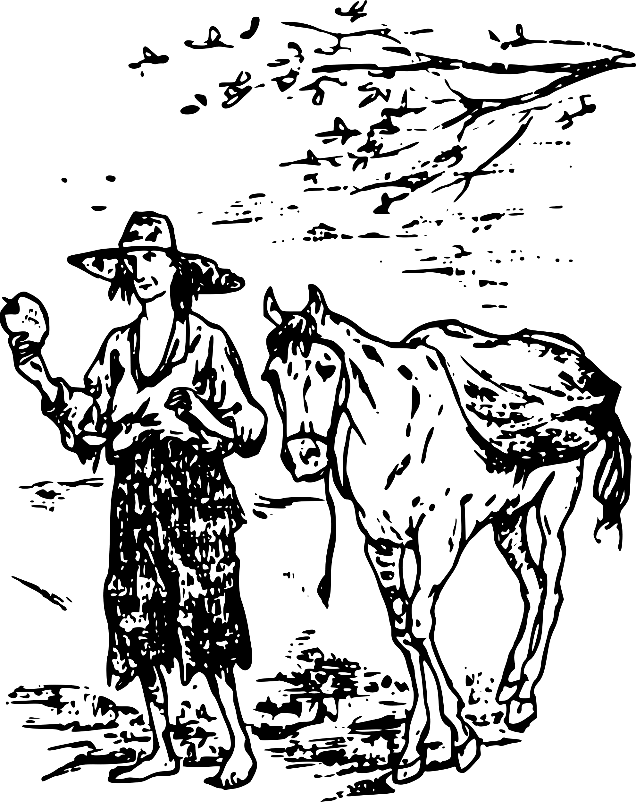
Most people have not heard of John Chapman. He was born in 1774. As an adult, John worked a nurseryman, which simply means he worked with plants, bushes, and trees.
Mr. Chapman especially loved apple trees. As a matter of fact, he planted them all around the town he lived in. Eventually, He started traveling around the country planting apple trees and giving away apple seeds.
Mr. Chapman became well-known for planting apple trees and sharing their seeds. Perhaps you’ve heard his nickname before, Johnny Appleseed.
Not unlike plants, trees, and seeds we plant on our own property, it’s safe to say that every tree plant and seed sowed by Johnny Appleseed did not produce fruit.
And that presumption brings us to today’s Parable.
***************************************
The best part of the Parable is that Jesus explains it to His disciples. That’s not something He does very often. Generally, Jesus would tell a Parable and leave it at that. This allowed the listener to either dismiss it or take time to ponder what Jesus said and allow the Spirit to open their hearts and mind to its meaning.
The first section of this Parable is the story itself:
“That same day, Jesus went out of the house and sat by the lake. Such large crowds gathered around him that he got into a boat and sat in it while all the people stood on the shore. Then he told them many things in parables, saying: “A farmer went out to sow his seed. As he was scattering the seed, some fell along the path, and the birds came and ate it up. Some fell on rocky places, where it did not have much soil. It sprang up quickly because the soil was shallow. But when the sun came up, the plants were scorched, and they withered because they had no root. Other seed fell among thorns, which grew up and choked the plants. Still, other seed fell on good soil, where it produced a crop—a hundred, sixty, or thirty times what was sown. Whoever has ears, let them hear.” Matthew 13:1-9
I want to key in on one point at the end of the above text, as Jesus himself will explain to the Parable to you and me in the rest of the story.


Matthew 13:9 is not just talking about being a good listener. If you can hear God’s word, then “really” listen to it. Take His word to heart, believe it, and obey it. We obey God’s word by not allowing it to lie dormant in our hearts. Instead, we do what it says; we follow God’s instructions.

Over several verses, Jesus discusses how and why He uses Parable, then He explains the Parable we read earlier:

“Listen then to what the Parable of the sower means: When anyone hears the message about the kingdom and does not understand it, the evil one comes and snatches away what was sown in their heart. This is the seed sown along the path. The seed falling on rocky ground refers to someone who hears the word and at once receives it with joy. But since they have no root, they last only a short time. When trouble or persecution comes because of the word, they quickly fall away. The seed falling among the thorns refers to someone who hears the word, but the worries of this life and the deceitfulness of wealth choke the word, making it unfruitful. But the seed falling on good soil refers to someone who hears the word and understands it. This is the one who produces a crop, yielding a hundred, sixty, or thirty times what was sown.” Matthew 13:18-23

Yes, this portion of the scripture is about listening to God’s word and what you do with it. But, it’s also about Faith.
What makes Good soil. You’ll notice Jesus never once says that the good ground doesn’t have rocks, thorns, or weeds on it. That’s because we will all and are tempted, go through problems in our lives, and face uncertain times. Yet, through it all, those in the good soil maintain a strong faith in their Savior and His love for them. They know that’s God’s Holy Spirit will guide them along the proper path and help them in times of need.

John Chapman was enthusiastic about planting apple trees and seeds. God wants you and I to be passionate and excited about planting and sowing the seed of the Gospel where ever we go.
So, listen, read, understand, believe, and act.

Dear Jesus. It’s not always easy to listen to your word, believe it, and act. Help us to hear and listen to your word. In this way, we may sow the seeds of The Good News to everyone we encounter. Amen



