The Parables of Jesus
March 5, 2022
“Greed is just another word for Covetousness.”
Luke 12:13-21

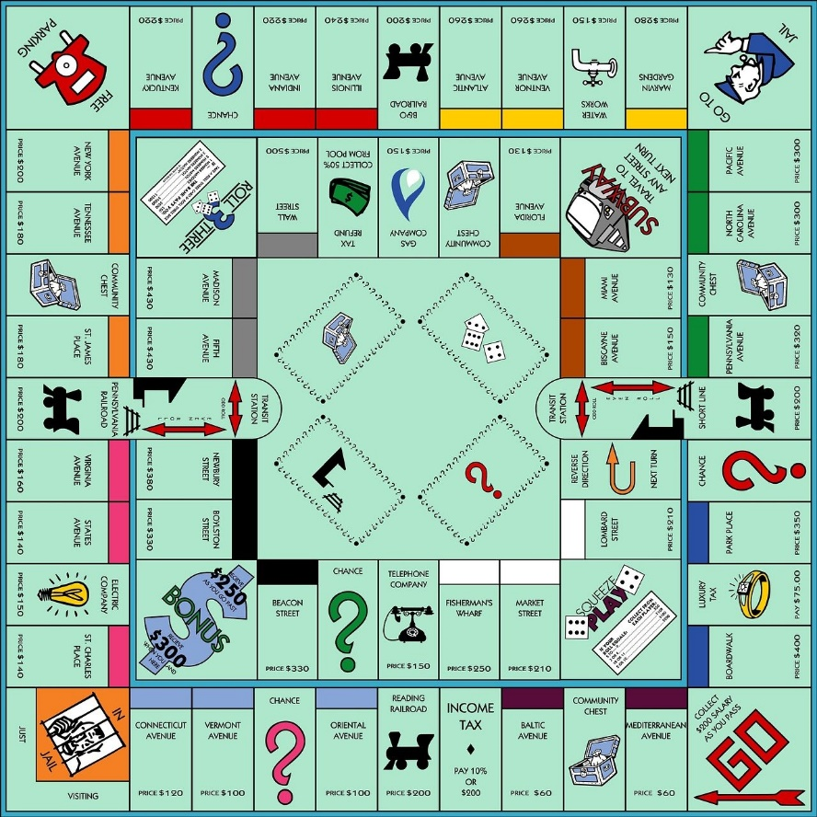
Have you ever played the game Monopoly? I played the game of Monopoly quite often with my friends, family, and classmates. But, as an adult, I now realize that no matter how you look at it, Monopoly is a game of greed.
I actually Googled the following sentence, “Is Monopoly a game of greed?” The first thing that popped up on Google was this:
“Monopoly is the sort of board game where greed is good. You win by hoarding money, ruthlessly purchasing property, and then building nice little green houses on that property to rent out like Airbnbs, only to transform them into massive red hotels as soon as possible to rent out for even more brightly colored money.” (theglobeandmail.com)
That is a straightforward, if not a rigid, definition of the game of Monopoly. Although I’m not sure if greed is ever good, even in a board game.
As kids and youngsters, you play the game of Monopoly until your money is wiped out and you say, “Darn!” Then, the game is over, and you move on. If only life were that simple Perhaps Monopoly doesn’t teach the best lessons in integrity and caring for others to teach our children. Still, it’s just a game, isn’t it?
******************************************************************
In the real world, we see greed all around us. People steal, cheat others out of their money, and do whatever they can so they might have more. More money, flashier cars, bigger homes, jewelry, and power.


Greed: excessive or rapacious (covetous) desire, especially for wealth or possessions. (Dictionary.com)
Today’s parable tells the story of a man who ponders building big barns to hold all of his crops and then sit back and enjoy life. But, first, let’s read the story from the Gospel of Luke:
“Someone in the crowd said to him, “Teacher, tell my brother to divide the inheritance with me.”
Jesus replied, “Man, who appointed me a judge or an arbiter between you? “Then he said to them, “Watch out! Be on your guard against all kinds of greed; life does not consist in an abundance of possessions.”
And he told them this parable: “The ground of a certain rich man yielded an abundant harvest. He thought to himself, ‘What shall I do? I have no place to store my crops.’
“Then he said, ‘This is what I’ll do. I will tear down my barns and build bigger ones, and there I will store my surplus grain. And I’ll say to myself, “You have plenty of grain laid up for many years. Take life easy; eat, drink and be merry.”’
“But God said to him, ‘You fool! This very night your life will be demanded from you. Then who will get what you have prepared for yourself?’
“This is how it will be with whoever stores up things for themselves but is not rich toward God.” Luke 12:13-21

In the above reading, you may have noticed that Jesus never directly advises the brother about his inheritance. Instead, Jesus tells a parable. Jesus gives a prelude to the parable by saying, “Watch out! Be on your guard against all kinds of greed; life does not consist in an abundance of possessions.”
Jesus is basically telling the man, the crowd, and us that the parable He is about to tell is about greed.
This rich, “fool, is entirely self-centered. When the rich man ponders his riches, he only thinks about himself. He never says a word about thanking God for the great harvest or giving to the needy.
The man is not someone who has a good relationship with God. He has the wrong attitude about life because the only things that matter to him are his possessions and money.
Earlier in this devotion, I gave you the definition of greed. So here is the meaning of covetousness: “Eager or excessive desire, especially for wealth or possessions.”
There is no real difference between greed and covetousness, is there? The rich “fool” is only interested in “stuff” and his own self-interests. If we become like him, we’ve totally embraced the world and have no time, effort, or inclination to be about the Lord’s work.
Here’s the point, if we get all caught up in what the world has to offer, we have no time to do God’s work here on earth. And if we are not doing His work, and we have all kinds of money and possessions, when He calls us to eternity, we have lived empty lives.
It’s true, you can’t take it with you. Even Bill Gates, worth billions of dollars, will someday leave this world behind, and not one penny will go with him.
There’s nothing wrong with having possessions and money. However, we must use those possessions and money to help others show God’s love by giving to the needy and serving others.
Then one day, we will be face to face with our creator, awaiting those words we long to hear from Him, “Well done, my good and faithful servant.”

Dear Lord. Help us to not be greedy and covetous people. Show us how to be a blessing to others with the gifts you have given us. We long not to be self-centered, but instead, we want to be Christ-centered, teaching, loving, and serving others. Amen.

