The Parables of Jesus
March 27, 2022
"I was lost."
Luke 15:11-32

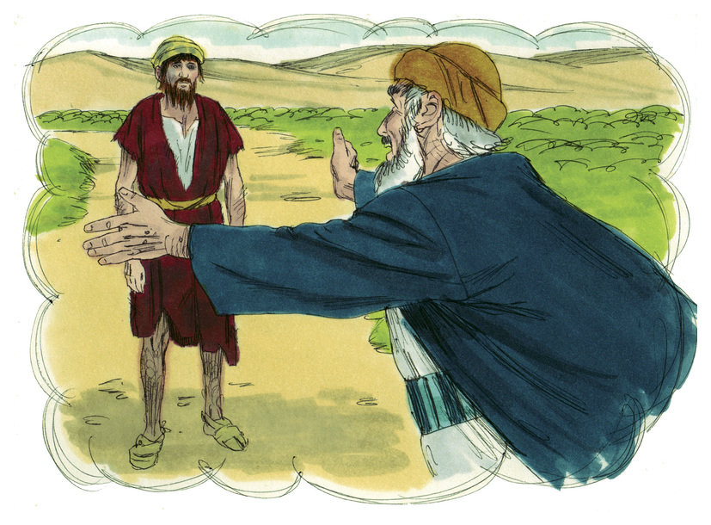
Have you ever been lost? There are a couple of ways to answer that question. I believe we've all gotten lost while traveling, and that is one way to answer it. The other is if you have ever felt lost and helpless. I would venture to say that we've all felt that way.
Many years ago, and when I say many, I mean 40-45 years ago. At the time, Kathy and I hadn't lived in Florida very long. We were visiting Disney World and got off the exit that takes you to what is now Disney Springs. Back then, it was a small, intimate shopping area called Walt Disney World Village.
I decided to take a shortcut. I thought I was following signs that would bring us to the hotel we were staying at just outside the village. That's when the trouble began. I turned down a paved road with no signs, and suddenly, we found ourselves in the middle of an orange grove.
There were orange trees on both sides of the car with fully blooming oranges. I couldn't turn around as there was no room. Branches full of oranges were banging against the roof and side of the car. Yes, we were on a very tight dirt path, seemingly no way out. We were a bit horrified and, for some reason laughing at the same time. I continued on the path between the orange trees for what seemed forever (It was probably no more than five minutes). Then, suddenly the trail opened up. I saw a road that ran perpendicular to the path in front of us. I hit the gas, and we were slightly airborne as we landed on the road. From there, we finally found our way back to civilization. I would never want to be lost like that again.
My story brings us to today's Parable.
*********************************************************
The Parable of the Lost (Prodigal) Son
This story is known as "The Lost Son" or "The Prodigal Son." Here's a definition of the word prodigal: "spending money or resources freely and recklessly; wastefully extravagant."
This is definitely a definition of the main character's actions in today's Parable.
"There was a man who had two sons. The younger one said to his Father, 'Father, give me my share of the estate.' So, he divided his property between them.
"Not long after that, the younger son got together all he had, set off for a distant country, and there squandered his wealth in wild living. After he had spent everything, there was a severe famine in that whole country, and he began to be in need. So, he went and hired himself out to a citizen of that country, who sent him to his fields to feed pigs. He longed to fill his stomach with the pods that the pigs were eating, but no one gave him anything.
"When he came to his senses, he said, 'How many of my Father's hired servants have food to spare, and here I am starving to death! I will set out and go back to my Father and say to him: Father, I have sinned against heaven and against you. I am no longer worthy to be called your son; make me like one of your hired servants.' So, he got up and went to his Father.
"But while he was still a long way off, his Father saw him and was filled with compassion for him; he ran to his son, threw his arms around him, and kissed him.
"The son said to him, 'Father, I have sinned against heaven and against you. I am no longer worthy to be called your son.'
"But the Father said to his servants, 'Quick! Bring the best robe and put it on him. Put a ring on his finger and sandals on his feet. Bring the fattened calf and kill it. Let's have a feast and celebrate. For this son of mine was dead and is alive again; he was lost and is found.' So, they began to celebrate.
"Meanwhile, the older son was in the field. When he came near the house, he heard music and dancing. So, he called one of the servants and asked him what was going on. 'Your brother has come,' he replied, 'and your father has killed the fattened calf because he has him back safe and sound.'
"The older brother became angry and refused to go in. So, his Father went out and pleaded with him. But he answered his Father, 'Look! All these years, I've been slaving for you and never disobeyed your orders. Yet you never gave me even a young goat, so I could celebrate with my friends. But, when this son of yours who has squandered your property with prostitutes comes home, you kill the fattened calf for him!'
"'My son,' the Father said, 'you are always with me, and everything I have is yours. But we had to celebrate and be glad because this brother of yours was dead and is alive again; he was lost and is found.'" Luke 15:11-32

We've all heard or read this passage many times. Take a few minutes to re-read the story and then think about these items:
Who do you think is the young Son's Father? Who is the young son?
What was the young Son's Ah-Ha moment that brought him back to His Father?
Why do you think the Father was so welcoming when his sinful son returned home?
Why do you think the older brother had such a lousy attitude concerning his Father's actions?
Who do you relate to more? The lost son or the older brother?

Many of the answers to the questions I just asked you are relatively self-evident. So let's look at the story as a whole.
One of the most exciting things about this story is that the Father is actually the main character, not the lost son. The Father is obviously a rich man who lives a lavish lifestyle. Yet he seems to handle his finances much better than his son is about to. After he "blows" his inheritance on wine, women, and song, the young son returns.
Before his return, the young son had an Epiphany of sorts and realized he had messed up against his Father and heaven. He didn't need to live in poverty. He could return to his Father, apologize and work as a servant if necessary.
It wasn't necessary. When the Father sees his son, he doesn't even listen to the scripted story his son was telling him.
Instead, the Father calls for his servant to give his young son a robe, jewelry, shoes and throws a feast in his honor, celebrating his return.
The Father approaches his eldest son and repeatedly asks him to come inside the house and celebrate his brother's return. But, the elder son wants nothing to do with the party.
This is a story of forgiveness and redemption and a jab at the pious religious leaders of the day (analogized by the eldest son). First, the Father allowed the son to use his free will to live the life he saw fit. Then, when the young son humbly returned, the Father forgave him.
Do you see yourself in this story at all? God's Holy Spirit has a path for us to follow throughout our lives. But, there are times we stray from the path (the lost son). Yet, when any of us return to the Lord and seek forgiveness, all of heaven is overjoyed. We are forgiven when we mess up, just like the young son. Jesus died for our sins; we are forgiven every time we mess up. Jesus' loving arms are always open and ready to welcome us back onto the Kingdom path.

Dear Jesus. We mess up all the time. We stray from the path that your Holy Spirit has set us upon. Yet every time we return to you with a penitent heart, you welcome us back. Thank you for your love, sacrifice, and the redemption we received. Amen.

