The Parables of Jesus
March 15, 2022
"What's the big deal about Parables?"
Matthew 13:10-17


Several years ago, I published my first book, Adventures in Youth Ministry. The book could partially be looked at as a memoir. But the real reason I wrote it was to share my experiences in youth ministry with the hope others would gather ideas from it.
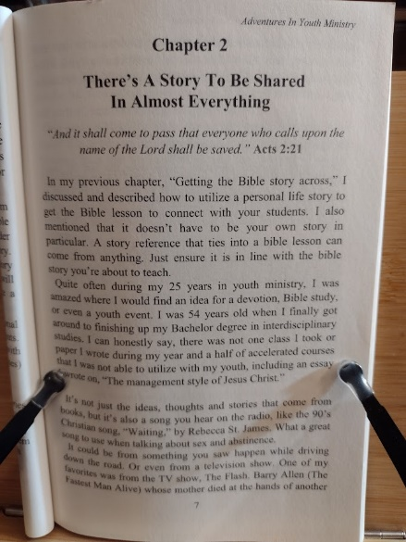
One of the critical points that is woven throughout the book is that of storytelling. I emphasized how important it was to incorporate personal stories into Bible studies, devotions, and outreach. In addition, I discussed how "There's a story to be shared in almost anything."
Hopefully, you've been following my devotionals over the last several years. In that case, you'd know that I often use a personal story that ties into the devotion's main points.
People in general, young and old, love to listen to stories. And when we as Christians can tie a story to lessons, devotions, and or conversations, it can better open up the Gospel story to others.
***************************************
During this Lenten season, I have been sharing with you a series of devotions titled "The Parables of Jesus."
Many people believe they know, or do know, what a Parable is. Is it a way of getting the point across using a story? Yes.
According to Merriam Webster, a Parable is:
"a usually short fictitious story that illustrates a moral attitude or a religious principle, such as the Biblical parable of the Good Samaritan"
The word Parable comes from the Latin word parabola, from Greek parabolḗ, meaning "comparison."
Jesus' Parables are considered metaphorical analogies. Although Jesus' stories are all called Parables, you could get technical and break them into three categories.
- Similitudes: In my research, I found that Matthew Henry's Commentary occasionally uses this word when referencing Christ's Parables. When Jesus says things such as: "Heaven is like" or "The Kingdom of God is like," He is telling a story from real life to help the hearers understand.
- Parables: are generally longer than similitudes and don't tell a real story from life, as they are fictitious. When Jesus says, "A farmer went out to seed His field," or tells the story of "The Prodigal son," these are examples of Parables.
- Exemplary story: where similitudes and Parables are analogies, an exemplary story gives an example in its account. The Good Samaritan story exemplifies how we should love our neighbor.
Don't be disillusioned; it's still okay to refer to Jesus' stories as parables. All I was doing was breaking them down into categories.

So, we come back to the why. Why did Jesus speak in Parables? Part of that answer is pretty evident. By using analogies and stories, He could get His message across easier.
But there's a little more to it than that.
After Jesus related the Parable of the Sower in Matthew 13, the following occurs:
"The disciples came to him and asked, "Why do you speak to the people in parables?"
He replied, "Because the knowledge of the secrets of the kingdom of heaven has been given to you, but not to them. Whoever has will be given more, and they will have an abundance. Whoever does not have, even what they have, will be taken from them. This is why I speak to them in parables:
"Though seeing, they do not see;
though hearing, they do not hear or understand.
In them is fulfilled the prophecy of Isaiah:
"'You will be ever hearing but never understanding;
you will be ever seeing but never perceiving.
For this people's heart has become calloused;
they hardly hear with their ears,
and they have closed their eyes.
Otherwise, they might see with their eyes,
hear with their ears,
understand with their hearts
and turn, and I would heal them.' But blessed are your eyes because they see, and your ears because they hear. For truly I tell you, many prophets and righteous people longed to see what you see but did not see it, and to hear what you hear but did not hear it."
Matthew 13:10-17

For Jesus, speaking in Parables had two reasons. The first was to reveal the Word of God. And the second was to conceal it. That might sound odd, but it's true. Jesus's Parables disclosed the truth of God's Word to believers but withheld it from some unbelievers.
Parables are easy to remember. Jesus's stories were relatable and spoke to things people knew about farming, families, servants, and perseverance.
Jesus wants everyone to understand God's Word, to know His love, and be saved. But, unfortunately, to this day, some refuse to listen to the Gospel message. Even though God gives people opportunity after opportunity to listen, God will withdraw His Grace from them if they continue to refuse.
Unfortunately, many people continue to harden their hearts against God's Word. Yet, it is not up to us to give up these people. As Christians, we continue to spread the Good News of Jesus Christ wherever and whenever we can. If people refuse to listen, God will make the final decision about their destiny.
At the end of the passage above, Jesus is speaking directly to His disciples when he says,
"But blessed are your eyes because they see, and your ears because they hear. For truly I tell you, many prophets and righteous people longed to see what you see but did not see it, and to hear what you hear but did not hear it."
Jesus is telling His disciples that they are truly blessed because they not only see Jesus but they take His teaching to heart. He knows they will continue to do so. This praise from Jesus is for you and me too. In the Bible, we can or have learned that Jesus is the promised Savior of the world. We see Jesus in the scripture, and we must continue to spread the Good News to others.
And when you do tell others God's Promise and Jesus as its fulfillment, don't be afraid to add a story. Perhaps the story of how you came to be a follower of Jesus.

Dear Jesus. You were and are the master of telling stories that we call Parables. Help us follow in your footsteps and continue to spread the Good News with your stories (Parables) as well as our own. Amen.

