The Parables of Jesus
“Great Oaks from little Acorns grow.”
March 12, 2022
Mark 4:30-32

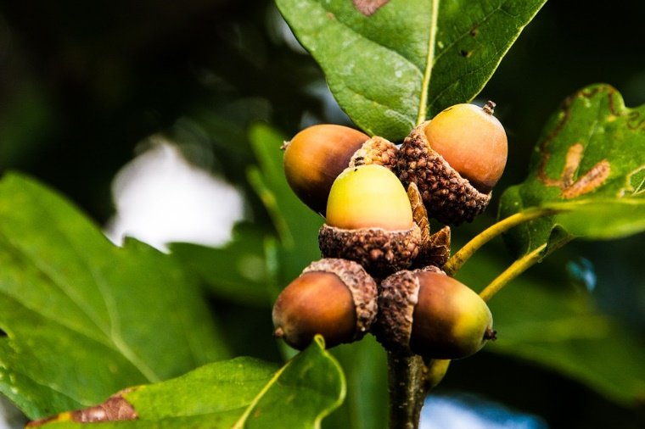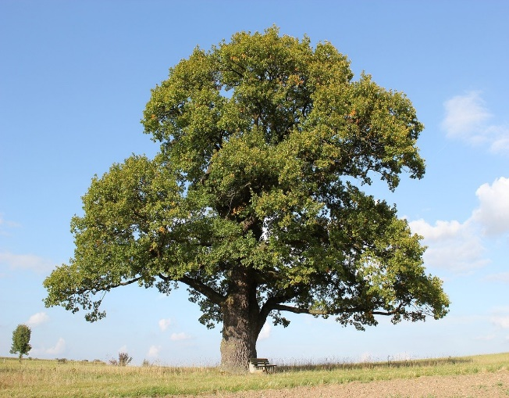
You’ve probably heard the term, “Great oaks from little acorns grow” before. As seen in the photo above, acorns are tiny. But if one is planted and it opens up, inside is the seed necessary for a giant oak to grow.
The phrase or proverb about great oaks is literal because it’s true. It is also an analogy for the idea that great things can come from simple beginnings. In other words, if we begin with taking small steps towards a goal, we can then take larger and larger ones moving forward.
************************************************
You might say I used the phrase as an example for today’s Parable. The Parable of the mustard seed.
“What shall we say the Kingdom of God is like, or what Parable shall we use to describe it? It is like a mustard seed, which is the smallest of all seeds on earth. Yet when planted, it grows and becomes the largest of all garden plants, with such big branches that the birds can perch in its shade.” Mark 4:30-32

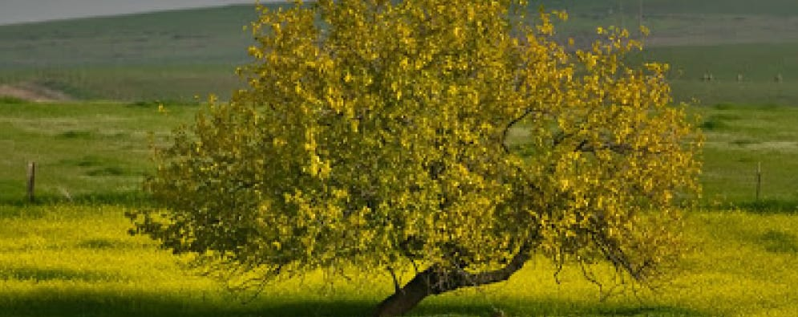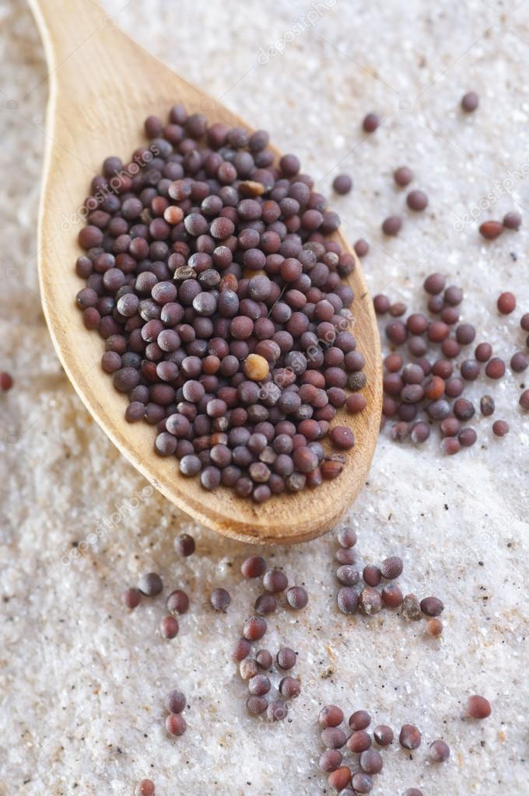
In this Parable, Jesus is being quite literal. The mustard seed was literally one of the smallest seeds the people of Israel could plant in their garden. Yet this tiny seed could grow into a tree that stood 8-10 feet with branches strong enough for birds to sit on.
Take a moment and think about what the seed represents.
The mustard seed represents Jesus. He came into this world as a tiny baby. The Bible even says, “And Jesus grew in wisdom and stature, and in favor with God and man.” Luke 2:52
As Jesus grew, so did His ministry. He touched so many lives in His short three-year ministry. You might even say, Jesus, planted many mustard seeds himself throughout His ministry.
But, the real growth of Jesus, the mustard seed, didn’t come till after His death and resurrection. For instance, we know that on one spectacular day, The Day of Pentecost, 3000 were brought to faith by the Holy Spirit.
Christ’s church and Kingdom have continued to grow for over 2000 years. We can’t determine the final size of Christ’s Kingdom by the initial seed, Christ, that was planted. Nevertheless, the Gospel has remarkable power and strength. It will continue to grow until his return.
Dear Jesus. You have put us here to do your work of spreading the Gospel message. Help us spread the seeds of the Gospel and nurture them in others. We know that the Holy Spirit will bring many of the seeds planted to full growth as the mustard seed grows to a large tree. Thank you for including us in your plan as we spread the Good News to everyone. Amen.

