The Parables of Jesus
“The Great Impersonator”
March 10, 2022
Matthew 13:24-30; 36-43

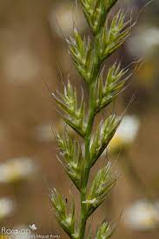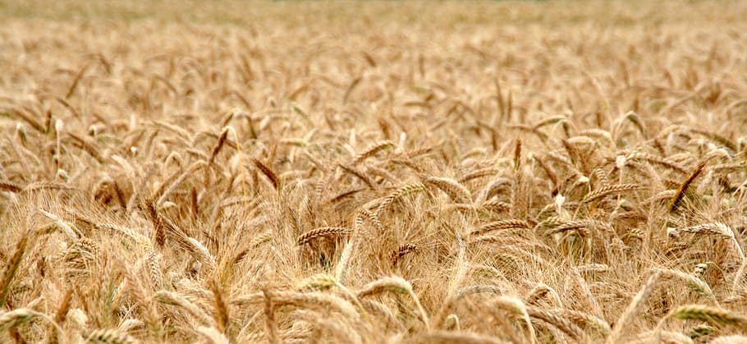
Have you ever heard of L. temulentum? I would venture to guess that you haven’t. It’s the scientific name for a weed called Darnel or Darnel RyeGrass. Unfortunately, Darnel grows among wheat plants, and it is difficult to tell the two apart until maturity. Therefore, it is pretty difficult to “weed” it out until the wheat and Darnel mature.
The similarity between wheat and Lolium temulentum is so great that in some regions, L. temulentum is referred to as true wheat (Triticum species). L. temulentum and wheat look alike until the ear appears and are distinguished as follows:
- The ears on the real wheat are so heavy that it makes the entire plant droop downward, but L. temulentum, whose ears are light, stands up straight.
- Wheat ripens to a brown color, whereas L. temulentum turns black.
(https://keys.lucidcentral.org/keys/v3/eafrinet/weeds/key/weeds/Media/Html/Lolium_temulentum_(Darnel_Ryegrass).htm)
********************************************
Right about now, you may be asking yourself, why did Joe just give me a Botany lesson on the difference between wheat and darnel ryegrass. I’m so glad you asked that question .
Today’s parable is called “The Parable of the Weeds.” It is believed by many people that the weed or weeds that are discussed in this parable are Darnel.
Jesus told them another parable: “The kingdom of heaven is like a man who sowed good seed in his field. But while everyone was sleeping, his enemy came and sowed weeds among the wheat and went away. When the wheat sprouted and formed heads, then the weeds also appeared.
“The owner’s servants came to him and said, ‘Sir, didn’t you sow good seed in your field? Where then did the weeds come from?’
“‘An enemy did this,’ he replied.
“The servants asked him, ‘Do you want us to go and pull them up?’
“‘No,’ he answered, ‘because while you are pulling the weeds, you may uproot the wheat with them. Let both grow together until the harvest. At that time, I will tell the harvesters: First, collect the weeds and tie them in bundles to be burned; then gather the wheat and bring it into my barn.’” Matthew 13:24-30
In this parable, we have another man good seed in what seems to be good soil. But he encounters a different problem than rocks, a path, or a scorching sun. In this story, an enemy comes into the field at night and scatters weed seeds.
The weeds and the good seed are tough to distinguish in their infancy; only when they mature is it safe to pull the weeds without damaging the good crops.
As I said, many believe the weeds would have been what we now call Darnel. In the “New Bible Commentary, 21st Century Edition, 1994 Edition, Pp. 922. Notes 25, “The weeds are probably Darnel. Which looks very like wheat in the earthy stages of growth and after that is so closely entangled with it that it cannot be removed without damaging the wheat.”
At this point, we know the problem and even Jesus’ parable answer to the problem.
“Let both grow together until the harvest. At that time, I will tell the harvesters: First, collect the weeds and tie them in bundles to be burned; then gather the wheat and bring it into my barn.”
Once again, Jesus takes the time to explain this parable to His disciples.
“Then he left the crowd and went into the house. His disciples came to him and said, “Explain to us the parable of the weeds in the field.”
He answered, “The one who sowed the good seed is the Son of Man. The field is the world, and the good seed stands for the people of the kingdom. The weeds are the people of the evil one, and the enemy who sows them is the devil. The harvest is the end of the age, and the harvesters are angels.
“As the weeds are pulled up and burned in the fire, so it will be at the end of the age. The Son of Man will send out his angels, and they will weed out of his kingdom everything that causes sin and all who do evil. They will throw them into the blazing furnace, where there will be weeping and gnashing of teeth. Then the righteous will shine like the sun in the kingdom of their Father. Whoever has ears, let them hear.” Matthew 13:36-43

Jesus’ explanation is very self-explanatory. Jesus is the Son of Man, who sows His Word. The believers are the good seeds that stand in this world. The weeds are the ungodly people that Satan plants amongst us. Why? So, we as believers might be pulled into the sinfulness the world has to offer.
One final note. You’ll notice that the parable refers to the “world,” not “the church.” This is because there are processes in place to deal with the unfaithful and sinners within the church.
Don’t ever think that historical events like the Spanish Inquisition or the Crusades were righteous in God’s sight. It is not our job to go out and destroy sinners in the world. Jesus will take care of that when He returns when he separates the weeds from the wheat.
We’ll return to some of these thoughts and ideas later this month when we discuss the parable of the sheep and the goats in Matthew 25.

Dear Jesus. We believe that one day you will return, and everyone will be held accountable for their actions. May your Holy Spirit guide us to walk in Your ways so on that day of your arrival, we will join you in eternity. Amen.

