Where's your focus?
February 8, 2022
Luke 10:41
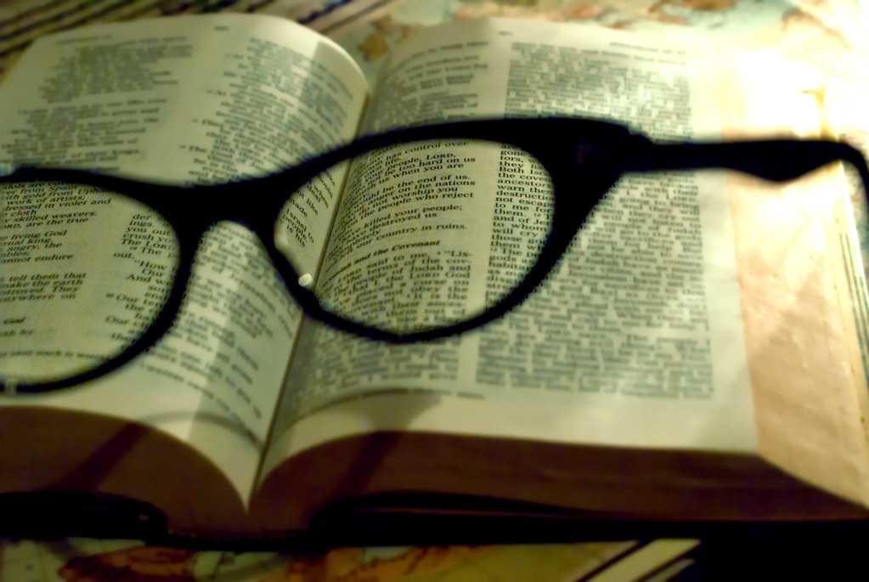
Several years ago, I was working in the yard. I had cut the lawn and decided I wanted to trim some tree branches in the backyard. I have two chain saws. One is a conventional handheld 16" chain saw. The other is a pole chain saw with an extension that allows you to cut branches up to 8 feet above your reach. I'm 6'4" and have pretty long arms, so with the pole saw, I would guess I can reach about 15-16 feet above the ground with the saw.
A branch in our "Rain Tree" was dead, and I thought I could cut it down with little effort. So I started up the pole saw and reached above my head, determined to cut down the branch. As a matter of fact, my entire focus was cutting down the limb.
The branch was probably about six feet long and twelve inches around. It was harder than I thought it would be. But I was determined, even though the pole was unsteady. So, I cut, and I cut ….
Let me pause here because there were two things about my surroundings that I hadn't thought about because I was so focused on cutting down the branch. First, the limb was long and thick. Was I going to be able to get out of the way when it came down after the saw cut through it? Second, there were several little stumps near me from some bamboo trees I had cut down at another time.
Yes, I was so focused on the branch I was oblivious to anything around me, including my safety. So, I cut, and I cut ….
"Crack!" The branch gave way. And, it was faster than me. As I tried to step out of the way with a chain saw pole in my hand, the branch hit me on the left forearm. As I moved and was struck by the branch, I tripped over one of the aforementioned stumps and landed flat on my back ….

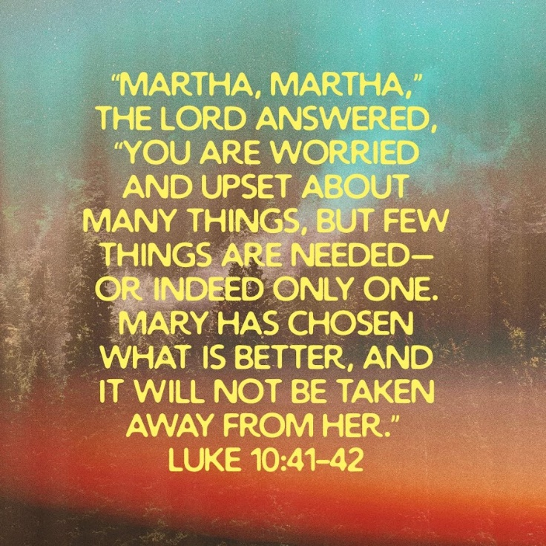

This incident very much reminds me of the Mary and Martha story in the Gospel of Luke. You probably know the story, but let's read it here once again.

"As Jesus and his disciples were on their way, he came to a village where a woman named Martha opened her home to him. She had a sister called Mary, who sat at the Lord's feet listening to what he said. But Martha was distracted by all the preparations that had to be made. She came to him and asked, "Lord, don't you care that my sister has left me to do the work by myself? Tell her to help me!"
"Martha, Martha," the Lord answered, "you are worried and upset about many things, but few things are needed—or indeed only one.10:42 Some manuscripts, but only one thing is needed Mary has chosen what is better, and it will not be taken away from her."

Jesus and His disciples had come to Mary and Martha's home (oh yeah, Lazarus was their brother, yet another story to discuss at a later date.)
Martha got very focused and put all of her time, thoughts, focus, and energy into food preparations for her guests. Nothing really wrong with preparing dinner for your guests. But when you have a distinguished guest like Jesus and His followers in your home, perhaps all you focus shouldn't be on food. Mary chose not to help with the food preparation and instead sat at Jesus' feet as He conversed with His friends and taught.
This really upset Martha. So, she approached Jesus and said, "I'm working in the kitchen preparing your meal, and my sister is just sitting here doing nothing. Can you please tell her to get with the program and help me?
But Jesus surprised her with his answer, "Martha. Martha, you are troubled about many things, but Mary has chosen the "good portion," which will not be taken from her."
In other words, Mary was focused on the right thing, Jesus, who was right in front of her. So her focus was on Him.
It's so easy to get focused on the wrong thing, me on my tree trimming, and Martha on the cooking.
(By the way, I ended up at a medical clinic. My arm and shoulder had gone numb when the branch hit me, and I had a very bloody gash on my arm. I have the scar to prove it)
It's easy to be distracted by the world and life and forget the one who is always with us. Jesus.
Take a breath, relax and refocus when you get caught up in the world. Don't be distracted or so focused on things that you lose your perspective. Instead, make Jesus the main focus of your life. Read His Words, follow His examples, show His love, and serve others as He did.

Dear Jesus. Like Martha, we sometimes focus on the wrong things in our lives. Help us to make you our primary focus at all times and not the distractions the world has to offer. Amen.

