Why are we so angry?
Proverbs 15:1
February 7, 2022

Yesterday, I read in the newspaper that a verbal altercation happened in the check-out lane at a Publix supermarket in Coral Gables, Florida. Unfortunately, the result of the verbal argument ended with one of the men pulling out a gun and killing the other man. I mentioned the story to my adult daughter several hours later, and she replied, "How stupid people are, now they're both dead."
She meant by that remark that one of the men was physically dead, and the man who shot the gun, who was arrested, might as well be dead. He's going to spend the rest of his natural-born life in prison.
At Disney World several days ago, a fight broke out at one of the rides because someone cut the line. At least six people got involved, throwing punches and hurling abusive words at each other. End result? Usually, you're escorted to the gate by security and, in some cases, banned for life from returning. All that violent behavior because someone cut in front of someone else in a line.
Lately, we seem to live in a world of sharp tongues. Accusations and threats hurled at others seem to elicit fiery responses. Perhaps it's the ever-changing pandemic news or the unending political fighting that is going on in our country. But, neither of these "reasons" are an excuse to be verbally abusive or violent.

When I see and hear these exchanges, they always remind me of little children who feel they always have to be correct. They say things back and forth like, "Yes I did," "No, you didn't," with voices elevating with each exchange. Then, continuing the argument until an adult has to step in and separate them.
Perhaps that is what we need?

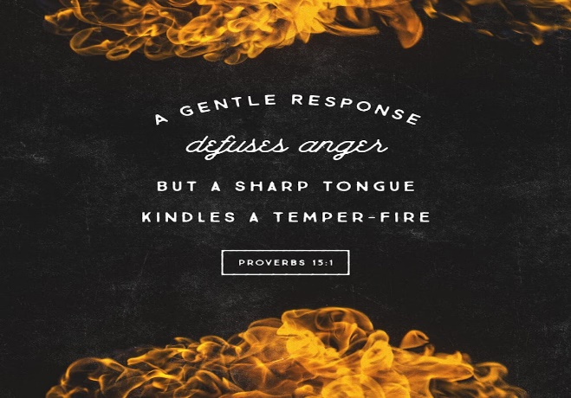
Of course, God can step in and stop any argument or disagreement in His own way at any time. He is the ultimate adult in the room.
Unfortunately, our sinful nature likes to return anger for anger. So, when someone hurts or insults us, our initial inclination is to get back at that person. But unfortunately, like the case in the Publix supermarket line, getting back at someone just escalates the situation and sometimes becomes deadly.
It's not always easy to turn the other cheek or just walk away from a confrontational situation.
Proverbs 15:1 says, "A gentle answer turns away wrath, but a harsh word stirs up anger."
Imagine what the results would have been if gentle words and not harsh words had been used during my two earlier illustrations.

My heart tells me that God wants the Christian Adults in the room to step up and defuse these situations with kindness and love.
If we love the Lord with all of our heart, soul, and mind and are instructed by God to love our neighbors as ourselves, isn't it our duty to help cooler heads prevail?
When you see situations around you deteriorating, be the adult in the room and help calm them. This is how we show love for our neighbors.

Dear Lord. Help us not to reply with anger for anger. Let us be an example of your Son's love for others. Help us keep a cool head and be the adult in the room by calming anger and hurtful words. Thank you for Your Word and the training it gives us as we continue to walk the path you have prescribed for us. Amen

Coming March 2, Daily Lenten Devotions.
"the Parables of Jesus"
(Joegministries.com)

