Advent stories and messages from around the world
The story behind the Carol, Silent Night
December 9, 2021
Psalm 33:1; Isaiah 12:5; Psalm 96:1; Exodus 15:1

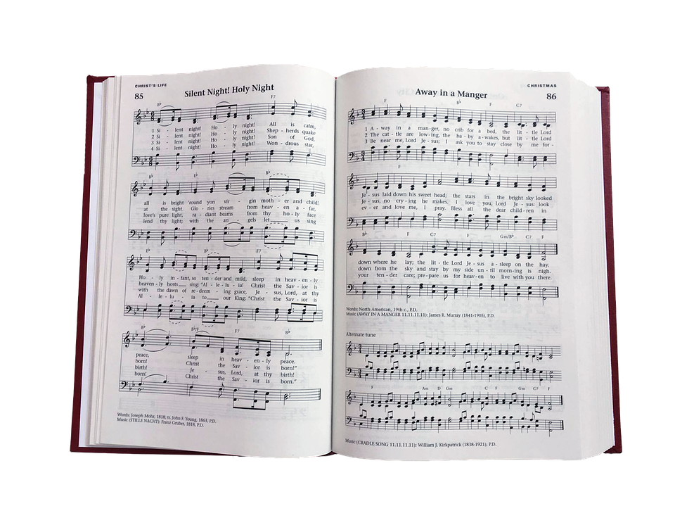

The Story of the beloved Christmas Carol, Silent Night, varies, depending on who’s telling it. Suffice it to say it was written in Germany. It is just as popular today as when first sung at St. Nicholas church in Oberndorf, Germany, over 200 years ago.
(The long and the short of it)
In the original German, Silent Night—or Stille Nacht —was created because Josef Mohr needed a carol for worship. On Christmas Eve of 1818, Mohr visited Franz Xaver Gruber with a poem he had written in 1816. Gruber quickly arranged the song to be played on a guitar with a choir because the church organ was broken. That evening at Midnight Mass, Gruber strapped on his guitar and led the congregation at St. Nicholas in the first rendition of Silent Night. (The Gospel Coalition.org)
*************************************************************************
Why do we sing in church? Why do we raise our voices in song to the Lord?
Let me share with you several verses from the Bible that come right out and tell us to “Sing to the Lord!”
Sing joyfully to the Lord, you righteous; it is fitting for the upright to praise him. Psalm 33:1
Sing to the Lord, for he has done glorious things; let this be known to all the world. Isaiah 12:5
Sing to the Lord a new song; sing to the Lord, all the earth. Psalm 96:1
Then Moses and the Israelites sang this song to the Lord: “I will sing to the Lord, for he is highly exalted. Both horse and driver he has hurled into the sea. Exodus 15:1
King David tells us to sing to the Lord, and so does Isaiah. Moses and the Israelites sang to the Lord in worship after He had closed the sea on the Egyptian army.
We pray to the Lord worshipfully. We read His Word and worship His deeds and Holy name. And we sing praises to the Lord, lifting our voices to Him in worship.
When I was younger, I did not like singing hymns. I thought they were boring written hundreds of years ago for a different time and generation. So as far as I was concerned, singing hymns was just singing a bunch of words no one uses anymore to totally outdated music.
That changed as I got older (much older). Now I read and pay attention to the words of the hymns we sing in church very closely. You know what? The music may not be contemporary (I still love contemporary Christian music). The words may sometimes be Old English and unfamiliar. But that’s okay. When you pay attention to the words of those old hymns, they are just as significant today as they were hundreds of years ago.
We praise the Lord in song because we love Him. And to Him, every word that comes out of our mouths when we praise Him is beautiful, even if we are off-key.
Every Christmas Eve Candlelight service I have attended always has the congregation sing Silent Night. To this day, I can’t get past singing the first verse without tearing and choking up to the point that I can’t sing.
The next time you sing Silent Night, remember it’s a hymn written over 200 years ago. Yet, people still enjoy singing it as they worship God and celebrate the birth of His Son Jesus. Amen.
Dear Lord. Thank you for all the wonderful music that has been written about you. Whether it was written 200 years ago by Josef Mohr or last year by Toby Mac, we know it is all beautiful to your ears as we sing your praises. Amen.

