Advent stories and messages from around the world
December 3, 2021
The Eight Reindeer of Christmas
Deuteronomy 6:5-9
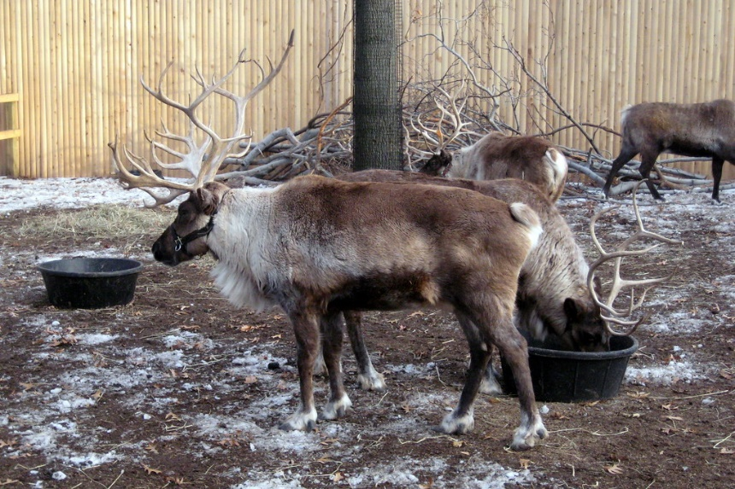
For many years I gave my High school youth group students several quizzes at Christmas time. One quiz would be secular. Secular, meaning it had questions about Santa Claus, reindeer, and other folklore of Christmas.
The second quiz was 25 questions long. But, again, it was biblical in nature; all of the questions about the birth of Jesus and the circumstances surrounding that event could be (or, in some cases, not be) found in the Bible.
At least half of my youth group could name at least six if not all eight of Santa's reindeer. (Dasher, Dancer, Prancer, Vixen, Comet, Cupid, Donner, Blitzen – Rudolph was dealt with separately)

The group of eight we know today as Santa's reindeer first appeared in Clement Clarke Moore's 1823 poem, "A visit from St. Nicholas." Today we know that poem, as it is now commonly referred to as, "The night before Christmas." Santa's reindeer were also referred to but not named in an anonymous 1821 poem, "Old Santeclaus with Much Delight."

But I digress. Remember the 25 Biblical-based questions I had my youth groups work on? I always had the students try and answer the questions in groups of two. And year in and year out over more than 20 years, with some of the same students taking the quiz several times, no duo of students ever got more than 17 of the questions correct.
They had no problem naming Santa's reindeer but stumbled continually on the same questions concerning the birth of Jesus. By the way, if anyone ever asks you, "How many animals were at the stable when Jesus was born?" The answer is, NO ONE KNOWS! It's not written anywhere in any of the Gospel accounts of Jesus' birth that there were animals present. Yet, we as logical human beings assume or presume that there were animals present because Jesus was laid in a feeding trough.
As I think about what knowledge is and isn't essential, I think of this passage from the book of Deuteronomy.
"Love the Lord your God with all your heart and with all your soul and with all your strength. These commandments that I give you today are to be on your hearts. Impress them on your children. Talk about them when you sit at home and when you walk along the road, when you lie down and when you get up. Tie them as symbols on your hands and bind them on your foreheads. Write them on the doorframes of your houses and on your gates." Deuteronomy 6:5-9
In this passage, Moses (Yes, He wrote the book of Deuteronomy) emphasizes the importance of training up our children in God's word. In Deuteronomy, Moses talks about the importance of our children, knowing and understanding the ten commandments.
But the training up of our children in knowing and understanding God's Word goes beyond the passage mentioned above. Yes, it speaks to God's Word. Still, it also indicates the importance of knowing Jesus intimately and His moral fiber.
Jesus is our teacher, mentor, friend, and example of what true servanthood is. Ultimately though, Jesus is our Savior. He gave up His life for ours.
You know what? It's okay to know the names of those fictional reindeer. But, it's even more important to know God the Father, God the Son, and God the Holy Spirit. Our creator, our savior, and our guide. Amen.

Dear Lord, help us bring up our children, knowing you and your Grace. Thank you for sending your Son Jesus to save and your Holy Spirit to guide us all the days of our lives. Amen

