Advent stories and messages from around the world
“Exchanging gifts at Christmas.”
December 22, 2021
John 19:39-40; Matthew 2:1-11

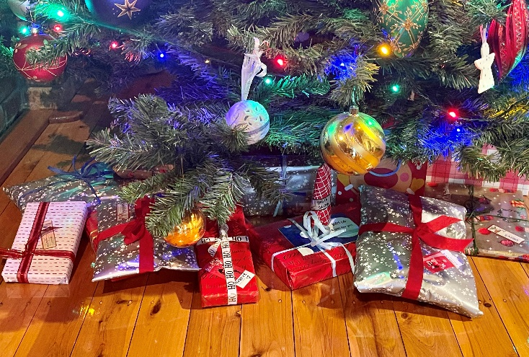

When I say, “Exchanging gifts on Christmas,” what comes to mind? Do you think of the tradition of giving gifts to friends, family, and co-workers at or on Christmas day? Or, do you think of December 26, when you go to your local retailer and exchange or return a gift you received that you don’t like or have no use for?
Suffice it to say, today I’m talking about the gift-giving of Christmas. Giving gifts has been around as long as people have been around. People have given gifts to dignitaries and heads of state, and other times as a thank-offering for something someone has done for them.
All over the world, friends, and family give gifts to each other for Christmas. And, most children believe in a gift-bringer, like St. Nicholas, Santa, or Father Christmas. In parts of Germany, they believe it is the Christkind that brings gifts, and in Spain, it’s the Wise men, while in parts of Italy, they believe it is an old lady called Befana. (Sometimes she is pictured as a witch)
People around the world also open their gifts at different times. In the Netherlands, some gifts are open as early as December 5, which is St. Nicholas Eve. On December 6, St. Nicholas Day, many children in Belgium, Germany, and other European countries open their gifts. While here in the United States, England, and Japan, we open our presents on December 25, Christmas day.
*******************************************
It’s the Monday before Christmas as I write this devotion. Last night at our church, we had a Christmas Nativity drive-through with 7 or 8 stations to stop at with music, readings, and Bible characters. I was one of the Wise Men (Dressed as a King). I was asked to present the reading for about 30 minutes at our station. So I read the passage below about 40 times and listened to it about 150 times last night.
I now have it memorized.
“After Jesus was born in Bethlehem in Judea, during the time of King Herod, Magi2:1 Traditionally wise men from the east came to Jerusalem and asked, “Where is the one who has been born king of the Jews? We saw his star when it rose and have come to worship him.”
When King Herod heard this, he was disturbed, and all Jerusalem with him. When he had called together all the people’s chief priests and teachers of the law, he asked them where the Messiah was to be born. “In Bethlehem in Judea,” they replied.
Then Herod called the Magi secretly and found out from them the exact time the star had appeared. He sent them to Bethlehem and said, “Go and search carefully for the child. As soon as you find him, report to me so that I too may go and worship him.”
After they had heard the king, they went on their way, and the star they had seen when it rose went ahead of them until it stopped over the place where the child was. When they saw the star, they were overjoyed. On coming to the house, they saw the child with his mother Mary, and they bowed down and worshiped him. Then they opened their treasures and presented him with gifts of gold, frankincense, and myrrh.” Matthew 2:1-11

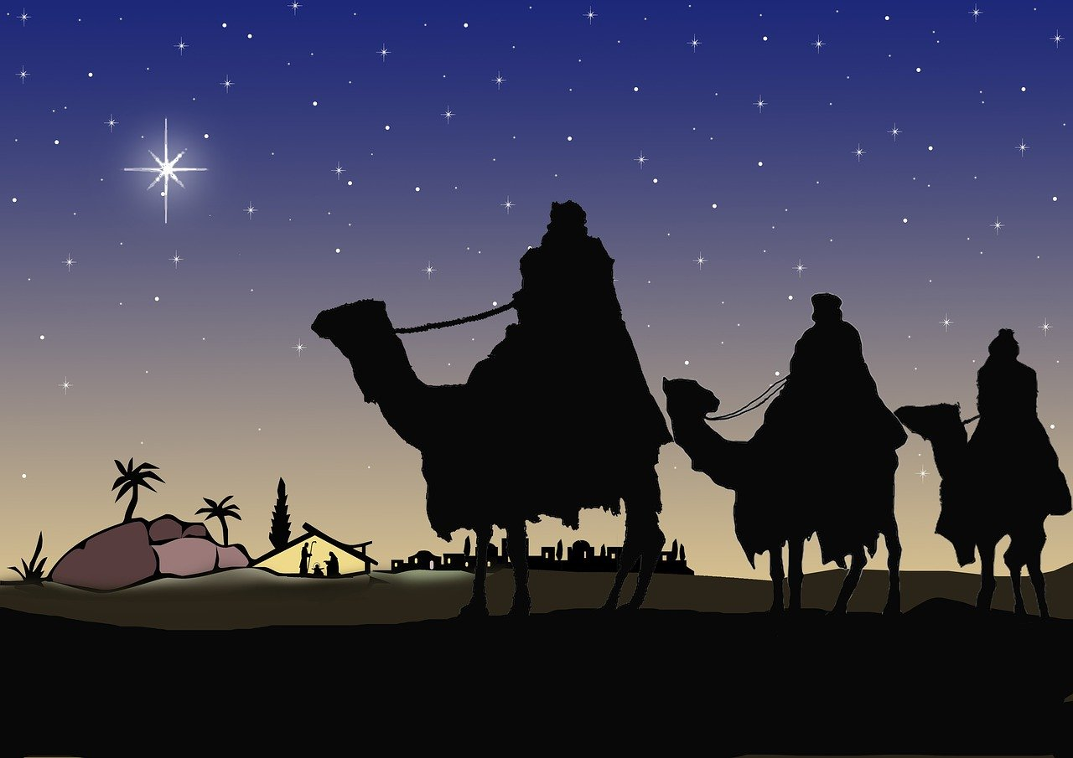

As Christians, this is why we give gifts at Christmas. We commemorate the Magi/Wisemen and their gifts to Jesus when they arrived at His home.
According to the Bible, the baby Jesus received three gifts.
- Gold – has long been associated with Kings. And we, as Christians, believe that Jesus is the King of Kings.
- Frankincense – Is sometimes still used during worship in churches. It shows that people would worship Jesus, and it too is a Kingly spice.
- Myrrh: is actually a perfume that is put on dead bodies. It is a prophecy that Jesus would suffer and die.

“Later, Joseph of Arimathea asked Pilate for the body of Jesus. Now Joseph was a disciple of Jesus, but secretly because he feared the Jewish leaders. With Pilate’s permission, he came and took the body away. He was accompanied by Nicodemus, the man who earlier had visited Jesus at night. Nicodemus brought a mixture of myrrh and aloes, about seventy-five pounds about 34 kilograms Taking Jesus’ body, the two of them wrapped it, with the spices, in strips of linen. This was in accordance with Jewish burial customs.” John 19:38-40

This year before you share gifts with your family and friends, take time to share the story of the Wise Men and the gifts that they brought the Son of God. Then exchange your gifts, remembering once again that without Christ, there is no Christmas.

Dear Lord. There are so many working parts to the Christmas Story. Angel, Shepherds, A Virgin, Wise Men, a jealous king, and of course your Son, Jesus. Thank you for sending Him for us, and never let us never forget that without His birth, death, and resurrection, there would be nothing to celebrate. Amen

