Advent stories and messages from around the world
"Where's the "Plum" in the pudding"
December 20, 2021
John 3:16
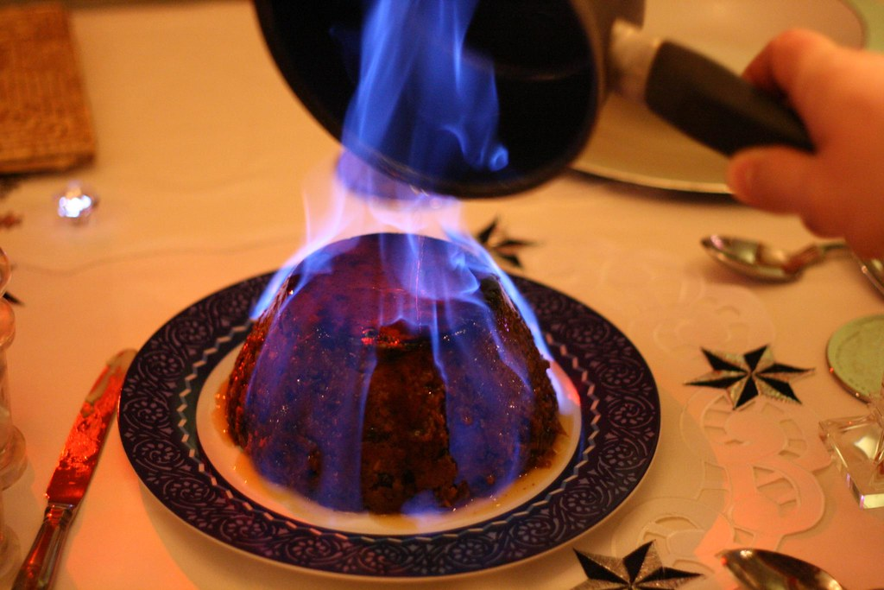
Have you ever eaten Plum pudding (A.K.A. Christmas pudding; figgy pudding)? If you have, then you already know there are no plums in plum pudding. The word "plum" is just a generic name used for any kind of dried fruit (raisins, figs, etc.). But, if you haven't, you at the very least heard "Tiny Tim in 'A Christmas Carol'" references it, as well as two of the verses of, "We, wish you a Merry Christmas."
The history of plum pudding goes back to the 15th century. Although it was initially called "Plum Pottage," it was a flavorful concoction filled with meat and root vegetables that would be eaten at the beginning of a meal.
Over the years, it morphed into what we now call Christmas or plum pudding. Christmas pudding even made its way in the church liturgy in England, with the last Sunday, before the first Sunday of Advent being, "Stir up Sunday."
'Stir-up Sunday' is the day when traditionally families gather together to prepare the Christmas pudding. Each taking a turn stirring the mixture ... The Collect of the Day for the last Sunday before Advent starts, "Stir up, we beseech thee, O Lord, the wills of thy faithful people."
(Historic-UK.com)
One more point. You may notice that the Plum pudding above is, Flambé. This is because in England when serving the dish, the lights are generally turned out in the room. Then the pudding is lit after being saturated with rum or brandy.
*****************************************************
Stir up Sunday while having religious roots; today is celebrated more as a day for the family to cook a great Christmas meal together.
Family. I get a little disappointed when I watch a Christmas movie. Quite often, one of the main characters says something like, "This is what Christmas is all about; it's about family and sharing love for one another."
Christmas is and isn't about family. The Christmas story includes the Holy Family, Jesus, Mary, and Joseph. And today, it's traditional to get together with family and friends and share a meal, Stir-up Sunday, and exchange gifts.
A meal is always a great way to bring the family together, sharing stories, memories, and love. And the gift exchange hopefully reminds us of the gifts the wise men brought to Jesus.
Yet again, let me emphasize something. Without Christ, there would be no Christmas. Don't get so caught up in the yearly festivities that you forget that you wouldn't be celebrating, but for one thing:
"For God so loved the world that he gave his one and only Son, that whoever believes in him shall not perish but have eternal life. For God did not send his Son into the world to condemn the world, but to save the world through him." John 3:16
This year and every year, make sure you share the story of the birth of Jesus with your family as part of your Christmas celebration. Without Jesus' birth, life, death, and resurrection, there's no reason to celebrate, is there?

Dear Lord. This Christmas, please help us to celebrate your Son Jesus. Because of your love for us, you sent Him to sacrifice His life, so we might have eternal life. By Grace through Faith, we are saved. Amen.

