Advent stories and messages from around the world
"The Angel on top of the Christmas Tree"
December 19, 2021
Matthew 1:20-24; Matthew 2:13, 19, 4:10-11

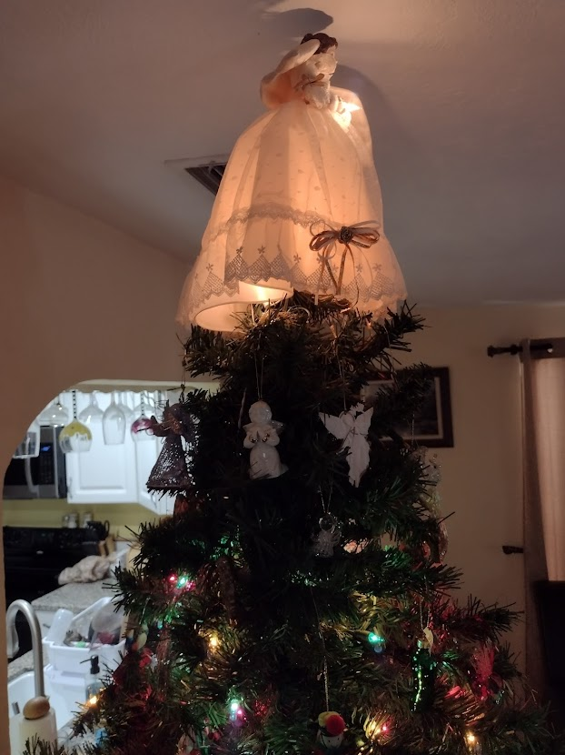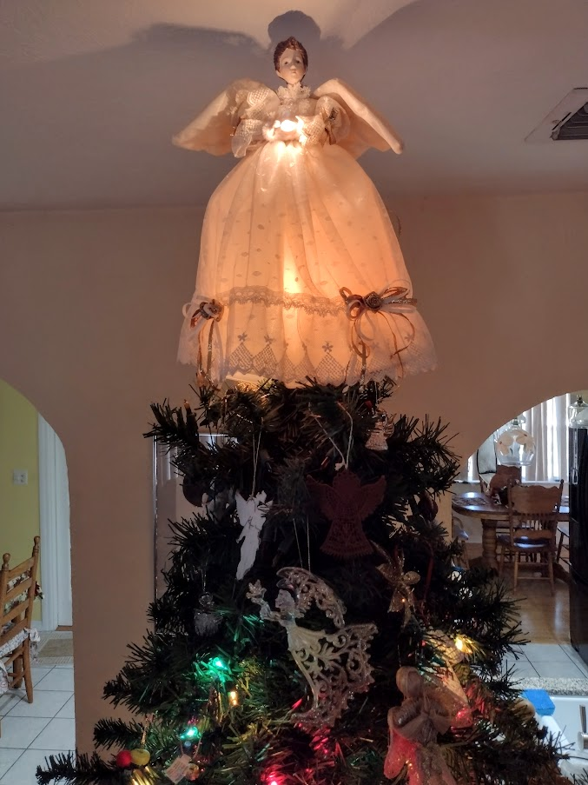

The photos above are of my family's Christmas tree and angel topper. We've had the same angel topper for our tree for 25 years. We also hang about 20-25 different angel ornaments toward the top of the tree.
Some families put stars at the top of their trees. There's nothing wrong with that at all. The star commemorates the wise men's star that brought them to the baby Jesus.
The practice of placing toppers on the Christmas tree commemorates the angels before, at, and after Christ's birth. Because the angels appeared high in the sky to the shepherds, today, we place the angel at the top of our trees.
After people started placing angels on the top of their trees (circa 1848), some families decorated the trees with paper streamers and later tinsel. The children would be told that it was angel hair from the angels leaning in too close to the tree when they decorated it. 😊
*****************************************
As I said earlier, angels were very much involved in and around the birth of Jesus.
"But after he had considered this, an angel of the Lord appeared to him in a dream and said, "Joseph son of David, do not be afraid to take Mary home as your wife, because what is conceived in her is from the Holy Spirit. She will give birth to a son, and you are to give him the name Jesus; 1:21 Jesus is the Greek form of Joshua, which means the Lord saves. because he will save his people from their sins."
All this took place to fulfill what the Lord had said through the prophet: "The virgin will conceive and give birth to a son, and they will call him Immanuel" 1:23 Isaiah 7:14 (which means "God with us").
When Joseph woke up, he did what the angel of the Lord had commanded him and took Mary home as his wife." Matthew 1:20-24

"When they had gone, an angel of the Lord appeared to Joseph in a dream. "Get up," he said, "take the child and his mother and escape to Egypt. Stay there until I tell you, for Herod is going to search for the child to kill him."
So, he got up, took the child and his mother during the night, and left for Egypt, where he stayed until the death of Herod." Matthew 2:13-14

"After Herod died, an angel of the Lord appeared in a dream to Joseph in Egypt and said, "Get up, take the child and his mother and go to the land of Israel, for those who were trying to take the child's life are dead."
So, he got up, took the child and his mother, and went to the land of Israel." Matthew 2:19-21
As you can see from the three passages above, angels were quite busy directing Jesus's earthly father. An angel also came to Mary to announce that she would be the mother of God, even though she was a virgin. Finally, thousands of angels appeared to the shepherds singing praise to God and directing them to go and see the Christ child.
There is another incident of angels involved in Jesus' life.

"Jesus said to him, "Away from me, Satan! For it is written: 'Worship the Lord your God and serve him only.' 4:10 Deut. 6:13"
Then the devil left him, and angels came and attended him."
Matthew 4:10-11
After Jesus was baptized but before he began His formal ministry, He went into the wilderness for 40 days. While He was there, Satan tried to match wits with Jesus, but He was no match for the Son of God. The passage says that "angels came and attended him."
Remember, Jesus was and is God, but he was also human. He got thirsty, hungry, and needed rest and sleep. It seems that the angels came and tended to His needs.
By now, many of you have decorated your tree. If you have an angel topper, share the store of the angels and how involved they were in the lives of Mary, Joseph, the shepherds, as well as Christ's.
Dear Lord. You sent your angel to announce to Mary that she would be the mother of Jesus. You sent angels to direct Joseph and proclaim our Savior's birth to the shepherds. Thank you for all you do in our lives and for sending your Son Jesus as our Savior. Amen.

