Advent stories and messages from around the world
Third Sunday of Advent – December 12, 2021
"Preparation is important for a good result."
Isaiah 40:3; Luke 7:18-28

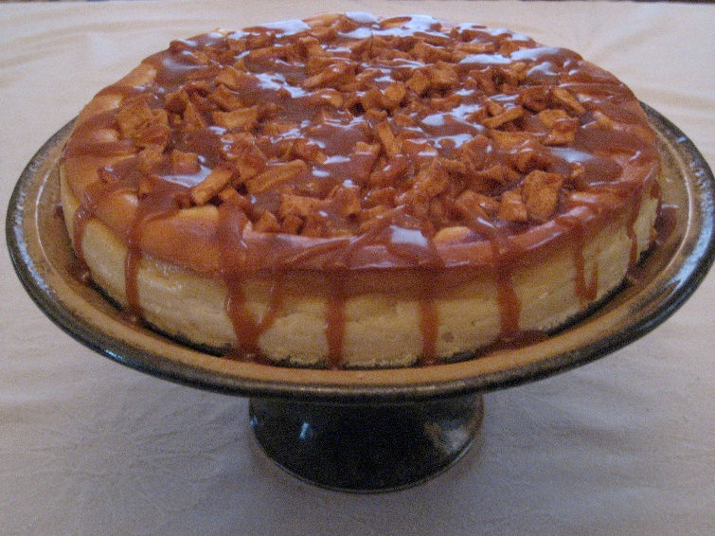
One of my favorite things to do is to bake. Of course, I bake cookies, pies, cakes, but my favorite thing to bake is cheesecakes. And, my favorite cheesecake recipe is "Praline Cheesecake."
I've learned over the years that you need to prepare when making a cheesecake. Unlike a box cake, where you add eggs, butter and pop it in the oven, cheesecake takes a bit more prep time.
For my Praline Cheesecake, I need three 8 oz. packages of cream cheese. The cream cheese to be soft so I can mix it with other ingredients. So, it's essential that I take the cream cheese out of the refrigerator at least an hour before I begin putting the ingredients together.
The other thing that needs to be done is to make the crust before making the cake ingredients. This involves mixing a cup of graham cracker crumbs and melted together. Then that mixture is pressed into a springform pan and baked at 325 for eight minutes. After the crust is done, it needs to cool before adding the cream cheese mixture.
I'm a bit of a stickler when it comes to ingredients, so I have all of my ingredients measured and lined up beforehand. One other bit of prep work is taking the three eggs out of the fridge used in the cheesecake mixture for at least 30 minutes before mixing them with the now softened cream cheese.
It sounds pretty involved, doesn't it? And that's not the whole recipe. But, you can only have a well-made and delicious cheesecake if you plan and prepare before the actual mixing and baking.
*******************************************************
God's pretty good at advance preparations too. So he promised someone would come to pave and prepare the way for the coming Savior.
A voice of one calling:
"In the wilderness prepare
the way for the Lord40:3 Or A voice of one calling in the wilderness: / "Prepare the way for the Lord;
make straight in the desert
a highway for our God. Isaiah 40:3

God sent John the Baptist (Jesus' cousin, the son of Elizabeth) to pave the way for Jesus' ministry. Jesus even verified that John the Baptist was indeed the person spoken of in the Old Testament.

"John's disciples told him about all these things. Calling two of them, he sent them to the Lord to ask, "Are you the one who is to come, or should we expect someone else?"
When the men came to Jesus, they said, "John the Baptist sent us to you to ask, 'Are you the one who is to come, or should we expect someone else?' "
At that very time, Jesus cured many who had diseases, sicknesses, and evil spirits and gave sight to many who were blind. So, he replied to the messengers, "Go back and report to John what you have seen and heard: The blind receive sight, the lame walk, those who have leprosy7:22 The Greek word traditionally translated leprosy was used for various diseases affecting the skin. are cleansed, the deaf hear, the dead are raised, and the good news is proclaimed to the poor. Blessed is anyone who does not stumble on account of me."
After John's messengers left, Jesus began to speak to the crowd about John: "What did you go out into the wilderness to see? A reed swayed by the wind? If not, what did you go out to see? A man dressed in fine clothes? No, those who wear expensive clothes and indulge in luxury are in palaces.
But what did you go out to see? A prophet? Yes, I tell you, and more than a prophet. This is the one about whom it is written:
" 'I will send my messenger ahead of you,
who will prepare your way before you.' 7:27 Mal. 3:1
I tell you, among those born of women, there is no one greater than John; yet the one who is least in the kingdom of God is greater than he."

As I mentioned in an earlier devotion, John never claimed to be the Savior. Instead, he said someone was coming that was far greater than himself. John told the people that he was not worthy to tie (Jesus') shoes and that he John baptized with water, but the one coming (Jesus) would baptize with the Holy Spirit).
Yes, there was and is no question John the Baptist's job was to prepare the way for Jesus' ministry. This preparation made way for the Son of God to fulfill His destiny as the Savior of the world.
Prepare yourself each day for what may come your way by immersing yourself in God's word and prayer. Let Christ's love shine in you, so others may know who He is. Amen.
Dear Lord. You sent John the Baptist to prepare for the coming of your Son Jesus. Help me to prepare each day for the world we face. Help me to be a beacon of light in the wilderness for you, so others may come to know you as I do.
Amen.

