Advent stories and messages from around the world
Shoes by the fire on Christmas
December 10, 2021
John 13:3-17

When I was young, I lived in Chicago. Like many cities and states up north, we had some freezing and icy weather. Snow, wind, sleet, and sometimes freezing rain. I can remember coming in after slogging through snow and sleet, and my body would be cold, and my shoes would be wet.
Back then, we had the old-style radiators in our home to heat the house.
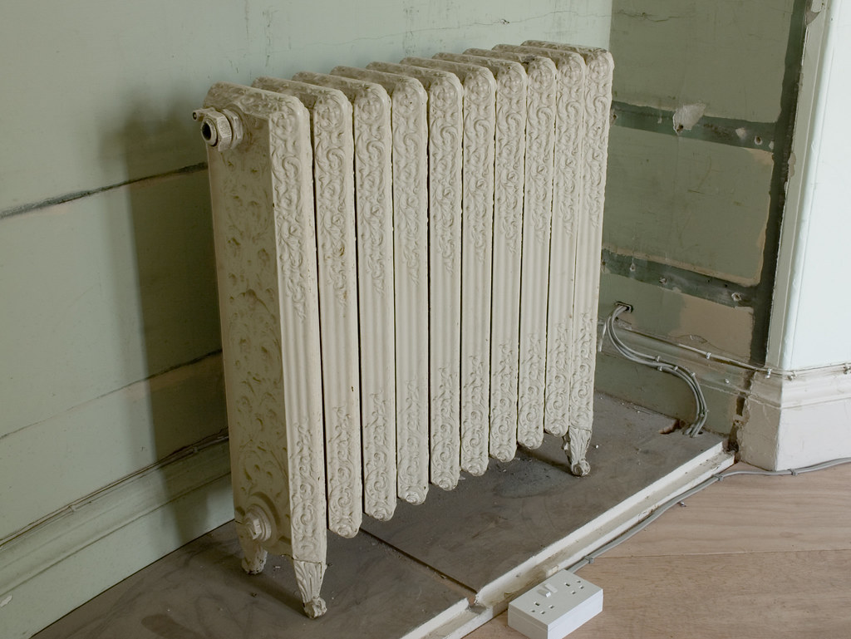

Our family would put our shoes near or under the radiator to dry them out. But those who had a fireplace sometimes put their shoes near the fireplace to dry their shoes and wet socks.


The children of France have a unique tradition at Christmas. They leave out their shoes in front of the fireplace on Christmas Eve, hoping Père Nöel will fill them to the brim with little presents, sweets, fruit, nuts, and anything else that will fit in there.
I guess the larger the shoe, the better. I'd probably make out pretty good since I have size 12 shoes.
*************************************************************
The first thing that comes to mind when I think of shoes is feet. And when I think of feet, I think of Jesus washing the disciple's feet at the last supper.
"Jesus knew that the Father had put all things under his power and that he had come from God and was returning to God; so, he got up from the meal, took off his outer clothing, and wrapped a towel around his waist. After that, he poured water into a basin and began to wash his disciples' feet, drying them with the towel that was wrapped around him.
He came to Simon Peter, who said to him, "Lord, are you going to wash my feet?"
Jesus replied, "You do not realize now what I am doing, but later you will understand."
"No," said Peter, "you shall never wash my feet."
Jesus answered, "Unless I wash you, you have no part with me."
"Then, Lord," Simon Peter replied, "not just my feet but my hands and my head as well!"
Jesus answered, "Those who have had a bath need only to wash their feet; their whole body is clean. And you are clean, though not every one of you." For he knew who was going to betray him, and that was why he said not every one was clean.
When he had finished washing their feet, he put on his clothes and returned to his place. "Do you understand what I have done for you?" he asked them. "You call me 'Teacher' and 'Lord,' and rightly so, for that is what I am. Now that I, your Lord and Teacher, have washed your feet, you also should wash one another's feet. I have set you an example that you should do as I have done for you. Very truly, I tell you, no servant is greater than his master, nor is a messenger greater than the one who sent him. Now that you know these things, you will be blessed if you do them." John 13: 3-17
What many people don't know about Jesus washing His disciple's feet was that He was keeping with tradition. It was traditional for the owner of a house or one of his servants to wash the feet of their guests as they entered the home. Why? This was not a ceremonial washing; it was a necessity for cleanliness.
We need to remember that the streets in a town like Jerusalem or any community of that time were dirt. But it's more than that. Most people walked either barefoot or had thin sandals. The streets were filled not only with people. There were horses, donkeys, goats, and sheep, walking the streets with their owners and "doing their business," whenever and wherever they wanted.
So, when someone came to your house, their feet weren't just dusty dirty; they were probably "Yucky," dirty.
There is no mention that the master of this household, where Jesus had the Passover meal with his disciples, had cleaned their feet as they entered his home. But, leave it to Jesus to take someone else's oversight or neglect and turn it into a teaching moment.
Here was the Son of God, on His knees cleaning his disciples' feet. Yes, their feet were probably filthy. But Jesus' actions were two-fold. One, He washed their feet of dirt and "debris." Two, He gave His disciples an example of what servanthood looked like. Serving others is not beneath anyone.
When we help others with food, money, housing, or paying a bill, we are being a servant of Christ, just like He was and is to all of mankind.
Jesus served us by coming to earth and allowed Himself to be arrested, beaten, and hung on a cross.
Why? Because He loves you and me. His words echo throughout history,

"Greater love has no one than this: to lay down one's life for one's friends."
You and I, as Christians, are friends of Jesus. Jesus gave His life for us. Jesus' shoes are pretty big ones to fill. So, the question is, "What are you willing to do to serve your Lord and Savior Jesus Christ?"

Dear Jesus. You serve us each and every day. You listen to our prayers, and you answer them. We are sick in body and sometimes spirit, and you hold us close as we are healed. Help us be a servant like you, giving of ourselves for others.
Amen

