Advent stories and messages from around the world
Monday, November 29, 2021
The Advent Calendar
Matthew 11:28; Luke 10:38-42

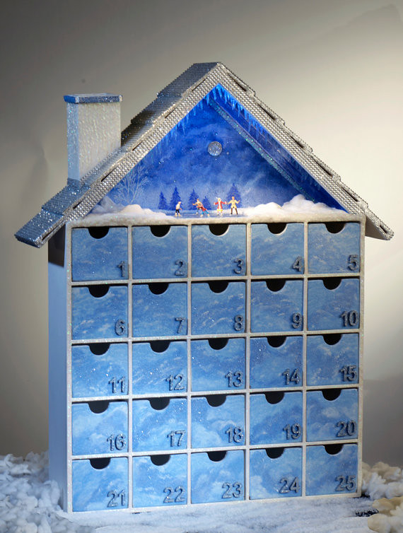

Before I talk about the Advent Calendar, it's probably a good idea to ask a question.
What is Advent?
Advent is a period of time before Christmas meant to prompt reflection as Christians look ahead to prepare for the birth of Jesus. Although most Advent Calendars are numbered 1-24 (denoting December 1 through December 24), Advent is not always exactly 24 days long. For example, this year (2021), Advent is 27 days long, beginning on Sunday, November 28.
The tradition of utilizing Advent Calendars dates back to the mid-19th century when German Protestants made chalk marks on doors or lit candles to count the days leading up to Christmas. However, the first modern-day Advent Calendar didn't appear until the early 1900s.
Today's modern Advent Calendars are made in a variety of shapes and sizes. Some of them have little cardboard doors you open each day, which reveals an image. Others have small drawers with a piece of chocolate or a positive message in them.
The calendars are an excellent way for families to get together for discussion, prayer, and fun during a busy Christmas season. By the way, even Lego has come out with an Advent Calendar.
******************************************************************
As we approach the celebration of the birth of Christ, have you taken time to look at your daily calendar? What do late November and December look like as you peruse your calendar?
Is your calendar filled with parties dates, shopping, school plays, preparing dinners, putting up decorations, and keeping up with the latest Hallmark Christmas movie? (I had to put that in as my wife and I are Hallmark movie nuts).
When I think about the busyness surrounding the modern-day Christmas season, I think of two Bible verses. The first may be best saved for December 26.
"Come to me, all you who are weary and burdened, and I will give you rest. Matthew 11:28.
I may be taking this text slightly out of context, but when I talk to people a day or so after Christmas, the word "exhausted" is used quite frequently. Perhaps if we had gone to the Lord and asked Him for help and direction on His priorities, we wouldn't be so wiped out on December 26.
The second bible passage that comes to mind is from Luke 10:38-42.
"As Jesus and his disciples were on their way, he came to a village where a woman named Martha opened her home to him. She had a sister called Mary, who sat at the Lord's feet listening to what he said. But Martha was distracted by all the preparations that had to be made. She came to him and asked, "Lord, don't you care that my sister has left me to do the work by myself? Tell her to help me!"
"Martha, Martha," the Lord answered, "you are worried and upset about many things, but few things are needed—or indeed only one. Mary has chosen what is better, and it will not be taken away from her."

In referencing our daily calendar, the pertinent portion of the passage above is: "Martha, Martha," the Lord answered, "you are worried and upset about many things, but few things are needed—or indeed only one. Mary has chosen what is better, and it will not be taken away from her."
Like Martha during Jesus' visit, we seem to have lost sight of what's essential. "Jesus' name, "Christ," is part of the word Christmas. The word Mas, or Mass, means to celebrate Christ in worship.
Nowadays, most of us spend far too much time worshipping worldly things in December and not enough time worshipping Jesus Christ.
Take a look at your calendar right now. How does December look? Is it filled with those things I mentioned earlier, like parties, dinners, shopping, etc.? Have you made our Savior Jesus an ongoing part of your December calendar, and for that matter, every month of the year?
I know it's a cliché, but remember, "Jesus is the reason for the season." So let's all make plenty of time to worship Him this year. Be a Mary, not a Martha. Amen.

Dear Jesus. Please help us to always put you first in our lives. Then, please guide us to what's important as we travel the path you have chosen for us through your Holy Spirit. Amen.

