Student/Family Bible Study
“Only one returned”
Luke 5:12-15; Luke 17:11-19 (ESV)
(Open your Bible study time with prayer)
(Ask several of your students to take turns reading the two stories out loud)
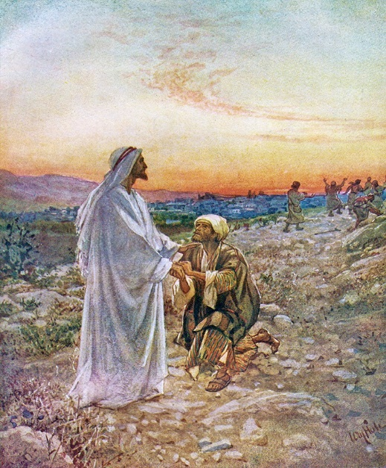
Jesus Heals a Man with Leprosy
In one of the villages, Jesus met a man with an advanced case of leprosy. When the man saw Jesus, he bowed with his face to the ground, begging to be healed. “Lord,” he said, “if you are willing, you can heal me and make me clean.”
Jesus reached out and touched him. “I am willing,” he said. “Be healed!” And instantly the leprosy disappeared. Then Jesus instructed him not to tell anyone what had happened. He said, “Go to the priest and let him examine you. Take along the offering required in the law of Moses for those who have been healed of leprosy. This will be a public testimony that you have been cleansed.”
But despite Jesus’ instructions, the report of his power spread even faster, and vast crowds came to hear him preach and to be healed of their diseases. But Jesus often withdrew to the wilderness for prayer.

Ten Healed of Leprosy
As Jesus continued on toward Jerusalem, he reached the border between Galilee and Samaria. As he entered a village there, ten men with leprosy stood at a distance, crying out, “Jesus, Master, have mercy on us!”
He looked at them and said, “Go show yourselves to the priests. And as they went, they were cleansed of their leprosy.
One of them, when he saw that he was healed, came back to Jesus, shouting, “Praise God!” He fell to the ground at Jesus’ feet, thanking him for what he had done. This man was a Samaritan.
Jesus asked, “Didn’t I heal ten men? Where are the other nine? Has no one returned to give glory to God except this foreigner?” And Jesus said to the man, “Stand up and go. Your faith has healed you.”

Who can tell me what leprosy is?

Leprosy (Hansen’s disease) is a chronic, curable infectious disease, mainly causing skin lesions and nerve damage.
Leprosy is caused by infection with the bacterium Mycobacterium leprae. It mainly affects the skin, eyes, nose, and peripheral nerves.
Symptoms include light-colored or red skin patches with reduced sensation, numbness, and weakness in hands and feet.
Leprosy can be cured with 6-12 months of multi-drug therapy. Early treatment avoids disability.
But wait, there’s more!
Very rare
Fewer than 20,000 US cases per year
Treatable by a medical professional
Spreads by airborne droplets, does that sound familiar? (COVID 19)
Requires a medical diagnosis
Lab tests or imaging often required
Chronic: can last for years or be lifelong
(CDC.org)
In Jesus’ time, people with leprosy were shunned and made to live in colonies outside of the main cities. At that time, it was incurable, and you would eventually die from the disease.
Because of their disease, lepers were considered unclean. Only after being declared clean by a priest could a leper re-enter society once again.
Okay. That’s your history lesson for the day. I think it’s essential that you know what the disease was that Jesus cured.
Whether it was the one or ten lepers, everyone, including the disciples, probably would have backed away from the leper(s). So, for Jesus to come close to them, let alone touch one, was unthinkable.
Let’s go back to the two stories. Let’s begin with the ten lepers and their healing first, and we’ll make some comparisons to the account of the one leper as we go along.
We know from the story in Luke 5 that Jesus had cleaned a man of leprosy earlier in His ministry. This one man who was healed was probably a Jew. In this second healing of leprosy, Jesus heals not one but ten men who ask for mercy (pity).
So, Jesus sends them to the priests, and while they are traveling, all ten were healed. In the healing of the leper in Chapter 5, he was healed immediately.
We find out in the reading that one of the lepers is a Samaritan, a foreigner. It is presumed that the other nine lepers are Jews.

(Why do you think only one of the ten returned to say thank you and praise Jesus and that one was a Samaritan?)

(A little Samaritan background)
Jews generally looked upon Samaritans as “ethnic and religious half-breeds.” (Serendipity Bible)

The Samaritans were half-Jew, half-Gentile. The race came about after the Assyrian captivity of the northern kingdom of Israel in 721 B.C. Certain people from the nation of Israel stayed behind. These people intermarried with the Assyrians producing the Samaritans. They had no dealings with Jews. (Don Steward, Blue letter Bible).

In Luke 9, Jesus and His disciples were not welcomed by a Samaritan Village. Yet, one chapter later, Jesus tells the story of the Good Samaritan. In John 4, Jesus talks to the Woman at the well. She is a Samaritan, and after speaking to Him, she comes to faith in Christ. in our reading of the ten lepers, the one who comes back to Jesus and gives thanks is a Samaritan.

(What’s the point Jesus is trying to make concerning Samaritans?)

Jesus wants us to understand that the message of the Gospel goes beyond racial barriers; it breaks them down. The Gospel of Jesus Christ is for everyone.
(Do you believe this to be true?)
Our job as Christians is to “Go and make disciples of all nations.” (Matthew 28). It seems like it’s so easy for us to do that. The church sends missionaries all over the world to do just that, spread the news of Jesus Christ.
Here’s the tricky part for many!
It seems to be much more difficult for many people (yes, even Americans) to bring and share the love of Christ’s Gospel with our own neighbors. The neighbors and people we encounter every day, who speak a different language, have a different skin color, different values, or customs than us.

(Why do you think this is so hard for us to do?)

A lone Samaritan leper comes back to Jesus and says, thank you. The nine Jews don’t. All people need to know the love that Jesus offers, no matter who or where they come from. We can give this message to others, not just through God’s Word, but also through our actions. We all need to be better at showing and sharing the Fruits of the Spirit.
“But the fruit of the Spirit is,
Love, joy, peace, patience, kindness, goodness, faithfulness, gentleness, self-control; against such things, there is no law. And those who belong to Christ Jesus have crucified the flesh with its passions and desires.” (Galatian 5:22-23)
Let me leave you with my favorite passage from the book of Matthew that I alluded to earlier. These are Jesus’ words, not mine!
Read them, understand them, live them!

Go therefore and make disciples of all nations, baptizing them in the name of the Father and of the Son and of the Holy Spirit, teaching them to observe all that I have commanded you. And behold, I am with you always, to the end of the age.” (Matthew 28:19-20)

(Close your study time with a prayer. Thank God for His many blessings and for His help in sharing His Gospel with everyone.)

