Children’s Message
Do you have a Spirit-led compass?
1 Corinthians 3:16; Galatians 5:22-23a
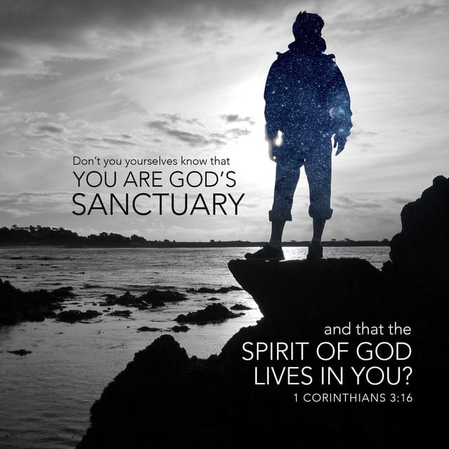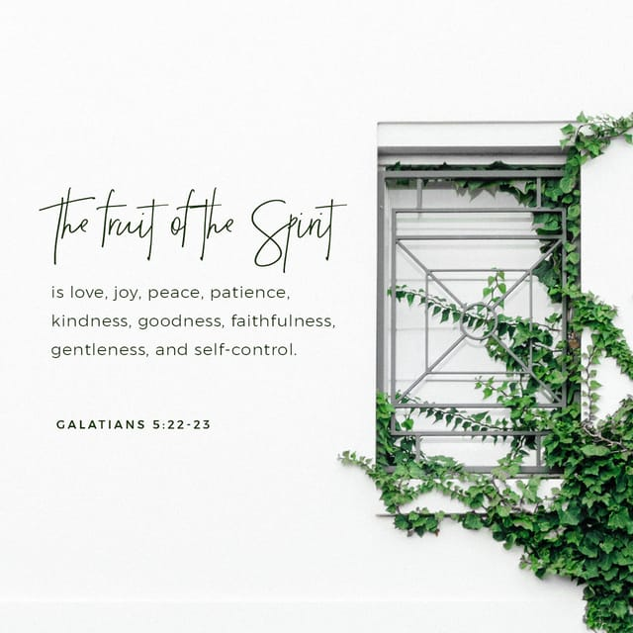
(For this message, you’ll need two compasses. The kind that is used in math class and the type that is used to give directions. The first can be found in the school supply section at any big store (Walmart, Target, etc.), and the second can be found in the sporting goods section at the same stores.)
(You’ll also need a piece of white paper on a clipboard to demonstrate how a math compass works. If you’ve never used a compass before, just open slightly more than the one pictured, use the pointed metal as the center on your paper. Now, slowly, leaving the pointy end on the paper, turn it around with the pencil on the paper. When you’re done, you’ll have drawn a circle.)
(Since we’re talking about the Holy Spirit in this message, I suggest you hand-out a piece of Dove candy to each child at the end of the message. This will help reinforce that the Holy Spirit is our Spiritual and Moral compass.)
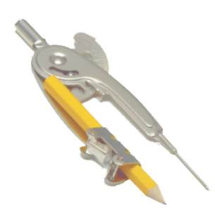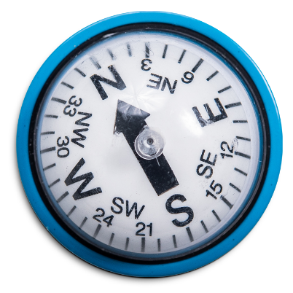
Good Morning!
How many of you have ever seen a compass?
(Wait for answers)
How many of you know what a compass is for?
(Those who do answer will probably say something about directions. Show them the math compass at this point.)
Is this a compass?
(Wait for answers?)
This is a math compass. Let me show you how it works. (On your clipboard draw a circle with the math compass).
This isn’t the kind of compass I’m talking about today. I want to tell you about this kind of compass.
(Show them the regular compass with N, S, E, W, on it)
This kind of compass can show us which direction to go. It’s a guide for us in case we get lost or if we’re not sure if we’re going in the right direction.
Let’s try out this compass. Now when you hold a compass, you’ll see there are 4 letters on it. N, S, E, W, that’s for North, South, East, and West.
And when you hold the compass, you always keep it with the N or north away from you. That doesn’t mean you’re facing north, but that’s how they work.
So, if you hold the compass the way you’re supposed to, and you face the back of the church, which way is the arrow pointing?
Now, let’s take the compass and hold it properly and keep turning in a circle until the arrow faces the N. Okay, so now we know that this way is north.
And if this way is north, then behind me is? And to my left is? (West) And to my right is? (East.). So, if we need to go to Jacksonville and we know it’s north of Merritt Island, now we know we must go which way? (Adjust this segment for your location) Very good!
You see how compasses are so helpful to give us direction? Well, God has given us a spiritual-moral compass to guide us, that’s the Holy Spirit. The Holy Spirit entered us when we were baptized and will be with us for our whole life. When we don’t know what to do in our lives, the Holy Spirit points us in the right direction, so we continue to live a Godly life.
Sometimes we rely on our feelings to help us make decisions.
Is it a good idea to rely on our feelings when we are making decisions?
(Wait for answers)
No, not really, because our feelings change, sometimes we’re in a good mood, sometimes a bad mood, so just because we feel good doesn’t mean our decision is a good one.
Sometimes we look at what others do to make decisions.
Is that always the best way for us to make a decision?
(Wait for answers)
No, or as my mom used to say, “If your friend decides to jump off a bridge, are you going to jump off a bridge too?”
You see, Jesus promised that God would send the Holy Spirit to guide us in all truth. That means the Holy Spirit will always steer us in the direction that God wants us to go.
Whenever you don’t know which way to go in life, you can always turn (open the Bible) to God’s word. We know that the Spirit will lead us to put our faith and trust in Jesus. The Holy Spirit will also help us to be the kind of person Jesus was. In Galatians 5:22, it says we should listen to the Holy Spirit. “But the fruit of the Spirit is love, joy, peace, patience, kindness, goodness, faithfulness, gentleness and self-control.”
That’ how Jesus acted and the Holy Spirit will help us to be that same kind of person.
(Hold your two compasses up)
This compass is to help us do math problems. This compass helps us go in the right direction, especially if we get lost.
But the best compass is the Holy Spirit, He guides us to stay on the path that God chose for us to follow even before we were born.
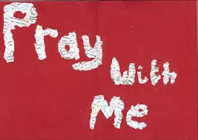
Let’s Pray. Repeat after me.
Dear Lord. Thank you for sending your Holy Spirit after Jesus returned to Heaven. Thank you for the faith for Jesus He fills us with, and the guidance He gives us during our entire lives.
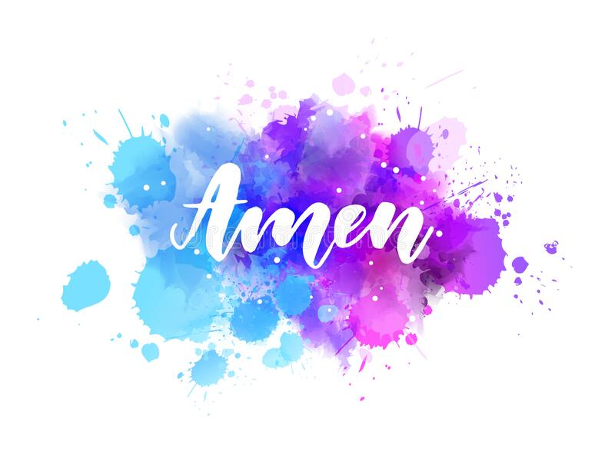
(Hand-out Dove candy to the Children, explaining the meaning of the symbolism of the dove and the Holy Spirit.)
